Managing and Adding Users in POLAR
You will require ADMIN access to perform this Walkthrough.
Open POLAR
Navigate to the Users section
Select Management | 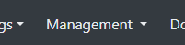
Select User Accounts from the drop down menu | 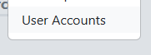
Add New Users
Select New User Account  (Found at the top right hand side of the screen). | 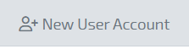
Complete the required details | 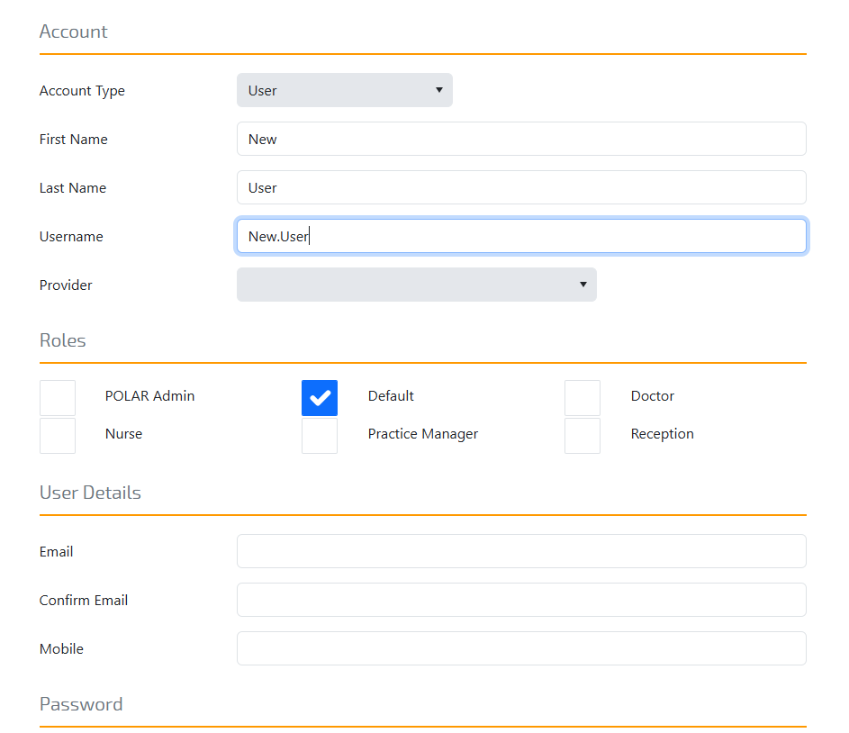
Select Create User | 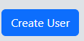
Delete Users
Double click on the User’s profile name | 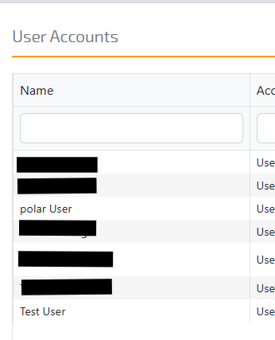
Select Delete Account  (Found in the bottom left corner of the screen) | 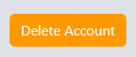
Update User Details
(including changing/resetting User passwords)
Double click on the User’s profile name
Change details as required
If user requires a password reset:-  To provide User with a specific password Select Change Password  To send the User an email so they can change their password Select Send Password Reset Email | 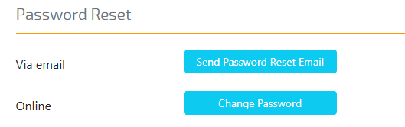
Select Save Account  (Found in the bottom right corner of the screen) | 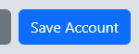
Users Reports
Single click on the User’s profile name
Online Report access-  The Reports Tab on the right hand side will show which reports that specific user has access to.  To provide access to a report tick the box to the specific report  To restrict access remove the tick or leave the box blank to the specific report | 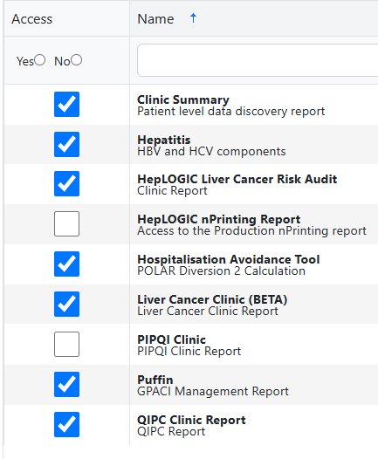
Emailed Reports-  The Mailed Reports Tab on the right hand side will show which reports that specific user will receive via the user’s recorded email address (To change the User’s email address refer to the Update user Details section).  To allow the User to receive an emailed report tick the box to the specific report  To restrict access and ensure the report is not emailed to the User remove the tick or leave the box blank to the specific report | 