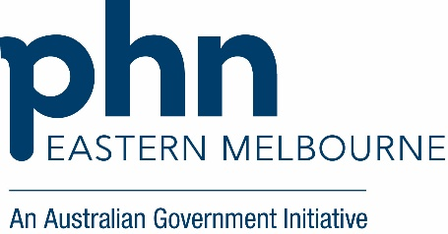

Indigenous Health

Quality Improvement Toolkit for General Practice
Health and wellbeing of First Nations people
Aboriginal and Torres Strait Islander (First Nations) people are the first peoples of Australia. They comprise hundreds of groups that have their own distinct set of languages, histories and cultural traditions, and contribute significantly to all aspects of life in Australia and to Australia’s cultural identity.
For First Nations people, good health is more than the absence of disease or illness; it is a holistic concept that includes physical, social, emotional, cultural, and spiritual wellbeing, for both the individual and the community.
When interpreting health and welfare data about First Nations people, it is particularly important to understand historical factors. Colonisation and subsequent discriminatory government policies have had a devastating impact on First Nations communities and culture. Ongoing entrenched disadvantage, political exclusion, intergenerational trauma and institutional racism can all have a negative impact on the health and welfare outcomes of First Nations people.
This context underlines the importance of culturally appropriate health initiatives tailored to the specific needs of First Nations communities.

What are health checks for Aboriginal and Torres Strait Islander people?
Health checks – often called 715 health checks or health assessments – are annual check-ups available through Medicare for First Nations people of all ages. They are designed to support health and wellbeing by identifying and managing both health conditions and their underlying risk factors – particularly those that disproportionately affect First Nations people, such as diabetes, heart disease, and mental health issues.
These health checks were introduced between 1999 and 2006 to improve access to culturally safe, preventive healthcare, with their development led by the community-controlled sector. People who identify as Aboriginal or Torres Strait Islander and have a Medicare card can get a health check every 9–12 months with their regular GP. Health checks are free at Aboriginal Medical Services and bulk-billing clinics.
(From Australian Institute of Health and Welfare)

Indigenous Health Quality Improvement Toolkit –
This toolkit supports general practices to increase the uptake of Indigenous Health Assessments (MBS Item 715) through structured quality improvement (QI) activities.

Purpose
- Improve access to culturally safe preventive care for Aboriginal and Torres Strait Islander patients.
- Address low uptake of Indigenous Health Checks and gaps in recording Indigenous status.
- Strengthen continuity of care through MyMedicare registration and Shared Health Summary uploads to the My Health Record.

Outcomes of this activity | - Identify patients eligible for an Indigenous Health Check using POLAR.  - Increasing the Indigenous status recording if low.  - Support continuity of care for identified patients by offering MyMedicare registration and uploading Shared Health Summaries to the My Health Record.  - Upskill Staff on cultural awareness.  - Ensure clinical staff are skilled in how to complete the Health Check use the correct templates in your Clinical Information Systems and bill the correct MBS items.

The following steps in this toolkit are examples of practical ideas to assist your practice team:
Step 1
Access your EMPHN Indigenous Health Report to identify activities you can request the report via email: digitalhealth@emphn.org.au
Step 2

Goal of this QI activity
Defining the goal of this activity provides your practice team with a statement of what you are trying to accomplish. Review the goal below and adjust the timeline if needed according to your general practice requirements.
 | QI Activity Goal Example:  For ten identified patients our team will aim to complete an Indigenous Health Assessment (MBS Item 715)
Secondary aims (for participating practices in MyMedicare and MyHealth Record):
- For the identified ten patients our team will aim to register 100% for MyMedicare if appropriate.
- For the identified ten patients our team will aim to upload a Shared Health Summary to the My Health Record.
*This is a sample goal. Practices can choose the number of patients and length of time to complete this QI activity based on their practice requirements.

Step 3
Recording your improvement for this activity


It is recommended to review each improvement step and select what may be appropriate for your practice to consider undertaking and test using Plan Do Study Act (PDSA) cycles to make sustainable changes. Use the following template to record your practice team activities and key learnings.
PDSA Template: Model for Improvement and PDSA template insert link when on website.

Measure – How will you measure the change for this activity?
Regular review of improvement activity measurement enables your practice team to assess progress and track whether the change(s) you are testing is leading to an improvement. It is best to measure at the beginning of the activity (baseline) and then at regular (monthly) intervals throughout.
 | Use the template Activity Measurement and Tracking Table in the PDSA (add correct link) Template to record your measurement for each of your identified ten patients. This will provide a straightforward way to capture your baseline and end of activity measurement for this activity.

Step 4
Identify your QI team and QI activity communication processes

Identify your change team | - Identify the lead and practice team members to drive quality improvement work  - Assign roles and responsibilities according to staff skill, interest and position.  - Allocate protected time for the QI team to perform required tasks in staff calendar e.g. 1hr per week  - Plan frequency and book meetings for QI team.  - Provide access to project files and related policy and procedures
Communication with the practice team | - Identify who will need to be kept informed.  - Identify the method(s) that will be used to inform and update staff of any changes resulting from this QI activity e.g. staff/Clinical/Admin/Nurse meetings, email, noticeboard, group chat.  - Ensure all staff are advised of the chosen communication(s) method.  - Provide monthly updates to all staff of ongoing changes e.g. add QI to staff/Clinical/Admin/Nurse meetings.  - Allow staff to contribute ideas and provide opportunities for staff feedback.  - Distribute minutes/action points following any meetings held and ensure staff are aware of any follow-up needed.  - Celebrate your successes

Undertaking regular meetings helps to maintain momentum and keep the team on track to successfully complete the QI activity. Completed PDSA activity templates can be used as evidence for PIP QI, and accreditation purposes.

Tasks to complete this activity:

Learn the essential steps on identifying patients’ eligible patients for an Indigenous Health Check

Ensure your Clinical Staff is upskilled on performing the checks (see video links below)
Link to webinar recording
Short videos to assist with preparation of the Indigenous Health Assessment by age:
https://cesphn.org.au/general-practice/help-my-patients-with/aboriginal-health
Step 5
Prepare your clinic for undertaking Indigenous Health Checks
Before starting the activity to identify your ten patients for an Indigenous Health Check consider the following:
Data Cleansing
Before you start to identify people, it is important to review and perform data quality activities.

Review your policy and procedure for deactivating past patients (non-attending and deceased) to ensure it is appropriate and being used routinely.
It is good practice to inactivate patients regularly (the inactivation timeframe they haven’t been seen for is a clinical decision, but commonly it can be 2 or 3 years). Commonly this task is done 3-6 monthly by the Practice Manager or Practice Nurse. It should go into their calendar and their job description, so if there is staff turnover, it gets handed on to the new staff member and it is not forgotten. Remind reception staff to always check “all patients” when they are looking for patients.
You may consider archiving or inactivating patients one-by-one who do not fit within the practice’s active patient definition. This may include:
- Archiving deceased patients.
- Merging duplicate patients.
- Archiving patients with a postcode not relevant to your areas/state.
- Archiving patients that have moved away or no longer attend the clinic.
- Archiving patients that have never attended the clinic e.g. those patients that have registered for an appointment but have never turned up (online bookings).
Resource: Bulk inactivating patients in Best Practice
Resource: Bulk inactivating patients in Medical Director

Implementation
- What is the Nurse/GPs capacity for appointments?
- Use of the correct Indigenous Health Check Templates for the specific age cohorts (Supplied Templates)
- Review consistent recording of patient consent in the patient’s clinical record.
- Review current reminder system to ensure a well-defined and effective system is implemented to support sustainability.

Patient Bookings
- Consider how long to allocate for each appointment (for GP and nurse time).

Inviting patients
- How many Health Assessment will you be planning each week?
- How will you send out invitations? SMS, email or personalised letter or opportunistic identification?
- Will your team follow up with phone calls and who will be responsible for this task?

Step 6
Identify eligible patients and implement strategies for increasing Indigenous Health Checks.

The EMPHN Indigenous Health Report has been developed to give an overall snapshot of your indigenous patient’s health. POLAR Clinic Summary Report is available to generate lists of eligible patients.

Tasks to complete this activity:
Developing a list of patients using POLAR
- Using the POLAR Clinic Summary Report/ Tracked MBS, identify the patients that are eligible for an indigenous health check.

POLAR Walkthrough: Identifying Indigenous patients eligible for a Health Check (Insert Link)

- GP/s and clinical team review the list of patients eligible and agree on the ten patients that are a priority for a recall.
- To identify your ten patients, consider the following:
- Identifying ten patients with the highest urgent hospitalisation risk score by adding the risk filter on the dashboard page.
- Working with one GP and ten of their identified patients.
- Patients that may have had a recent hospital admission.
- Patients with multiple comorbidities
- Patients that have had a change to medications.
- Patients that have had a significant change to personal circumstances.
- Check list of identified patients to ensure that a Health Assessment has not been performed at another clinic.
- Review patient's My Health Record for evidence of previous claims.
- Log in to PRODA and use the MBS items online checker in HPOS to review claim records. See MBS for HPOS (eLearning)
- Check the appointments schedule to see if any of the identified eligible patients have any future appointments booked and notate on their record to speak to the patient at time of appointment.
- Agree on method to contact any remaining patients inviting them to attend the practice for an assessment. Note you may want to stagger these to avoid appointment issues.
- Once all ten patients have been reviewed, complete an overall reflection. Consider:
  - Presenting the overall results with your clinical and non-clinical colleagues at a practice meeting including identified successes and barriers.
  - Practice-based discussion to be held on how to minimise the barriers and agreement on practice processes to be implemented/amended including actions to improve.
  - Plan to implement change
Next steps: Consider your next ten patients you will identify and repeat tasks 1-6 above.
 | Activity Check in  Did you complete any of these activities? If yes, document your completed activity using the PDSA template.


Where to get help?
EMPHN general practice improvement & digital enablement: digitalhealth@emphn.org.au
EMPHN practice support: practicesupport@emphn.org.au
HealthPathways Melbourne: info@healthpathwaysmelbourne.org.au

Resources
Fact Sheet Medicare Health Assessment for Aboriginal and Torres Strait Islander People  Medicare health assessment for Aboriginal and Torres Strait Islander people (MBS item 715) | 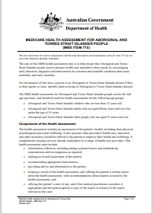
Poster available on this link:  Annual health check for Aboriginal and Torres Strait Islander people – poster – Your health is in your hands | Australian Government Department of Health, Disability and Ageing | 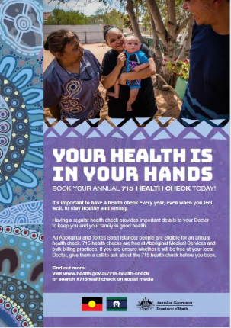
Patient Brochure available on this link:  Annual health check for Aboriginal and Torres Strait Islander people – brochure – Your health is in your hands | Australian Government Department of Health, Disability and Ageing | 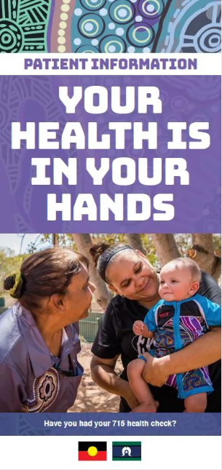
Department of Health, Disability and Ageing | Annual health checks for Aboriginal and Torres Strait Islander people | Australian Government Department of Health, Disability and Ageing
RACGP Guidelines:  Available to download on this link: National guide to preventive health care for Aboriginal and Torres Strait Islander people Fourth Chapter | 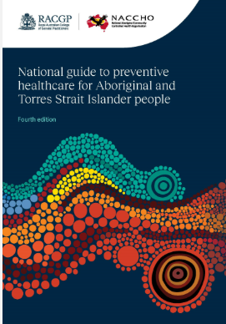
Your guide to Medicare for Indigenous health services:  https://hpe.servicesaustralia.gov.au/BOOK/IHS/IHSBOOK1.pdf | 
Central East Sydney PHN have a number of resources including templates and short videos on how to complete the Indigenous Health Check by age | 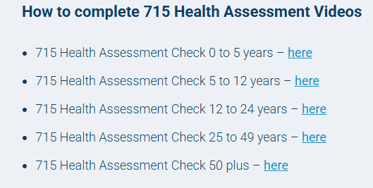  https://cesphn.org.au/general-practice/help-my-patients-with/aboriginal-health
Practice Incentives Program  The Practice Incentives Program – Indigenous Health Incentive (PIP IHI) encourages health services to meet the health care needs of Aboriginal and Torres Strait Islander people with a chronic disease. Health services include general practices, Aboriginal Medical Services and Aboriginal Community Controlled Health Services. See link for more information: | https://www.health.gov.au/our-work/practice-incentives-program-indigenous-health-incentive?language=en
Asking the Question | Short video on Asking the Question:  https://www.youtube.com/watch?v=jKHDqfB7ujs
My Health Record | https://www.digitalhealth.gov.au/healthcare-providers/initiatives-and-programs/my-health-record
My Medicare | https://www.health.gov.au/our-work/mymedicare
Guidelines for Aboriginal and Torres Strait Islander Terminology | https://healthinfonet.ecu.edu.au/healthinfonet/getContent.php?linkid=675466&title=The+Australian+Indigenous+HealthInfoNet+guidelines+for+Aboriginal+and+Torres+Strait+Islander+terminology&contentid=44676_1

