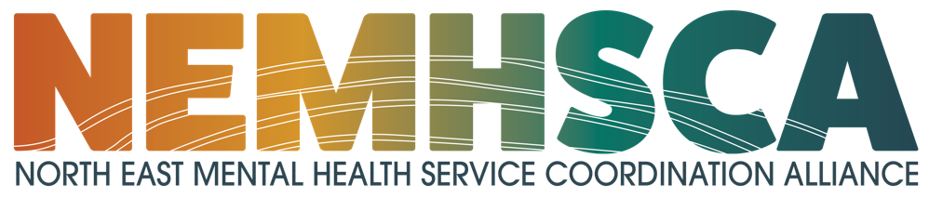

**Terms of Reference**

**May 2024**

1. **Vision, purpose and aims of North East Mental Health Service Coordination Alliance (NEMHSCA)**

North East Mental Health Service Coordination Alliance (NEMHSCA) is an inter-agency mental health and wellbeing partnerships that works together to improve service coordination in the North East Region of Melbourne.

**Vison**

The communities we serve receive person-centered, timely and flexible mental health and wellbeing support through effective regional service coordination.

**Purpose**

To enhance service integration and communication so that communities can access responsive and appropriate mental health, AOD and wellbeing support.

**Aims**

* Improve, support and promote safe, recovery-focused, person-centered and collaborative practices across mental health sector.
* Promote structured and coordinated Lived Experience Leadership, and workforce development models.
* Support members to navigate mental health system reforms.
* Provide platform for consultation and information sharing.

1. **The NEMHSCA Governance Structure**

The Mental Health Service Coordination Alliance (MHSCA) Governance Committee leads strategic direction and provides operations oversight of NEMHSCA and Eastern Mental Health Service Coordination Alliance (EMHSCA).

The purpose of the MHSCA Governance Committee is to:

* Ensure that EMHSCA and NEMHSCA Alliance and Working Group activities align with the stated purpose and strategic directions.
* Ensure appropriate governance arrangements are in place with respect to funding and budgetary planning.
* Generate and / or endorse MHSCA’s positions on issues of relevance to the sector.
* Oversee, review, and provide ongoing recommendations for enhancement regarding future MHSCA focus and functioning.

Members on the Governance Committee represent the constituents of EMHSCA and NEMHSCA and are informed by them as well as being responsible for providing direct feedback to them.

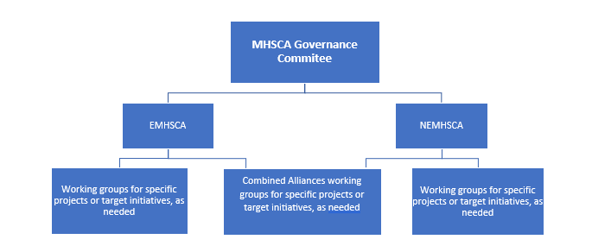Working groups for specific projects will be established as needed based on strategic priorities.

1. **The NEMHSCA Membership**

* The Alliance is an inter-agency group of representatives from agencies directly impacted by the mental health reform and provide mental health and wellbeing services in the north east region (including AOD, homelessness and family violence agencies).

Each NEMHSCA partner organisation will delegate a representative that holds decision making authority for their organisation, can attend meetings regularly and holds demonstrated interest in supporting the NEMHSCA Strategic Priorities.

The members focus on specific action areas that require a collaborative approach and support momentum of the implementation of the Royal Commission recommendations.

*Please note only one representative from each agency will be required, unless the agency is large and has more than one distinct area.*

It is the responsibility of members who are resigning from their position within their organisation to handover information about their role with the Alliance to another suitable leader within the organization.

* Holstep Health is the auspice agency for the Mental Health Partnerships Manager position that oversees the day-to-day operations of the NEMHSCA project.
* Co-chairs are elected from the member agencies every year.
* The Eastern Melbourne Primary Health Network (EMPHN) is the funder of the NEMHSCA project.
* Potential new member organisations are to be considered by the Mental Health Service Coordination Alliance Governance Committee upon request or otherwise via annual review, and if accepted, the project coordinator will extend an invitation.
* By invitation of the Co-chairs others may attend for all or part of one or more meetings of the Alliance as a resource or in an advisory capacity. Any member of the group may seek the Co-chair’s permission for a non-member to attend part of all of the meeting for the development of the work of the Alliance or for information sharing.

1. **Roles and Responsibilities**

**Co-chairs**

The role of Co-Chairs is to:

* Be the first point of contact for discussion and representation on issues relating to NEMHSCA.
* Represent NEMHSCA at relevant forums and meetings.
* Be a supportive leader for NEMHSCA, Working Groups, NEMHSCA Member Agencies and the Alliance Project Coordinator.
* Work closely with the Alliance Project Coordinator to manage workload and priorities for the NEMHSCA.
* Direct and oversee the Alliance Project Coordinator in meeting convening, agenda preparation, minutes, report preparation and action follow up.
* Ensure that planning and budgeting for the future is carried out in accordance with the wishes of Eastern Region MHSCA.
* Co-Chair NEMHSCA Governance Committee meetings and forums for the elected period.
* Undertake the role of a member of the Eastern Region MHSCA Governance Committee

**Members**

The role of Members of NEMHSCA is to:

* Provide feedback to the Alliance Project Coordinator on agenda items and meeting papers required for the Alliance meetings.
* Participate in the development and approval of NEMHSCA Strategic Plan.
* Provide information, advice and direction to strengthen the implementation of the NEMHSCA Strategic Plan.
* Provide expert information and advice on the issues relevant to the NEMHSCA.
* Participate in the development of NEMHSCA positions on issues of relevance to the sector.
* Participate in the review and approval of ongoing recommendations for enhancement regarding future NEMHSCA focus and functioning.
* Participate in the project specific Working Groups as needed.

**Alliance Project Coordinator**

The role of the Alliance Project Coordinator is to:

* Have an administrative function of the NEMHSCA.
* Undertake meeting convening, agenda preparation, minutes, report preparation and action follow up at the direction of the Co-chairs.

1. **Reporting**

* Six monthly reports on the progress of NEMHSCA against the strategic plan and actions, are provided to the Eastern Region Mental Health Service Coordination Alliance Governance Committee by the NEMHSCA project coordinator and is endorsed and provided to the NEMHSC Alliance.
* Minutes are distributed to members of the NEMHSC Alliance no later than two weeks after the meeting, as well as one week from the date of the most recent meeting.

1. **Meetings**

* The Alliance will meet bi-monthly via MS Teams, with at least one in-person meeting encouraged to take place annually or as required.
* Alliance members must be prepared to attend 75% of all meetings each year.
* If a member is unable to attend a meeting, they will be responsible for nominating a proxy.
* Guest speakers with information relevant to the strategic direction of NEMHSCA will be welcomed but must be approved and placed on the NEMHSCA governance committee meeting agenda by the Project Coordinator.
* A quorum shall consist of the majority (more than 50%) of members of the Alliance. Meetings without a quorum may proceed at the discretion of the chair with notes recorded and distributed to the Alliance. No formal decision making will be conducted without a quorum.

1. **Review**

* The Terms of Reference and the membership of the Alliance shall be reviewed annually by the Mental Health Service Coordination Alliance Governance Committee with any changes to be approved by the consensus of the members.
* Review of the Alliances performance shall be conducted annually and reported to the NEMHSCA partners and the Mental Health Service Coordination Alliance Governance Committee.

**Date endorsed.**

**1 June 2024**

**APPENDIX 1 NEMHSCA’s Commitment to communities**

NEMHSCA makes the following commitments in seeking meaningful involvement and contribution from community members in reshaping services that directly affect them.

* NEMHSCA recognises lived experience and the need for and value of consumer, carer and peer worker expert advice into the design and implementation of the alliance and its activities. NEMHSCA is dedicated to strengthening consumer and carer collaboration and participation by providing an expert advisory group to advise and inform the Governance Committee and the NEMHSCA Alliance on its activities and decision making.
* NEMHSCA recognises the ongoing struggle with disposition of the Aboriginal and Torres Strait Islander people and communities, past and present. NEMHSCA is dedicated to building stronger relationships with Aboriginal and Torres Strait Islander peoples, communities and services. NEMHSCA acknowledges Aboriginal and Torres Strait Islander people as the Traditional Custodians of the North East region of Victoria and recognises the enormous health gaps and challenges in accessing culturally safe, appropriate and responsive services. NEMHSCA is dedicated to gaining expert advice by engaging with local Community.
* NEMHSCA values and supports its culturally and linguistically diverse communities (CALD). NEMHSCA recognises that culture and ethnicity shape the way people understand health and wellbeing and that services need to improve the way they engage with their diverse communities, particularly where disparities in health outcomes are evident. NEMHSCA is committed to being a culturally safe and responsive entity that promotes health and wellbeing for the CALD communities.
* NEMHSCA values and supports its LGBTIQ+ people and communities. NEMHSCA recognises that a disproportionate number of the LGBTIQ+ communities experience poorer health outcomes, and these experiences are interrelated with discrimination and marginalisation. Actual or perceived discrimination from services can lead people to delay or deny seeking care. NEMHSCA is committed to being an entity that promotes safety and inclusivity for the health and wellbeing of the LGBTIQ+ communities.

**APPENDIX 2 Good Faith and Guiding Partnerships Principles**

All members of NEMHSCA agree to act in good faith and demonstrate goodwill at all times during all aspects of the work that the Partnership undertakes together. To this end, the Partnership will collectively and conscientiously work to uphold the following shared principles:

* Partnerships add value through integration.
* Partnerships mean clear, honest and informative communication.
* Partnerships are respectful and comprise sharing authority.
* Partnerships and performance count.
* Partnerships actively embrace a culture of learning and innovation.