Attending your appointment via a Video Call

Main Street Medical Service
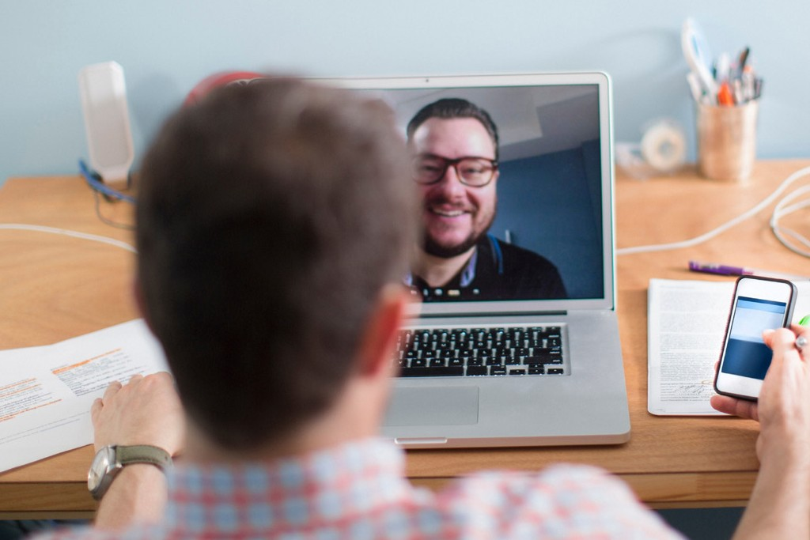

Where appropriate, you can have your consultation online via a video call
Video calling is as convenient as a phone call, with the added value of face-to-face communication.
It can save you time and money,
and brings your care closer to home.

Where do I go to attend my appointment?
To attend your appointment, go to:
https://vcc.healthdirect.org.au/t/mainstreetmedicalservice/join

Instead of travelling to your appointment, you enter the clinic’s waiting area online.
The health service is notified when you arrive, and your clinician will join you when ready.
There is no need to create an account. No information you enter is stored.

What do I need to make a video call?
A good connection to the internet
If you can watch a video online
(e.g. YouTube) you can make a video call
A private, well-lit area where you will not be disturbed during the consultation
One of these:
- Google Chrome web browser (recommended) or Firefox web browser on a desktop or laptop (Windows or MacOS), or on an Android tablet or smartphone
- Safari web browser on an Apple desktop or laptop (MacOS), or iPad or iPhone
Web-camera, speakers and microphone
(already built into laptops or mobile devices)
See over for more information on how to make a video call.

Is it secure?
Video calls are secure; your privacy is protected. You have your own private video room, that only authorised clinicians can enter.

How much does a video call cost?
The video call is free (except for your internet usage). However, the regular costs – if any – of a medical consultation still apply.

How much internet data will I use?
You don’t use any data while waiting for a clinician to join you.
A video consultation uses less than half of the data you would use while watching a YouTube video in High Definition*.
Data use is less on lower-speed internet connections, or if you’re using a less powerful computer, tablet, or smartphone. These factors can also reduce the overall quality of the call.
Data use increases when there are more than two participants in the call.

Smartphone & tablet users
If you can, connect to a home or work Wi-Fi network to avoid using your mobile data allowance.
- That’s about 230 MB on a mobile device, and 450 MB on a PC for a 20 minute call, which is similar to Skype® or FaceTime®.

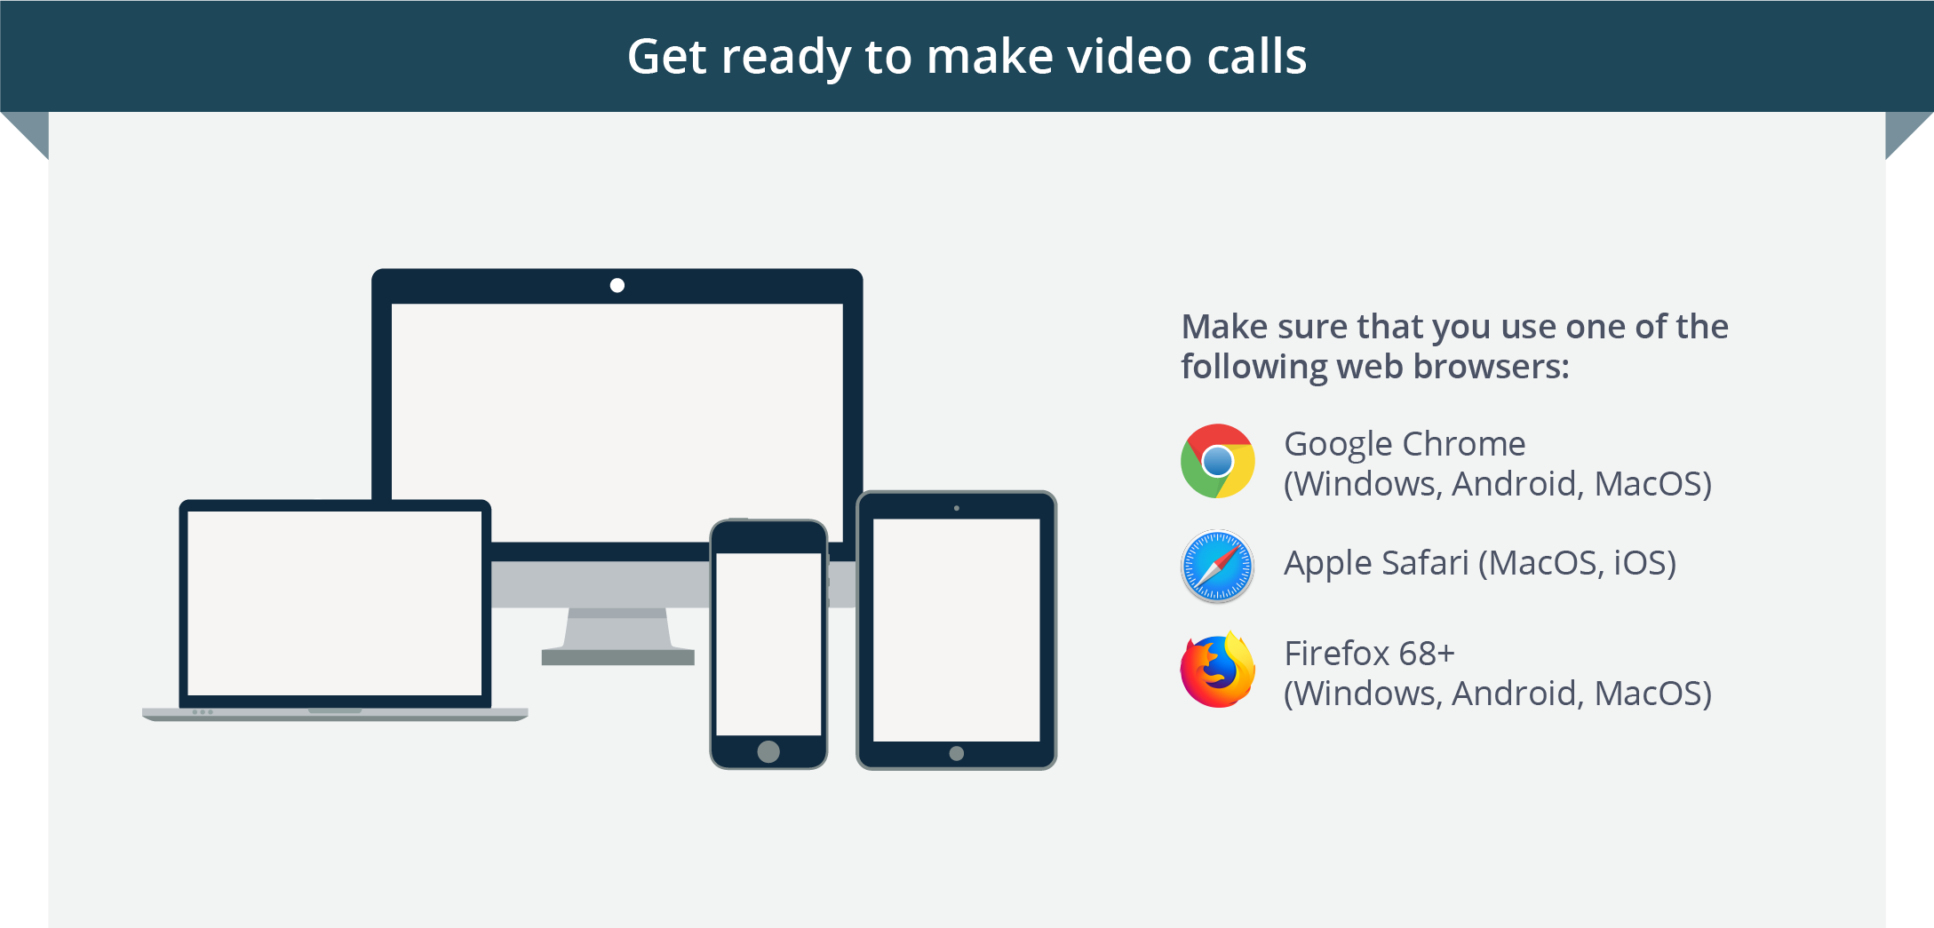
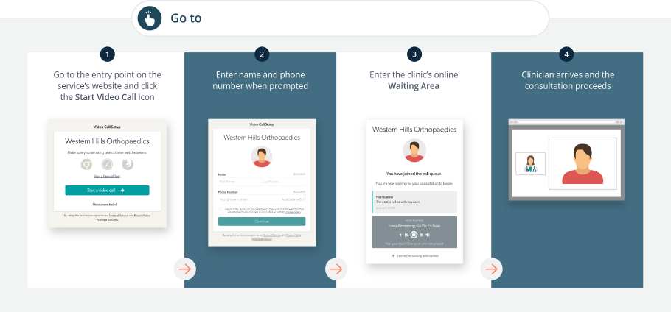
https://vcc.healthdirect.org.au/t/mainstreetmedicalservice/join

What do I do if something is not working?
  - Go to https://vcc.healthdirect.org.au/troubleshooting
More information
If you are having trouble logging into your telehealth appointment, please call Main Street Medical Service on 02 6343 1211 and advise the practice staff member.

