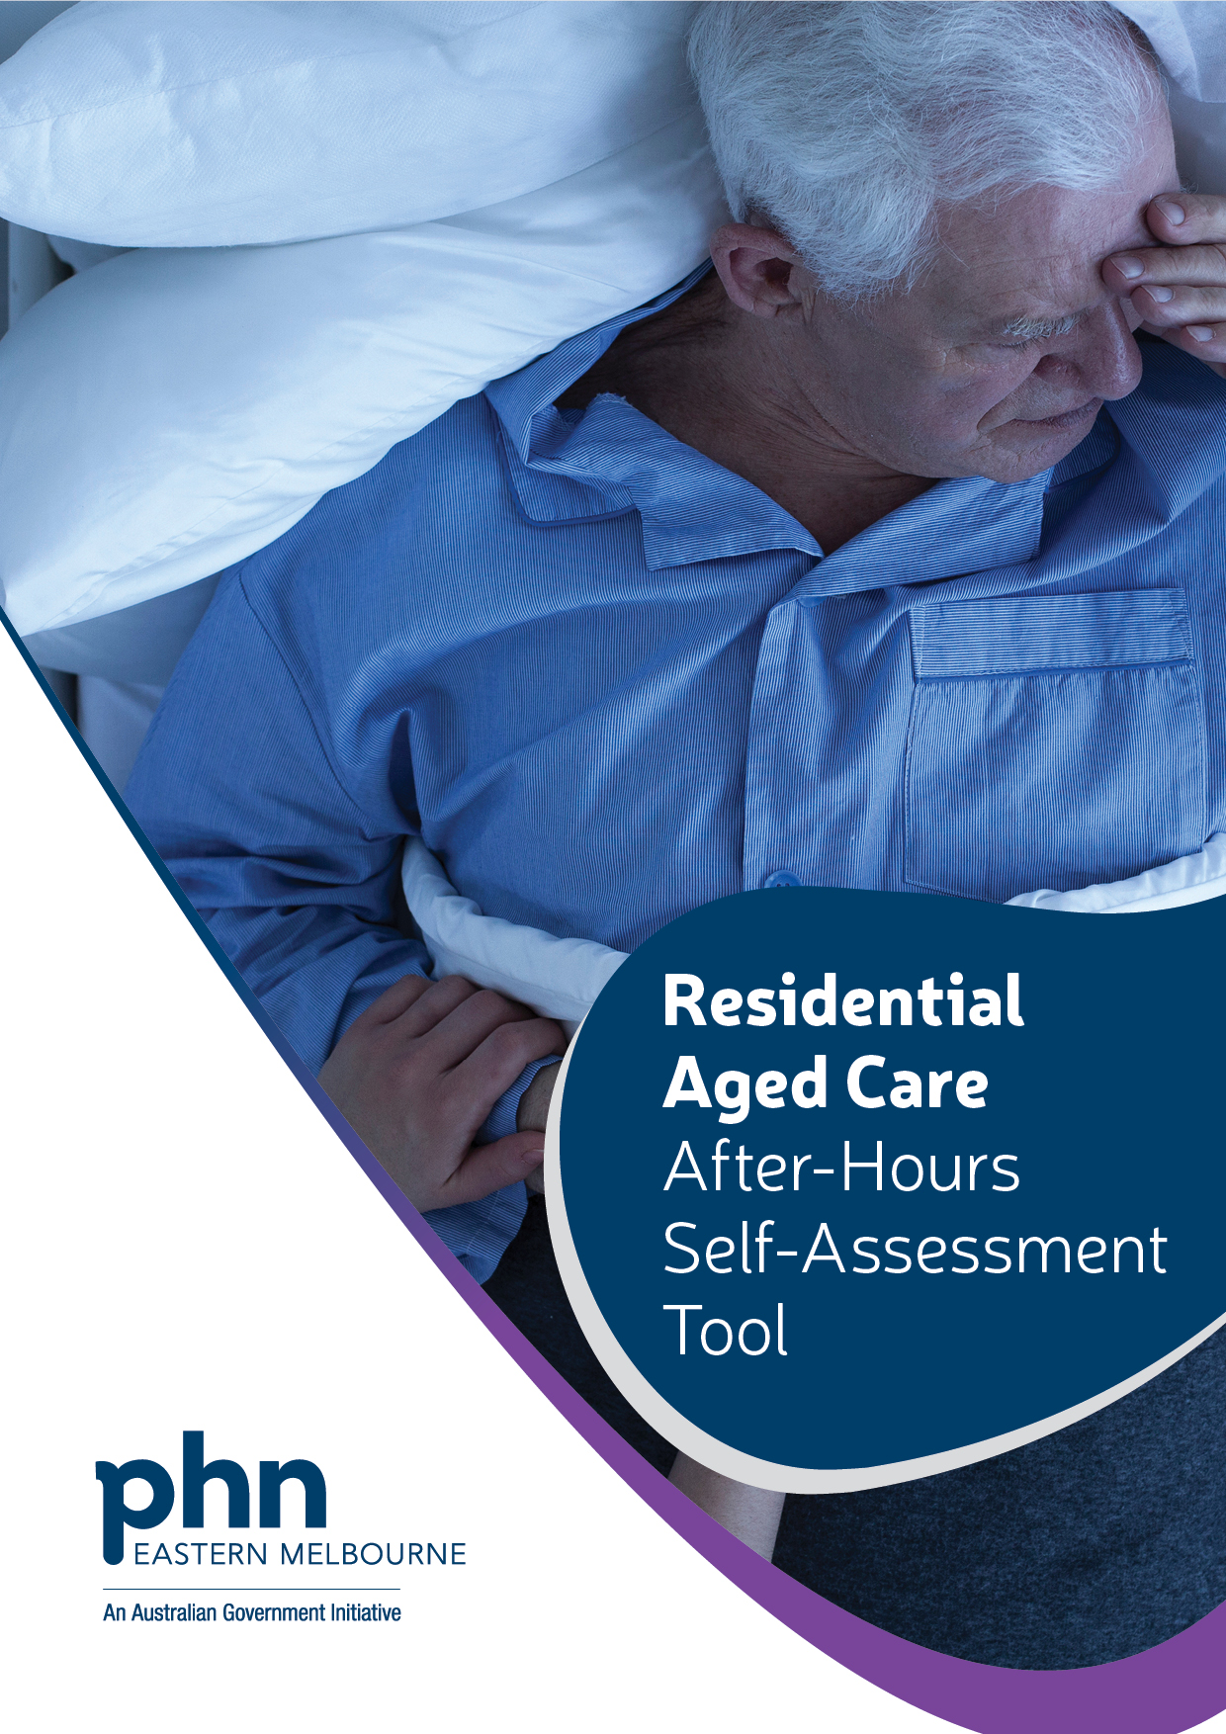

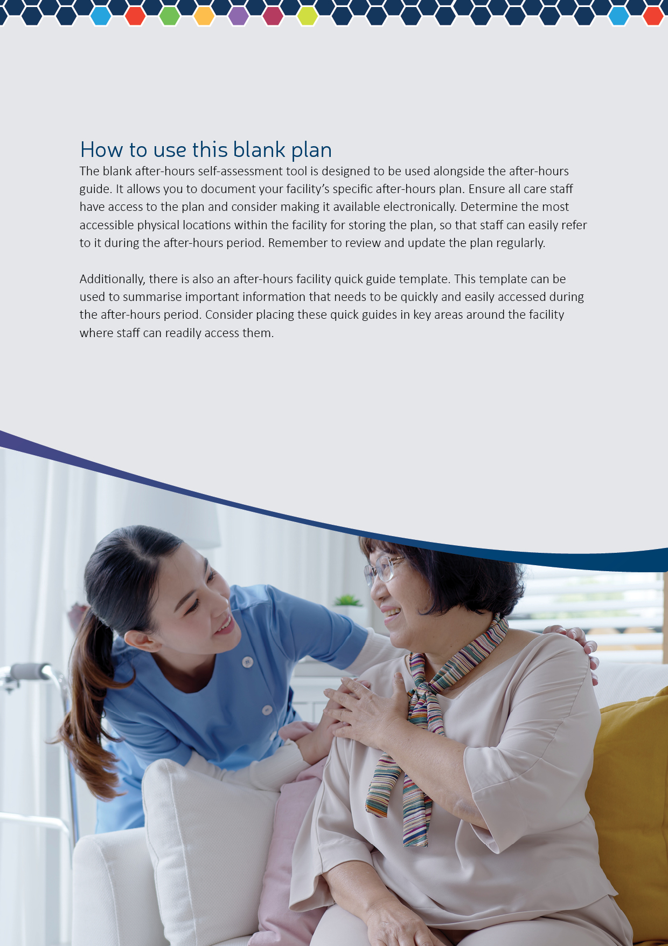
Clinical Governance Aged Care Standards 1,2,6 and 8
Key components of Clinical Governance for FACILITY plans
Processes and Procedures | In place? Y/N | Detail the actions required and plan to implement: | Date to implement: | Date completed and by (name):
There is a clear process for escalating a resident's care during after-hours, including specific prompts for escalation and assigned responsibilities. | Click to enter text. | Click or tap here to enter text. | Click or tap to enter a date. | Click to enter text.
There are clear plans, processes, and structures for determining how care is delivered, including how residents cultural and spiritual needs and preferences are addressed. | Click to enter text. | Click or tap here to enter text. | Click or tap to enter a date. | Click to enter text.
There is a clear process for monitoring risks associated with after-hours care, and related mitigation strategies. | Click to enter text. | Click or tap here to enter text. | Click or tap to enter a date. | Click to enter text.
The documents that underpin the way we do things in our organisation are accessible and stored in an accessible location. | Click to enter text. | Click or tap here to enter text. | Click or tap to enter a date. | Click to enter text.
A clear process is in place for reporting after-hours incidents, and all staff are trained on it, including how often training is refreshed. | Click to enter text. | Click or tap here to enter text. | Click or tap to enter a date. | Click to enter text.
There is a clear process for communicating to staff about after-hours procedures, including escalating resident care needs. | Click to enter text. | Click or tap here to enter text. | Click or tap to enter a date. | Click to enter text.
There are documented principles that guide the provision of person-centred care for residents during the after-hours period. | Click to enter text. | Click or tap here to enter text. | Click or tap to enter a date. | Click to enter text.
There is a list of key people/documents to consult for resident care needs after hours, such as family, RACF manager, and Advanced Care Plan. | Click to enter text. | Click or tap here to enter text. | Click or tap to enter a date. | Click to enter text.
There is a clear process for documenting facility and individual resident after-hours plans, stored in an accessible location. | Click to enter text. | Click or tap here to enter text. | Click or tap to enter a date. | Click to enter text.
There is a clear process for updating facility and individual resident after-hours plans. | Click to enter text. | Click or tap here to enter text. | Click or tap to enter a date. | Click to enter text.
Key components of Clinical Governance for RESIDENT plans
Processes and Procedures | In place? Y/N | Detail the actions required and plan to implement: | Date to Implement: | Date completed & by (name):
Each resident has a documented after-hours care plan, including their preferences for primary and secondary contacts and culturally appropriate providers | Click to enter text. | Click or tap here to enter text. | Click or tap to enter a date. | Click to enter text.
The plan is stored in an accessible location for permanent and agency staff in emergencies | Click to enter text. | Click or tap here to enter text. | Click or tap to enter a date. | Click to enter text.
Principles are documented to ensure that residents have a say in their after-hours care plan | Click to enter text. | Click or tap here to enter text. | Click to enter text. | Click to enter text.

Workforce Aged Care Standard 7
Key components of Workforce for FACILITY plans
Processes and Procedures | In place? Y/N | Detail the actions required and plan to implement: | Date to Implement: | Date completed & by (name):
Documented roles and responsibilities for ensuring resident care in the after-hours, including:  - nominated staff for completing comprehensive physical assessment of a resident.  - responsibilities of non-clinical staff | Click or tap here to enter text. | Click or tap here to enter text. | Click or tap to enter a date. | Click or tap here to enter text.
Process for training nominated staff in the use of tools, for assessing and communicating resident care needs in the after-hours, e.g.:  - Emergency Decision Guidelines  - ISOBAR  - Comprehensive physical assessment | Click or tap here to enter text. | Click or tap here to enter text. | Click or tap to enter a date. | Click or tap here to enter text.
Documented GP preferences for individual resident care in the after-hours. | Text here | Click or tap here to enter text. | Click or tap to enter a date. | Click or tap here to enter text.
List of local services who provide after-hours care, including providers who can support resident’s cultural and spiritual needs and preferences. | Click or tap here to enter text. | Click or tap here to enter text. | Click or tap to enter a date. | Click or tap here to enter text.
If a resident is Palliative, are they linked with a specialist or generalist Palliative care provider, and where is this information collected and stored? | Click or tap here to enter text. | Click or tap here to enter text. | Click or tap here to enter text. | Click or tap here to enter text.
Key components of Workforce for RESIDENT plans
Processes and Procedures | In place? Y/N | Detail the actions required and plan to implement: | Date to Implement: | Date completed & by (name):
Documented GP per resident, and preferred emergency contact for after-hours care (if GP unavailable). | Click or tap here to enter text. | Click or tap here to enter text. | Click or tap to enter a date. | Click or tap to enter a date.
Documented specialist palliative care provider per resident and contact for after-hours care. | Click or tap here to enter text. | Click or tap here to enter text. | Click or tap to enter a date. | Click or tap to enter a date.
Documented providers per resident, who can support a resident’s cultural and spiritual needs. | Click or tap here to enter text. | Click or tap here to enter text. | Click or tap to enter a date. | Text here
Procedure for communicating outcomes of resident care delivered in the after-hours to GP and nominated others. |  | Click or tap here to enter text. | Click or tap here to enter text. | Click or tap here to enter text.

Systems and Processes Aged Care Standards 3 and 4
Key components of Systems and Processes for FACILITY plans
Date completed
Processes and Procedures | In place? Y/N |  | Detail the actions required and plan to implement: | Date to implement
There is a defined process for recognizing and responding to resident deterioration. |  | Click or tap here to enter text. | Click or tap here to enter text. | Click or tap here to enter text.
Assessment tools are utilised to assess residents' care needs during the after-hours period. |  | Click or tap here to enter text. | Click or tap here to enter text. | Click or tap here to enter text.
There is a process in place to evaluate the effectiveness of after-hours planning, including how well residents' cultural and spiritual needs and preferences are addressed. |  | Click or tap here to enter text. | Click or tap here to enter text. | Click or tap here to enter text.
An electronic record management system is used to capture and share information about resident care during the after-hours period. |  | Click or tap here to enter text. | Click or tap here to enter text. | Click or tap here to enter text.
Access to non-electronic resident information is ensured in the after-hours, in case of a blackout or other technological issues that may affect electronic systems.  Consider where hard copies are stored for quick access for new/agency staff. |  | Click or tap here to enter text. | Click or tap here to enter text. | Click or tap here to enter text.
Key components of Systems and Processes for RESIDENT plans
Processes and Procedures | In place? Y/N |  | Detail the actions required and plan to implement: | Date to implement
A process is in place to evaluate the effectiveness of delivering after-hours care plans for each resident, taking into consideration their cultural and spiritual identity. This evaluation helps ensure that the care provided aligns with their unique needs and preferences. | Click or tap here to enter text. |  | Click or tap here to enter text. | Click or tap here to enter text.
There is a process in place to regularly update the after-hours care plan for each resident. This ensures that the plan remains current and reflects any changes in the resident's needs or preferences over time. | Click or tap here to enter text. |  | Click or tap here to enter text. | Click or tap here to enter text.
Date completed
Local Needs and Services Aged Care Standards 7 and 8
Key components of Local Needs and Services for FACILITY plans
Processes and Procedures | In place? Y/N | Plan to implement | Action by date | Date and completed:
There is a clear and accessible list of medical contacts for after-hours care, which includes both preferred and back-up supports. This list provides the necessary information for contacting medical professionals outside of regular business hours when residents require care. | Click or tap here to enter text. | Click or tap here to enter text. | Click or tap to enter a date. | Click or tap here to enter text.
There is a clear and accessible documented list of local/contracted pharmacies available in the after-hours, including their hours of operation. | Click or tap here to enter text. | Click or tap here to enter text. | Click or tap to enter a date. | Click or tap here to enter text.
There is a clear process for using onsite Imprest medication system for accessing urgent medication in the after-hours. |  | Click or tap here to enter text. | Click or tap here to enter text. | Click or tap here to enter text.
There are a clear and accessible documented list of mental health and behavioural supports available in the after-hours. | Click or tap here to enter text. | Click or tap here to enter text. | Click or tap to enter a date. | Click or tap here to enter text.
Key components of Local Needs and Services for RESIDENT plans
Processes and Procedures | In place? Y/N | Plan to implement | Action by date | Date and completed:
Residents' after-hours care plans document their preferred pharmacy for where scripts are held. | Enter text | Click or tap here to enter text. | Click or tap to enter a date. | Click or tap here to enter text.
Residents' after-hours care plans include their preferences for mental health support. | Enter text | Click or tap here to enter text. | Click or tap to enter a date. | Click or tap here to enter text.
Residents' after-hours care plans include their individual needs, preferences, and cultural/spiritual considerations (for example Aboriginal and/or Torres Strait Islander, LGBTI, CALD (Culturally and Linguistically diverse, person with disability). The plans also list service providers who can meet their unique needs during the after-hours period. | Click or tap here to enter text. | Click or tap here to enter text. | Click or tap to enter a date. | Click or tap here to enter text.
Residents' after-hours care plans document who to contact for translation into their preferred language in the after hours. | Click or tap here to enter text. | Click or tap here to enter text. | Click or tap here to enter text. | Click or tap here to enter text.
Residents' after-hours care plans document if they are for hospital transfer when a resident is palliative. |  | Click or tap here to enter text. | Click or tap here to enter text. | Click or tap here to enter text.

Infrastructure Aged Care Standards 5 and 8
Key components of Infrastructure for FACILITY plans
Processes and Procedures | In place? Y/N | Date completed and by (name): | Date to implement |  | Date completed and by (name):
Reliable internet connection is available to support telehealth services for after-hours resident care. | Click or tap here to enter text. | Click or tap here to enter text. | Click or tap here to enter text. |  | Click or tap to enter a date.
There is a documented list of emergency contacts for after-hours support, which includes key contacts for electricity, internet, IT and resident documentation software providers. | Click or tap here to enter text. | Click or tap here to enter text. | Click or tap here to enter text. |  | Click or tap to enter a date.
There are designated spaces for providing resident care that respects and accommodates their cultural and spiritual needs and preferences. This includes specific considerations for end-of-life care. | Click or tap here to enter text. | Click or tap here to enter text. | Click or tap here to enter text. |  | Click or tap to enter a date.
Key components of Infrastructure for RESIDENT plans

Processes and Procedures | In place? Y/N | Detail the actions required and plan to implement: | Date to implement |  | Date completed and by (name):
Individual preferences for utilising telehealth services are documented for each resident. | Click or tap here to enter text. | Click or tap here to enter text. | Click or tap here to enter text. |  | Click or tap to enter a date.
Resident preferences for the location of after-hours care are documented, considering their cultural, spiritual, and personal needs. | Click or tap here to enter text. | Click or tap here to enter text. | Click or tap here to enter text. |  | Click or tap to enter a date.
Resident preferences for hospital transfer when palliated are documented and clear. | Click or tap here to enter text. | Click or tap here to enter text. | Click or tap here to enter text. | Click or tap here to enter text.

