Patient Flagging

Prepared for:
POLAR User Documentation Library

Version Control
Author/contributor | Version Comments | Updated | Version
Diego Benitez | Initial Draft | 04/05/2023 | DRAFT - v0.1

POLAR User Documentation (PUD) No. 018

Document Release: DRAFT v0.2

Contents
1 Configuring and using a Flag 3
1.1 Flag creation 3
1.1.1 Step 1: Creating a flag 3
1.1.2 Step 2: Adding a flag 4
1.1.3 Step 3: Create a Flag Status 5
1.2 Flag Access - Configuration 6
1.2.1 Review 7
1.3 Applying a Flag 7
1.4 Managing a flagged cohort 11
1.4.1 Locations 14
1.4.2 Apply the last report filter option: 15
1.5 Patient Flagging - Management 17
1.6 Deleting a Flag 17
1.7 File Importing 20
1.7.1 Import troubleshooting 22
1.7.2 Review 22
1.8 Using Flags in the Clinical Summary Report 23
1.9 Stakeholder/PHN flags versus Practice Flags 24

Configuring and using a Flag
There are two components to patient flagging:
- Flag creation: This is the administrative function performed by the Stakeholder.
  - NOTE: Only a POLAR administrator can create and manage patient flags.
- Flag allocation: A function performed by the practice user, e.g. The Practice adds a flag against a patient cohort based on an area of interest.

Flag creation

Step 1: Creating a flag
Navigate to the ‘Flags’ menu in POLAR Explorer. Select the ‘Flags Setup’ menu item:
Figure 2 – Setting up a flag
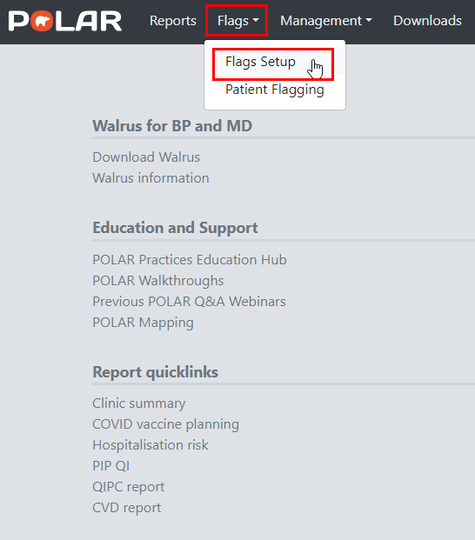
The ‘Flags Setup’ menu displays a screen showing previously created flags or allows you to create new flags by selecting the ‘Add Flag’ option.
NOTE: Stakeholders can assign flags to a practice, or a practice can create their own flags:
Figure 3 - Flag review or creation
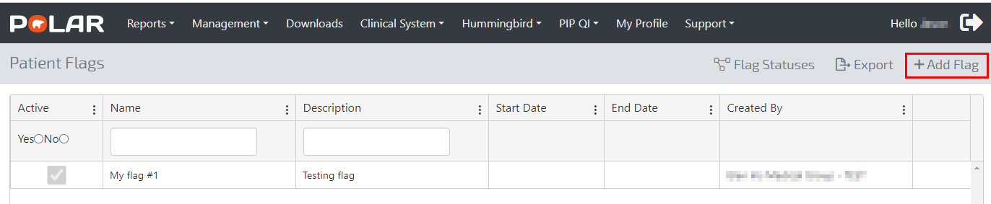

Step 2: Adding a flag
Select the ‘Add Flag’ option to display the ‘Add New Flag’ screen:
Figure 4 - Adding a new flag
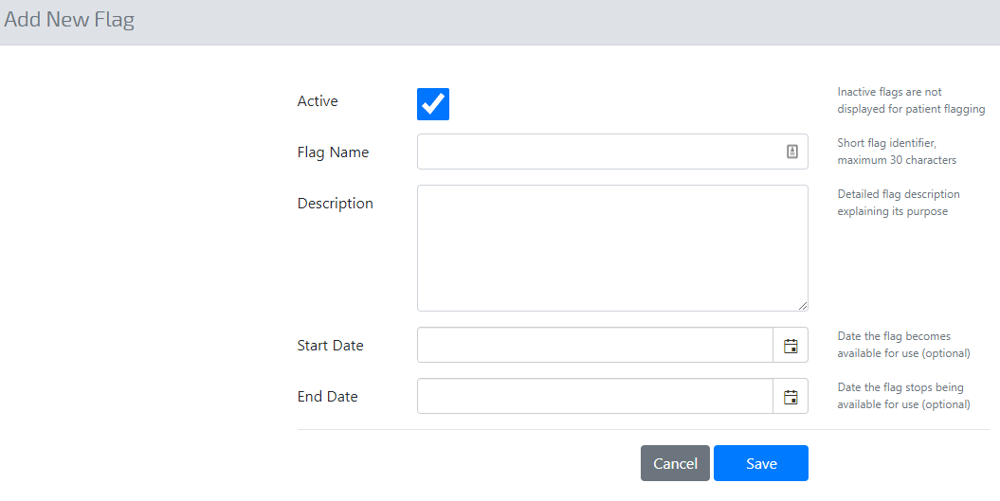
NOTE: In the following example, we will create a New Patient Flag called ‘Residential Aged Care Facility (RACF)’.
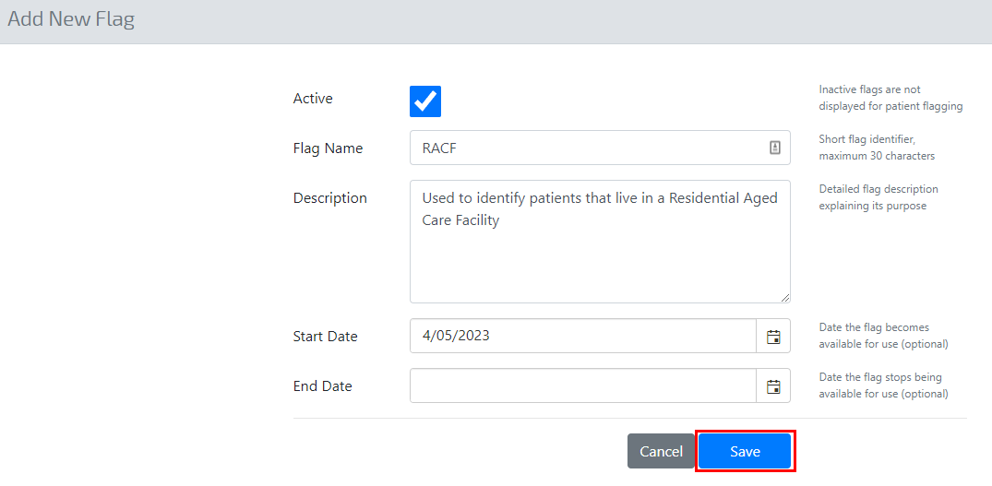
NOTE: The Start and End Dates are optional. In this example, the Flag can be applied from 4/5/2023 onwards. Having no End Date means the Flag can be used as long as the Practice deems it necessary.
Saving the Flag directs the user to the ‘Edit Flag’ screen where changes can be applied to the newly created Flag:
Figure 5 - Allocating a flag status
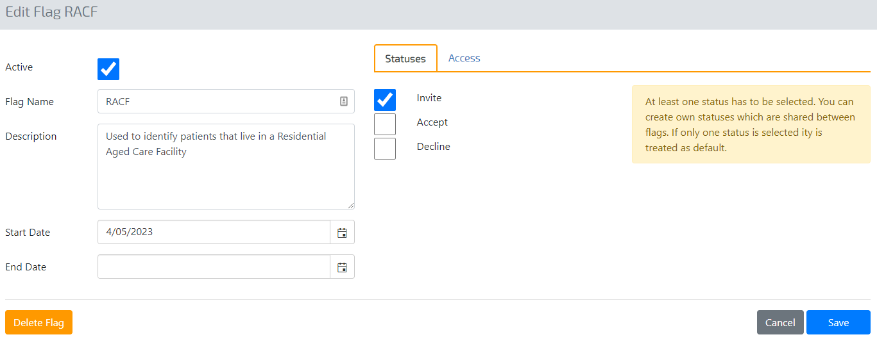
NOTE: By default, a Flag will always require one Status, e.g. Invite, which means applying the Flag will allocate the patient to the cohort.
NOTE: If you require a custom Flag status, e.g. ‘Pending’, the Status must be configured before creating the Flag.

Step 3: Create a Flag Status
To create a flag status, click the ‘Flag Statuses’ menu option:
Figure 6 - Creating a flag status
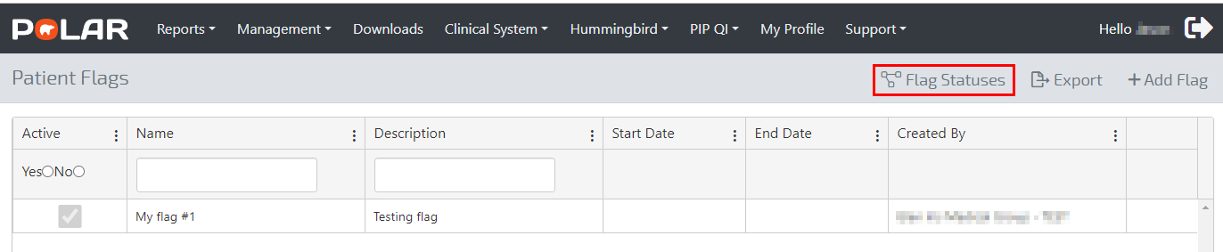
In this example, we have created a new status of ‘Yes’:
Figure 7 - Configuring a new status
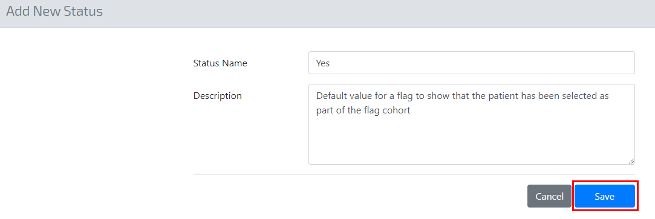
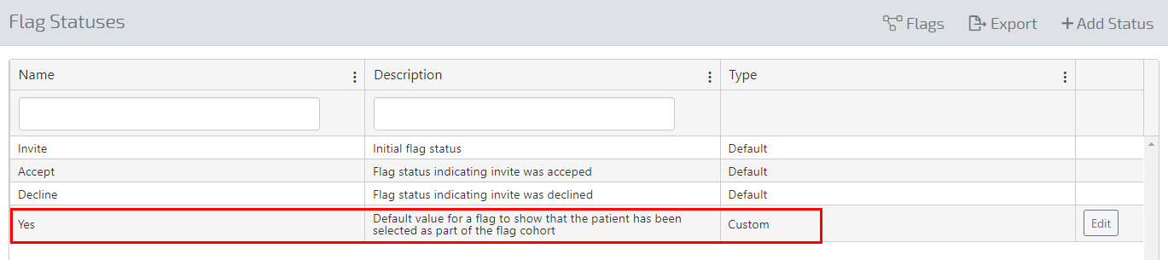
NOTE: A Flag Status can be created for any use case, depending on how the Stakeholder intends to manage the Flag, e.g. If the Flag had stages associated with it, then the required stages could be statuses as in the example above. For example, a Flag created for a research project may require three statuses: ‘Invite’, ‘Accept’ or ‘Decline’. In this example, the patient will have a different status depending on how they respond to the project, e.g. the Invite status may turn into an Accept or Decline. The Status will further allow the Practice or Stakeholder to analyse patient cohorts by first filtering the data by the Flag and then Status, e.g. showing the patients for the Heart Research project (Flag) with a status of Accept.
Using the example in Figure 8, we can select the Status of ‘Yes’ for our RACF flag:
Figure 8 - Setting the new Status for a Flag
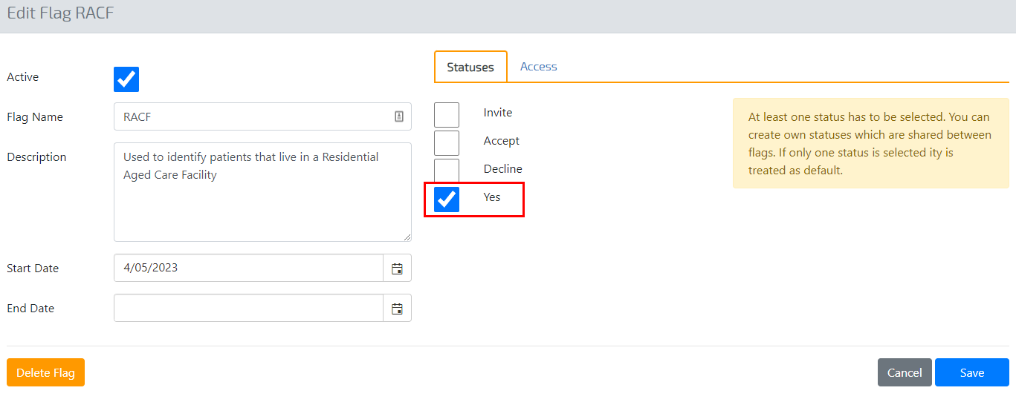

Flag Access - Configuration
Once the ‘Flag’ and associated statuses have been configured, the Flag’s creator will be required to grant access to a practice or location.
NOTE: A stakeholder can create a flag across many sites or locations within their catchment. In contrast, a Practice/site can only create and allocate a ‘Flag’ for the site or a location within the Practice in instances where Multi-Location has been configured within the CIS.
In Figure 9, the RACF flag has been made available to the Site called ADHA (Site ID: 20015). Therefore only the ADHA site can see and use the RACF flag to flag patients.
Figure 9 - Granting flag access
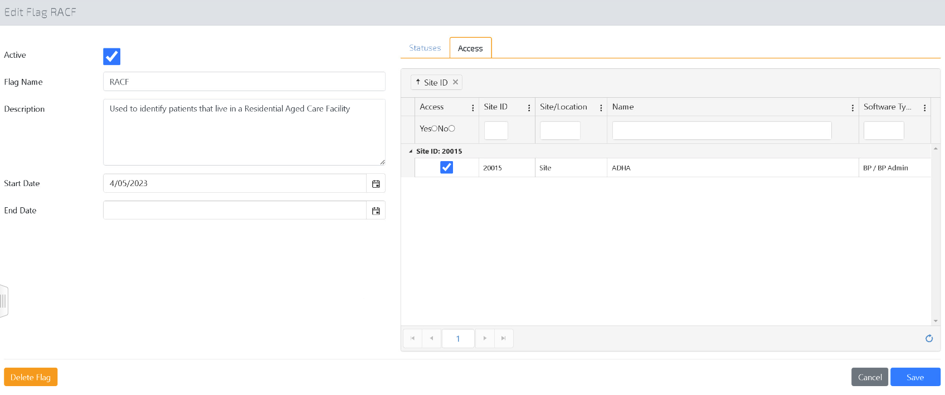

Review
- We have created a Flag called RACF.
- We have created a status called ‘Yes’, which was applied to the RACF flag.
- We have given the ADHA site (Site ID 20015) access to that Flag, enabling the site to flag patients living in a Residential Aged Care Facility (RACF).
NOTE: Flags can be edited through the ‘Patient Flags’ screen:
Figure 10 - Editing a flag
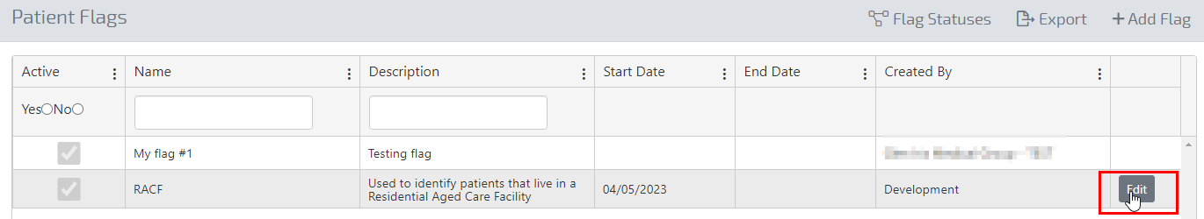

Applying a Flag
Any POLAR report can be used to ‘Flag’ patients through the ‘Patient Flagging’ menu item, as illustrated in Figure 11 for the Clinic Summary Report:
Figure 11 - Patient Flagging menu item
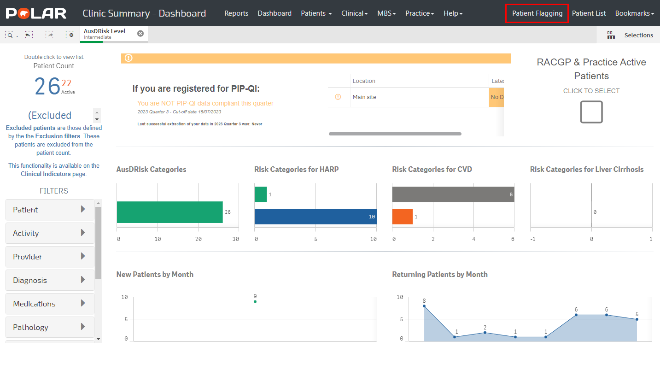
To apply a ‘Flag’, the user must select an overall patient cohort using the Clinic Summary Report. In this example, we will apply some simple filters, e.g. RACGP & Practice Active Patients, to return a patient cohort of 25 patients (Fig 12):
Figure 12 - Using the Clinic Summary report to filter a patient cohort
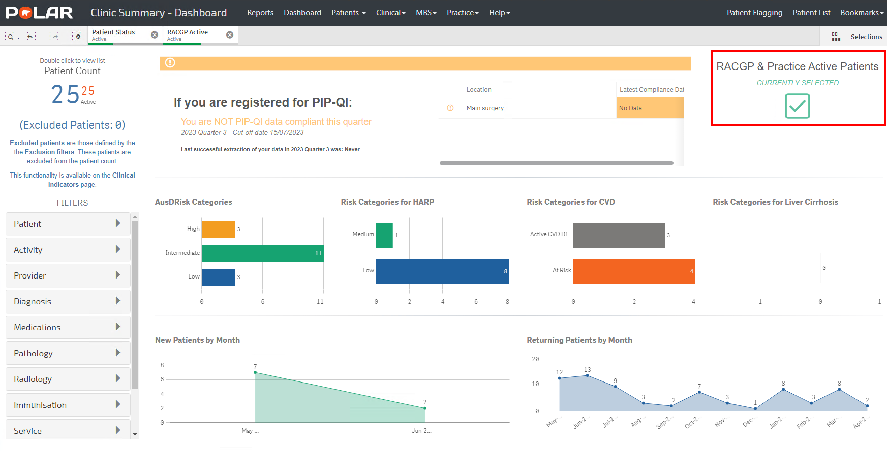

Select the ‘Patient Flagging’ (as displayed in Fig 11) menu to view the ‘Patient Flagging’ screen, as demonstrated in Figure 13.

Figure 13 - Patient Flagging screen
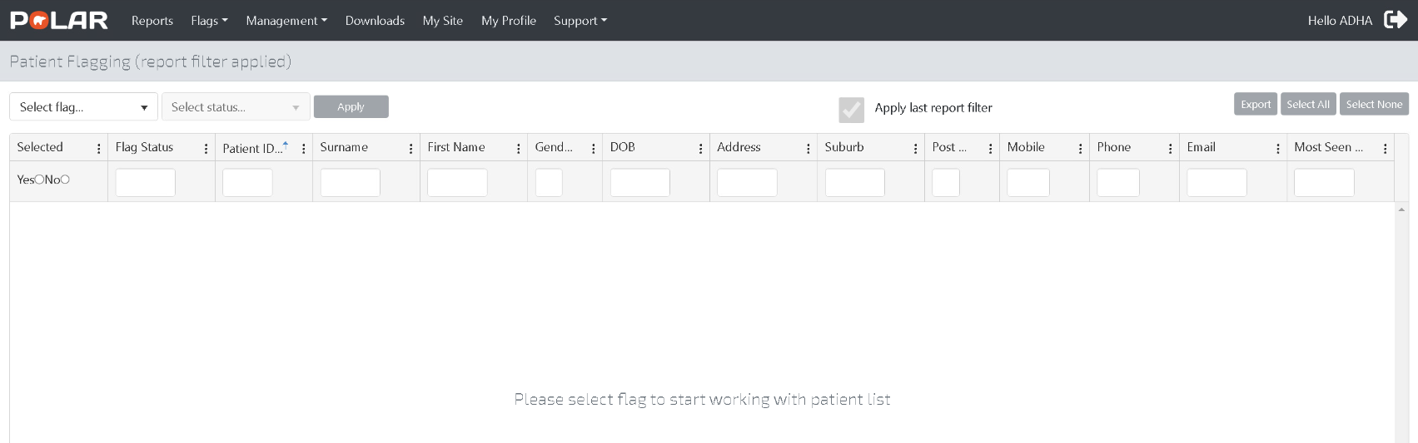
The user can use the ‘Patient Flagging’ functionality to apply flags to the selected 25 patient cohort (Figure 12).
Figure 14 Patient Flagging Screen - Apply Flag
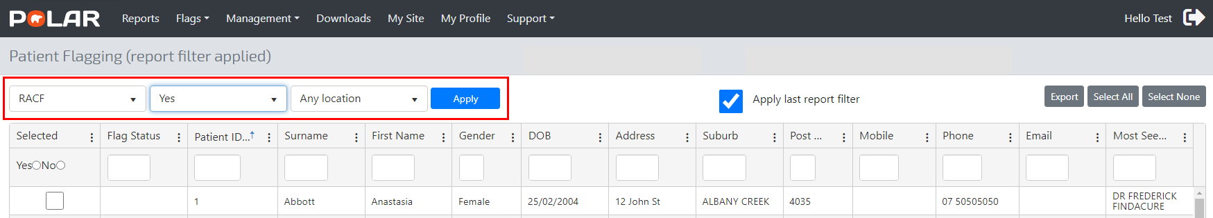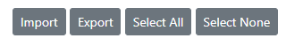
NOTE: Patients can be selected individually or as a group using the ‘Select All’ option. Figure 15 illustrates the ‘Select All’ option which applies the RACF flag to all selected patients:
Figure 15 - Applying a Flag to all selected patients using the ‘Select All’ option
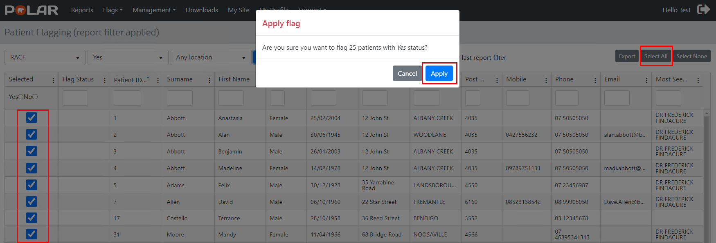
Select Apply to change the Flag Status for cohort patients to ‘Yes’ (Figure 16).
Figure 16 - Flag status update
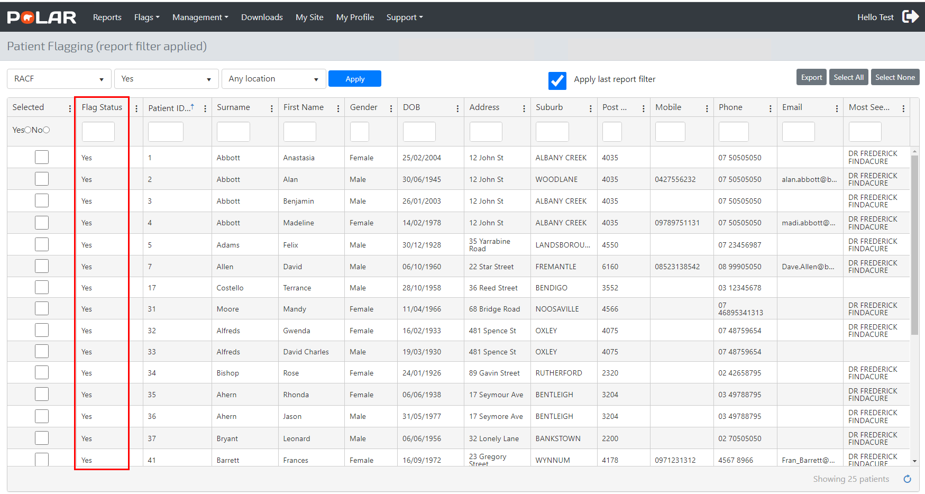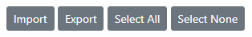
NOTE: To change a flag status, click on the individual patient and select the appropriate flag status. Click Apply. Figure 17 illustrates the ‘Clear’ flag status for patient Felix Adams:
Figure 17 - Changing the flag status for individual patients
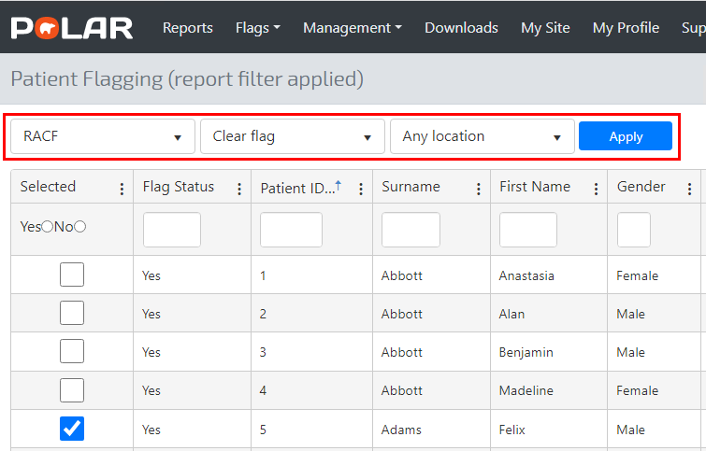
The user is prompted to confirm the selection (Figure 18).
Figure 18 - Clear status validation prompt
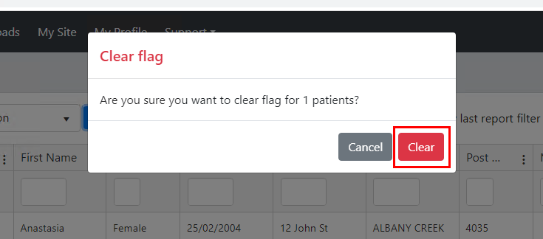
Select ‘Clear’ to remove the Flag status for patient Felix Adams in the ‘Patient Flagging’ management screen:
Figure 19 - Flag status updated
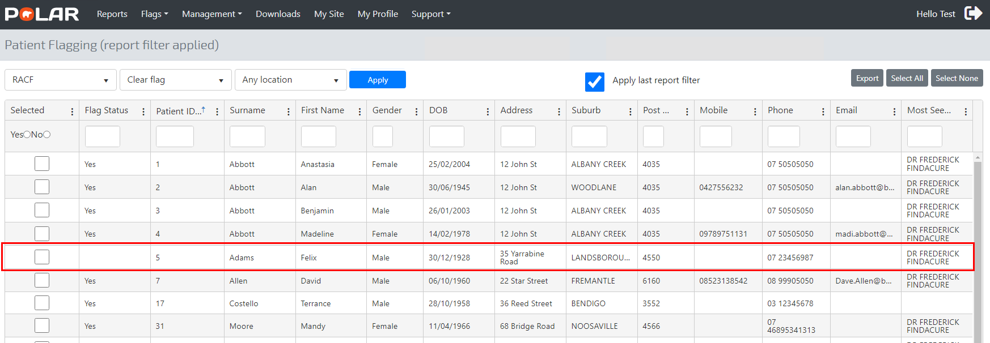

Managing a flagged cohort
There are two options for the management of flag cohort patients:
- Update a flag status for an existing cohort, as demonstrated in Figure 17, or
- Modify/edit the flag cohort by allocating a flag to a currently non-flagged patient.
Figure 20 illustrates the process of adding patients to the RACF flag based on applying new filter criteria, e.g. Patients over 90 years old:
Figure 20 - Adding to an existing patient cohort
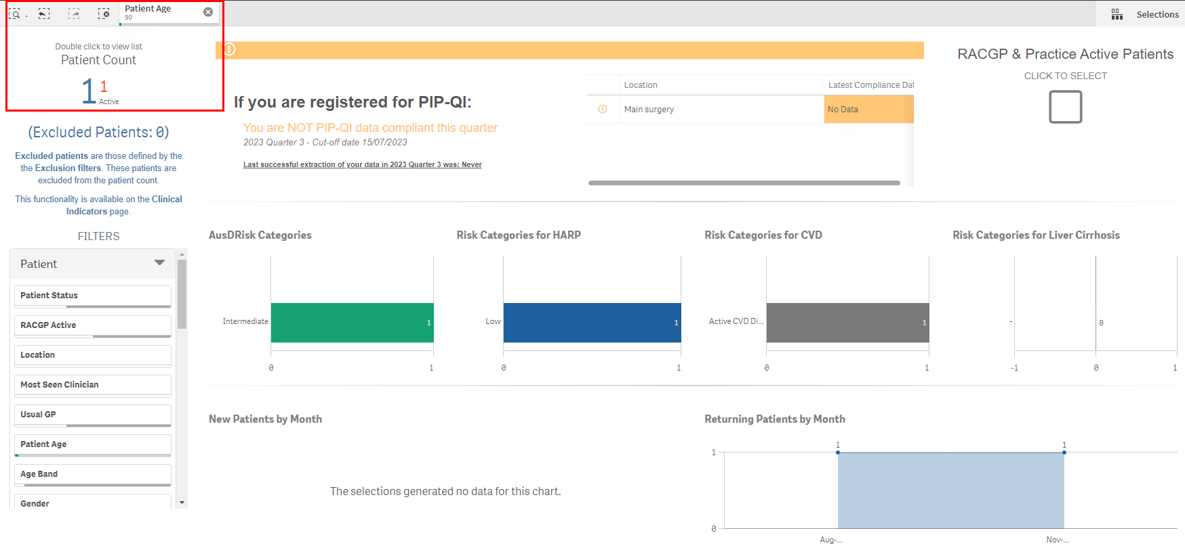
Select the ‘Patient Flagging’ menu and then the ‘RACF’ flag. Apply the ‘Yes’ Status to the ‘RACF’ flag for the patient Gwenda Alfreds:
Figure 21 - Adding a patient to the RACF flag cohort
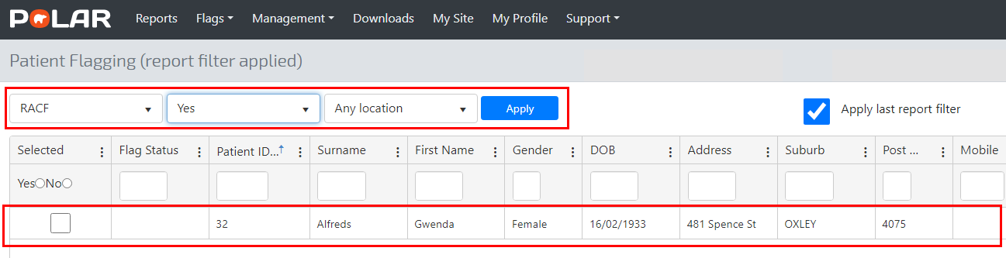
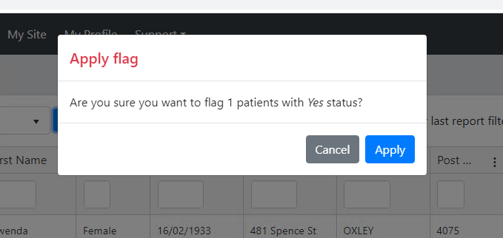
Figure 22 - Flag status update
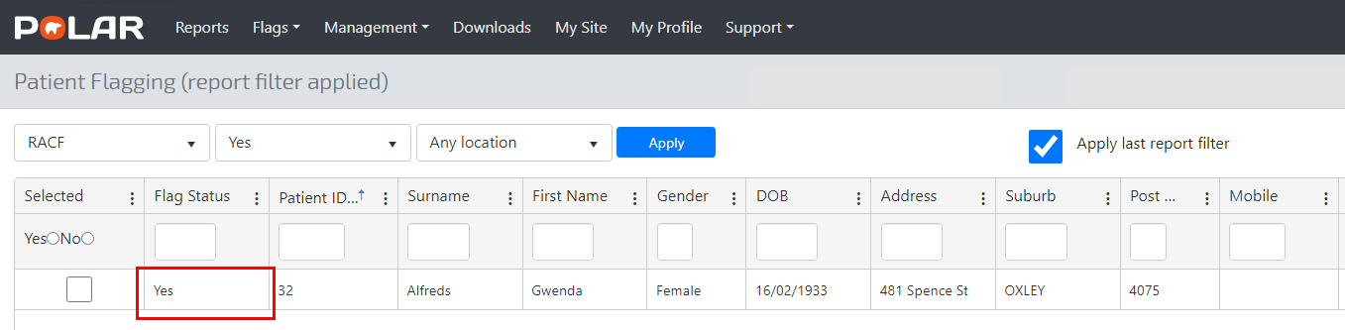
Filter a Flag cohort by Status, e.g. RACF = Yes. A patient cohort based on a Flag and Status is displayed by selecting the Patient Flag to ‘RACF’ followed by the appropriate status. (Figure 23 illustrates filtering a Flag Status to ‘Yes’ for the ‘RACF’ flag):
Figure 23 - Flag status filtering
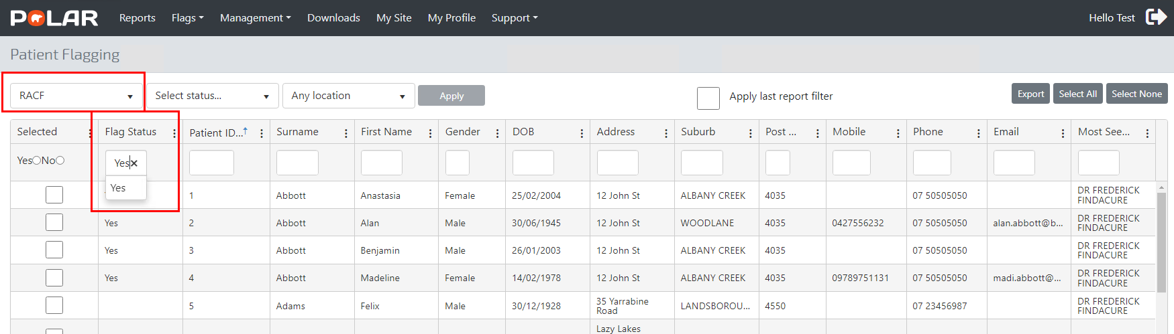

Figure 24 - Applying Flag and status filter options
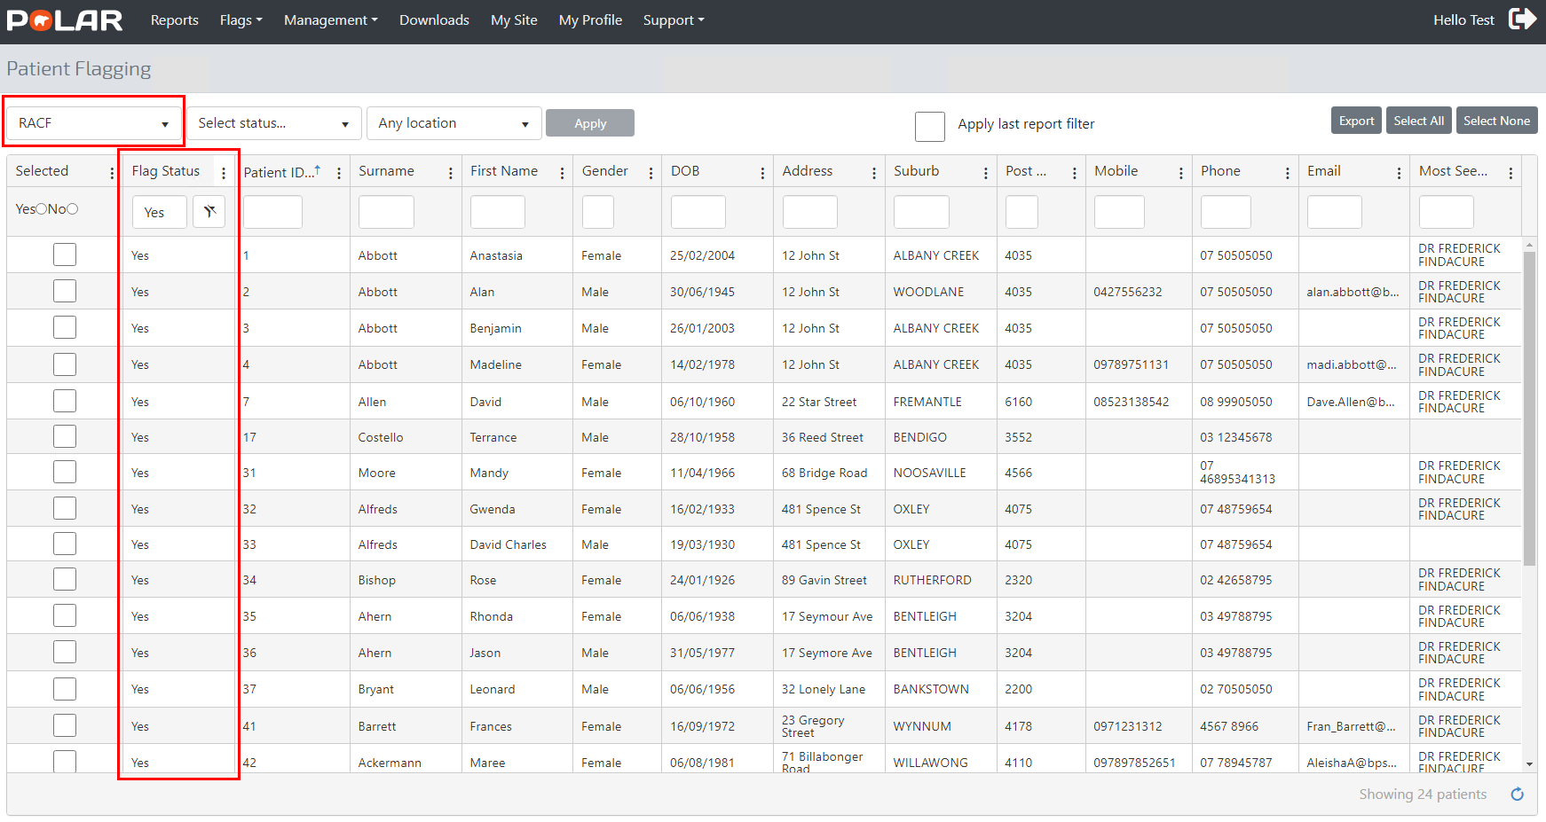
NOTE: The ‘Select All’ or ‘Select None’ buttons quickly apply or remove flags for a large patient cohort, e.g., Selecting ‘Select All’ will select all patients (Fig 25).
Figure 25 - Using the ‘Select All’ option
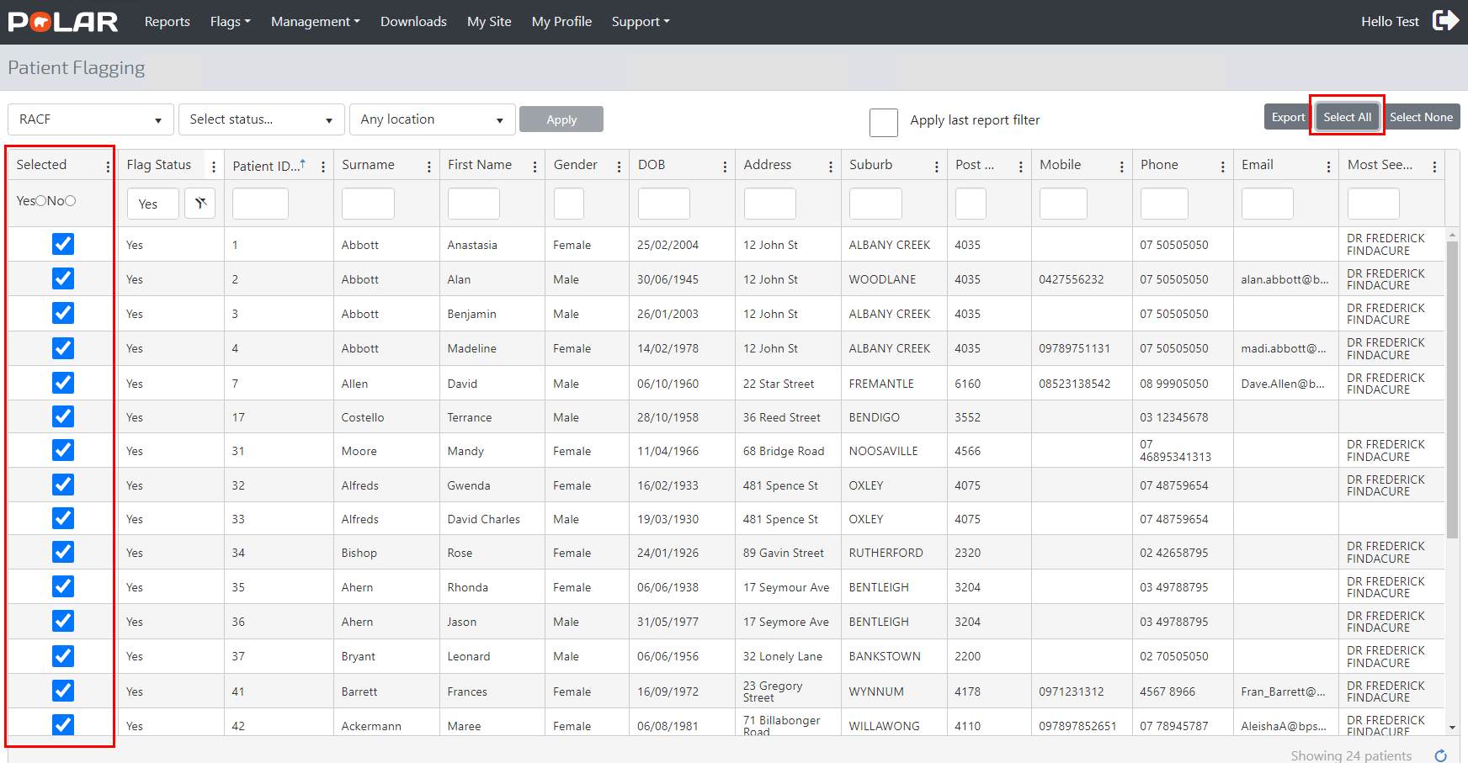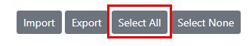
Use ‘Select None’ to remove all flags:

Figure 26 - Using the ‘Select None’ option
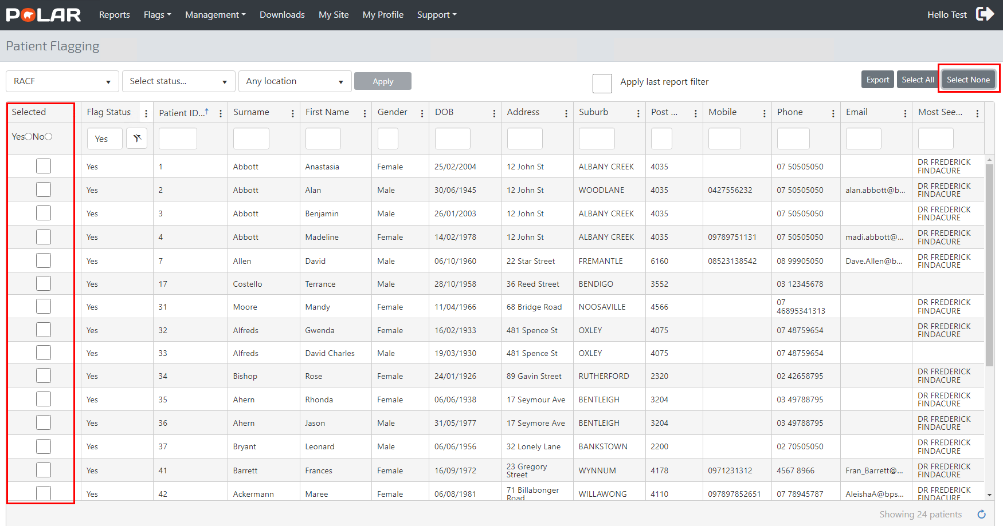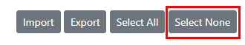
NOTE: The ‘Export’ button will export all patients listed to an Excel spreadsheet (Figure 27). Please note that Microsoft Excel or compatible software is required to access the exported file.
Figure 27 - Patient list export
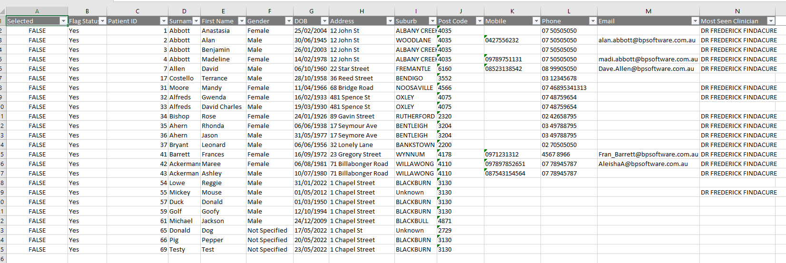

Locations
For practices with a Multi-location configuration, e.g. Clinical Information System is separated into locations, patient flags can be applied for a location as displayed in Figure 28:
Figure 28 - Applying flags for patients based on a CIS location
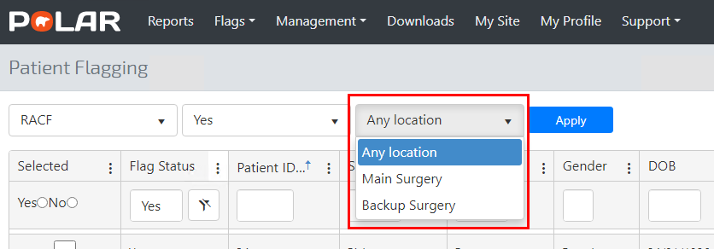
NOTE: Users will have access to patients at a location based on access configured in POLAR, e.g. If a user has access to the ‘Main Surgery’ Location, they will not see any patients registered to the ‘Backup Surgery’ Location as (Figure 28).

Apply the last report filter option:
The ‘Apply last report filter’ check box (Figure 29) allows users to apply the filters selected in a report to populate the patient list in the ‘Patient Flagging’ management screen:
29 - Apply last report filter check box
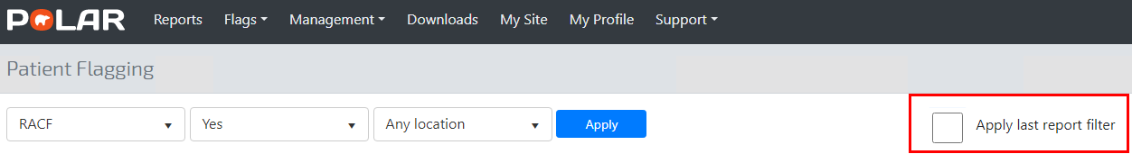
In Figure 30, the user has selected the ‘RACGP’ and ‘Active’ check box to filter the ‘Clinic Summary’ report to 15 patients.
Figure 30 - Applying the ‘Last report filter’ check box from a report
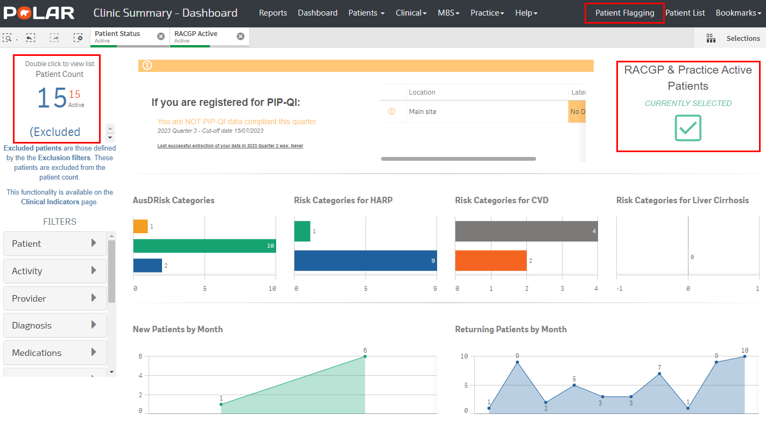
The filter set applied in the ‘Clinic Summary’ report returns 15 patients (Fig 30). Select the ‘Patient Flagging’ menu item to retain the patient list generated through the ‘Apply last report filter’ check box (Fig 31).
Figure 31 - Apply last report filter default option
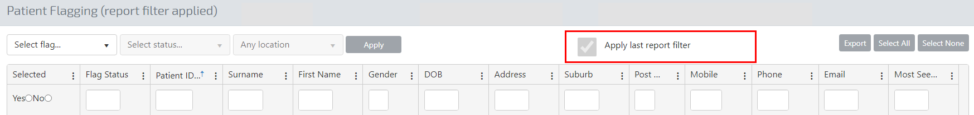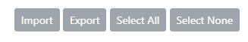
NOTE: The patient list is not populated until a Flag is selected:
Figure 32 - Apply last report filter - functionality
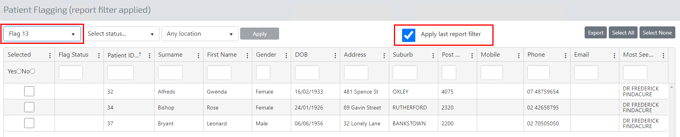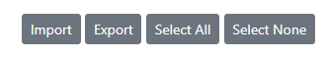

Patient Flagging - Management
Customise the columns in the ‘Patient Flagging’ screen by selecting or deselecting columns of interest. In Figure 33, ‘Age’ and ‘Patient Status’ columns are removed from the screen.
NOTE: Reselecting the columns would make them visible again:
Figure 33 - Column configuration
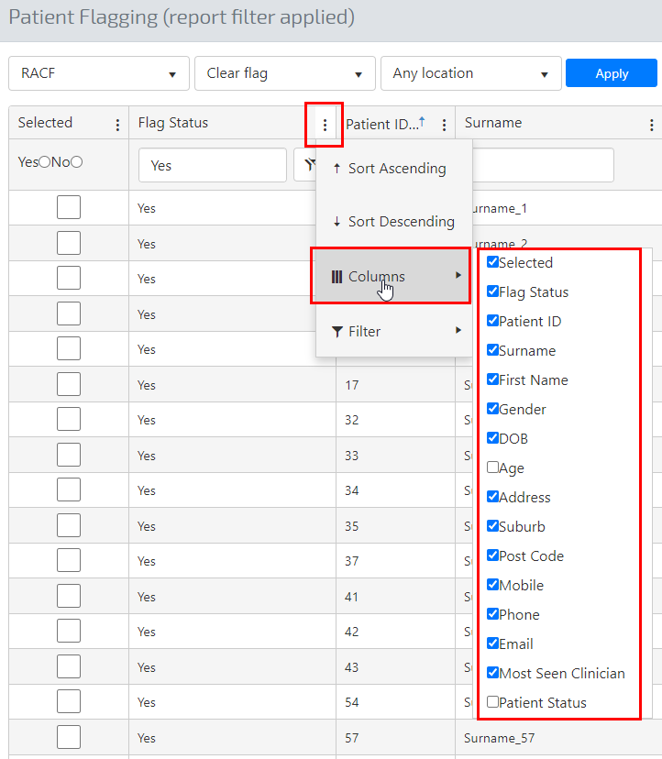

Deleting a Flag
Flags can be deleted through the ‘Edit Flag’ menu, followed by selecting the ‘Edit’ button, as demonstrated in Figure 34.
Figure 34 - Deleting a flag through the Edit screen
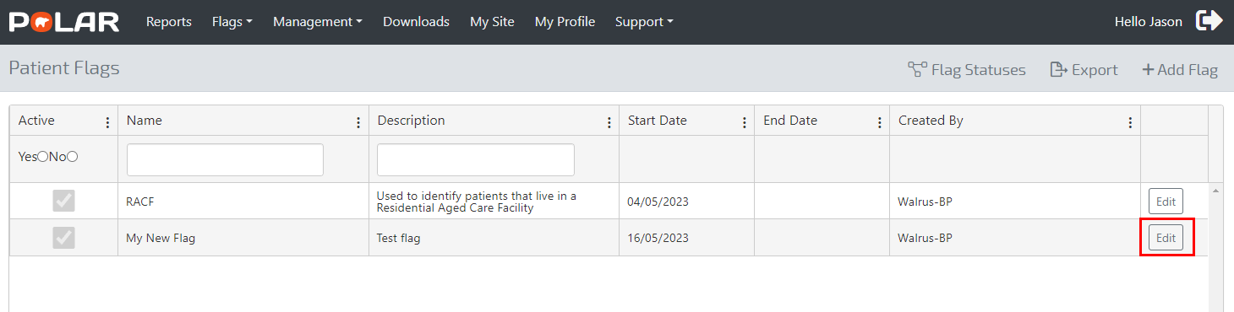
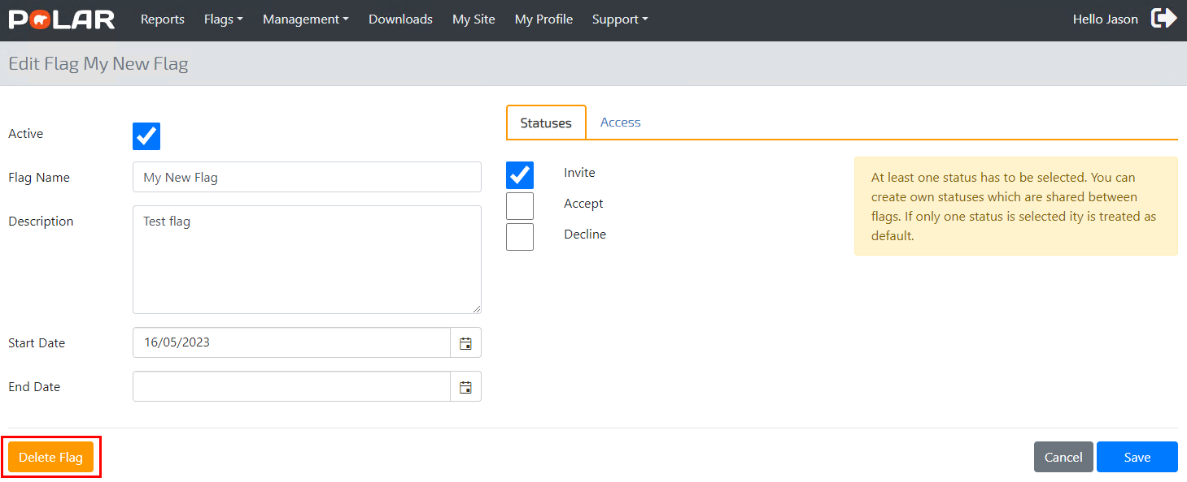
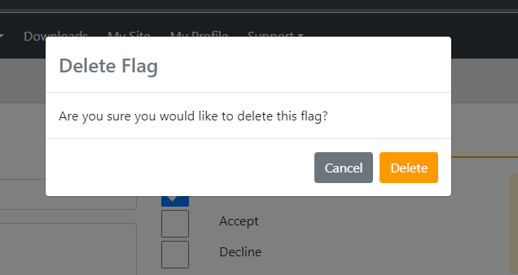
NOTE: A flag can only be ‘Deleted’ when it is not applied to any patients, e.g. In Figure 35, there is no option to ‘Delete’ the RACF flag, as it has been allocated to patients. Clearing the Flag for the cohort would present the user with the delete option, as demonstrated in Figure 36.
Figure 35 – No Delete option because the Flag is in use
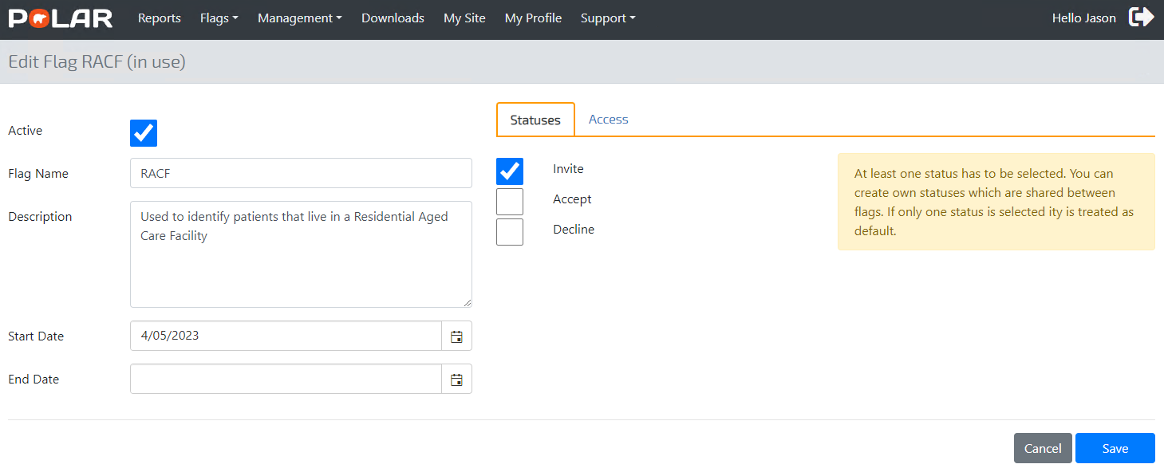
Figure 36 - Clearing the Flag allows for deletion
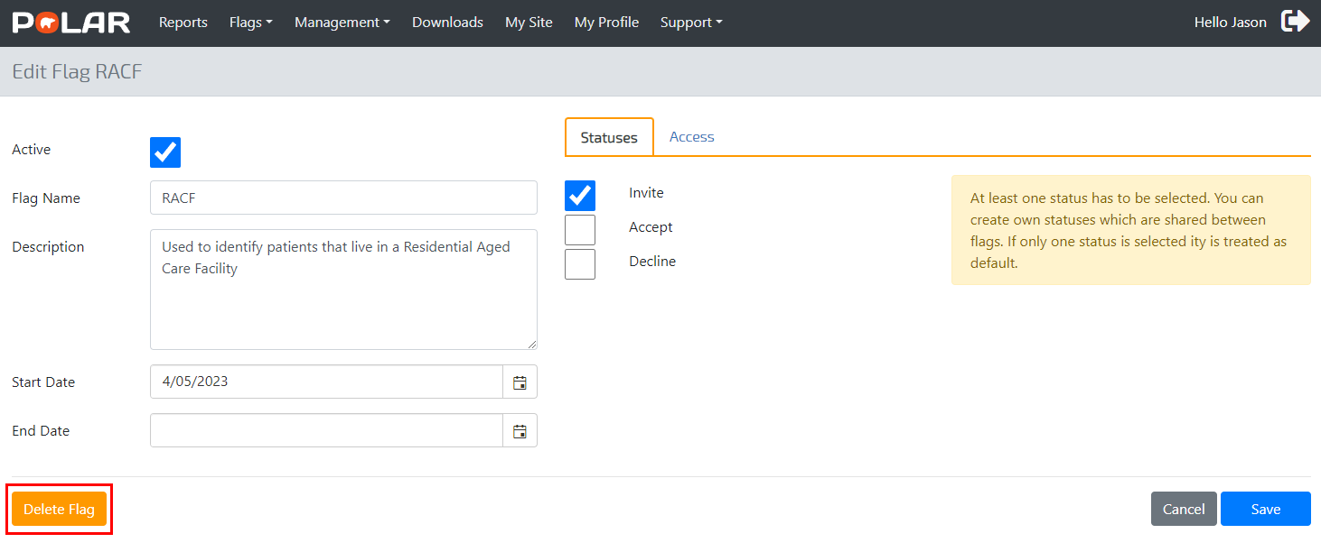

File Importing
Sometimes, a user will export a patient list to manage outside the system, e.g., manually update a status for a flag. In these instances, a user can import the patient list into the system and update the status in the Patient Flagging interface built into POLAR Explorer based on the edited external list.
Figure 37 - Exported Patient List
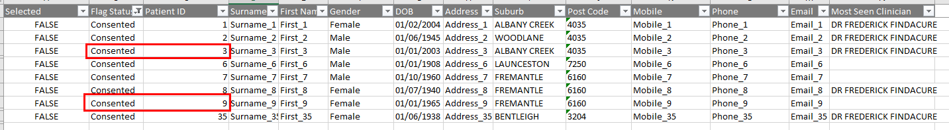
Figure 37 shows a list of patients exported from the Patient Flagging interface. The user can now change Patient IDs 3 and 9 statues from ‘Consented’ to ‘Declined’ in the Excel list, as demonstrated in Figure 38.
Figure 38 - Flag Status Change via Excel Export
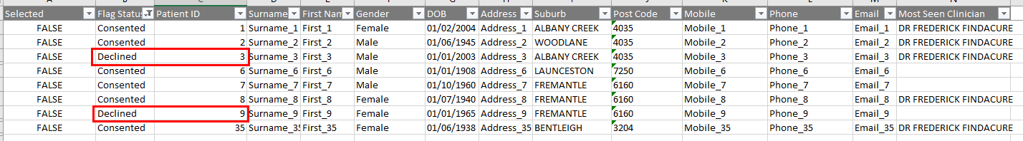
Saving the list will allow the user to use the import function built into the system, as seen in Figure 39. NOTE to avoid updating the statuses for the incorrect Flag, the imported list must match the Flag displayed in the Patient Flagging interface, e.g. RACF in Figure 39. Also, the Flag Statuses must already be configured in the system for the Flag, including the correct spelling, e.g. ‘Cosented’ or ‘Declined’ as seen in Figure 39.
Figure 39 - Import Function
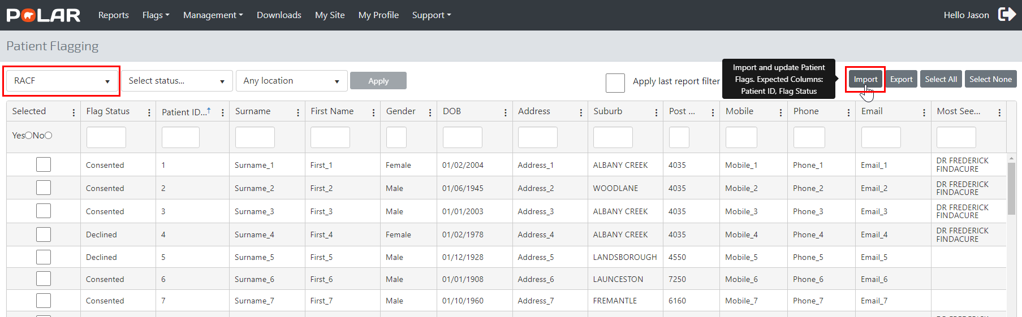
Selecting the ‘Import’ button in Figure 39 will prompt the user to browse the saved Excel file, as seen in Figure 40.
Figure 40 - Importing the Saved Excel File
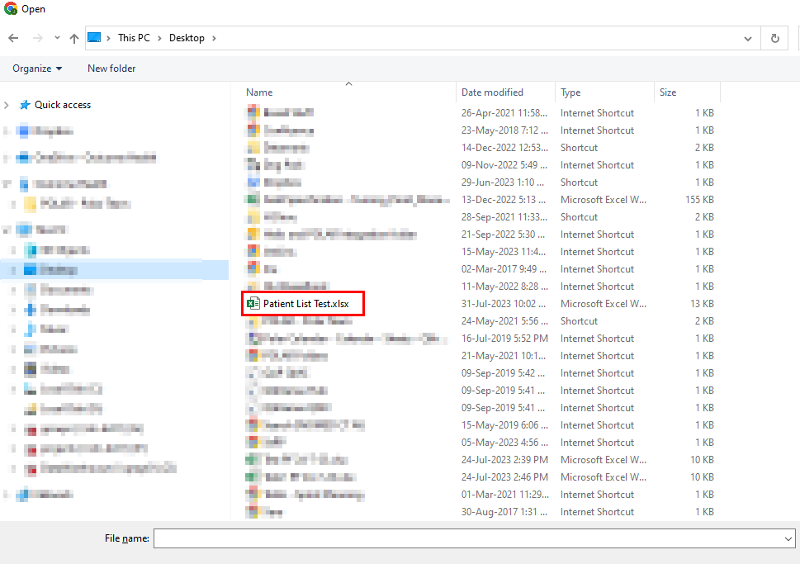
A successful import process will display the following message:
Figure 41 - Successful Import Process
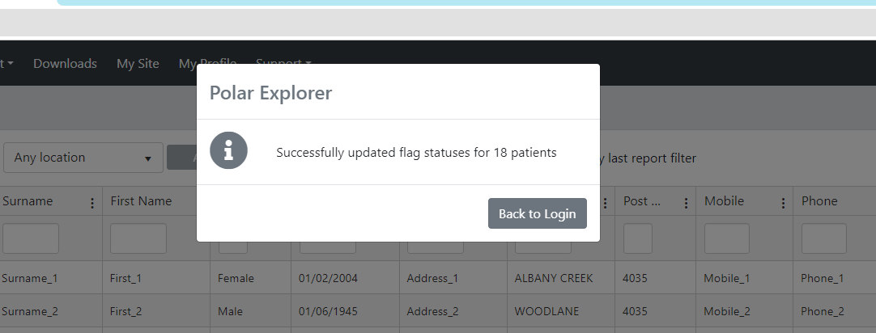
NOTE: Patient IDs 3 and 9 now have a Flag Status of ‘Declined’ for the RACF flag:
Figure 42 - Status Update from an Import Process
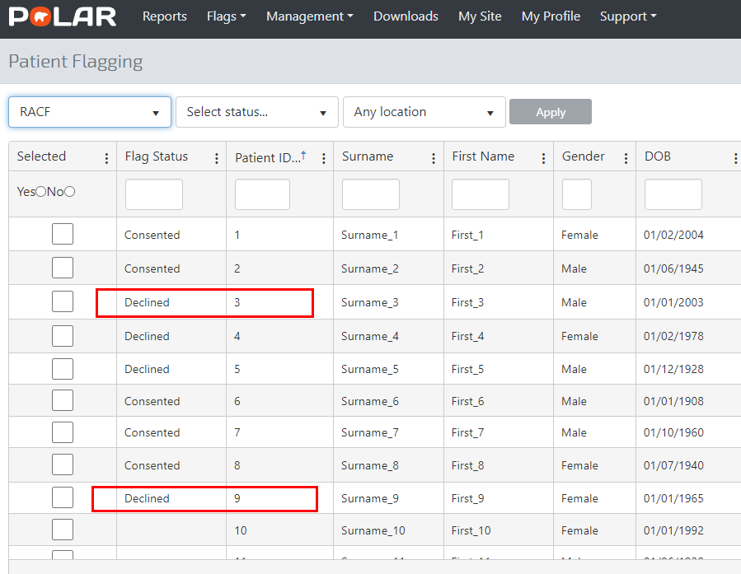

Import troubleshooting
As discussed, the import process should be relevant to the Flag displayed in the Patient Flagging interface. NOTE that an import process cannot be performed (is greyed out) unless a Flag is selected:
Figure 43 - A user must choose the correct Flag if they want to import a list
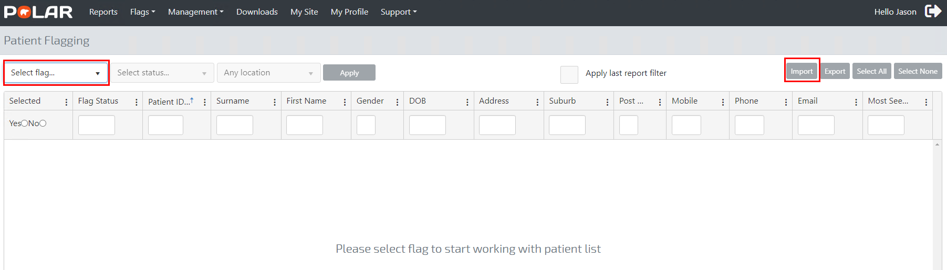
Flag Statuses MUST be the same as what has been configured in the POLAR System.
In Figure 44, the user is trying to import a ‘Decline’ status for Patient ID 9- Noting the Flag Status in POLAR is ‘Declined’.
Figure 44 - An Incorrect Flag Status Entred
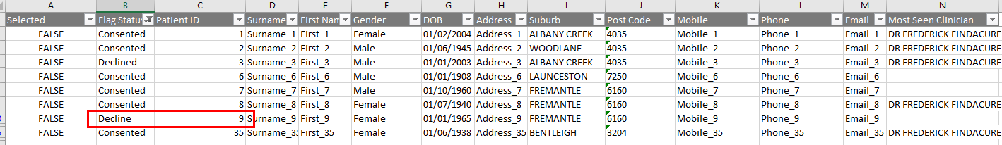
This import process will return the following error:
Figure 45 - The Error Returned from trying to Import an Incorrect Flag Status
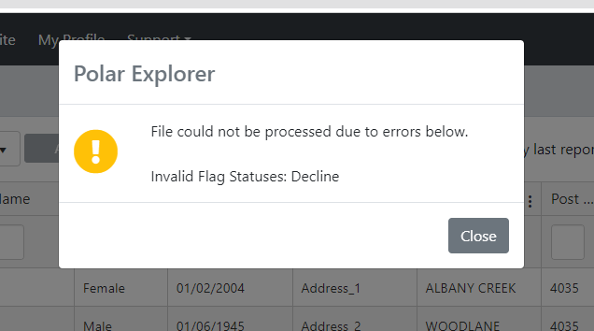
NOTE Changing the flag status to ‘Declined’ in the Exported List will fix this error.

Review
- Exported Patient Lists can be imported back into the system with modified statuses.
- The Flag relevant to the import list must be selected before an import process can be performed.
- The Flag Status on the import list must exist in the system in the same format, e.g. the correct spelling.

Using Flags in the Clinical Summary Report
As demonstrated in Figure 37, a supported use case for patient flagging includes using the POLAR Clinic Summary report to filter a patient cohort based on a flag and associated status.
Figure 38 – Using Filters in the Clinic Summary Report
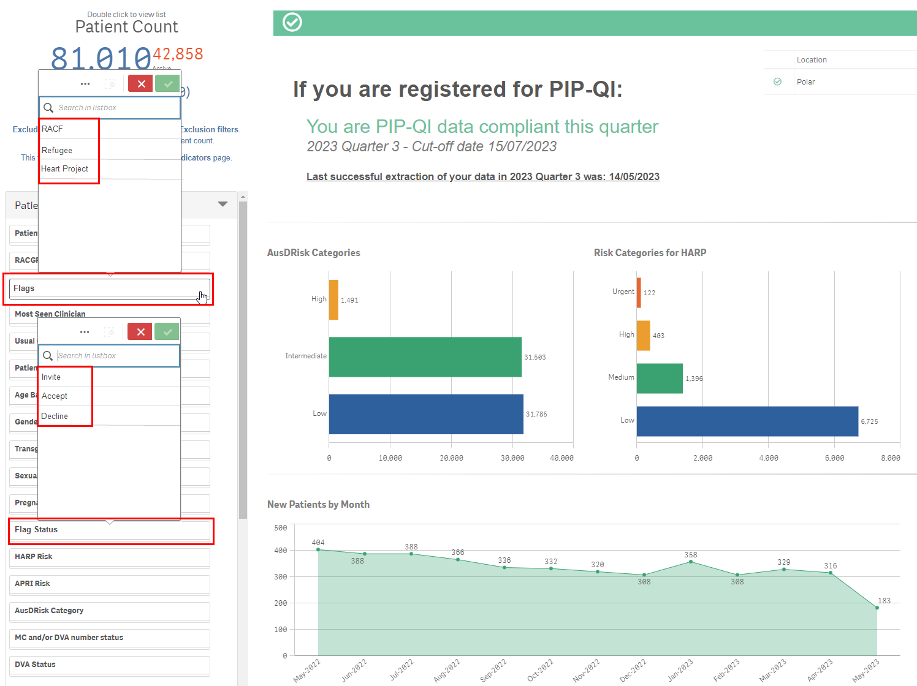
Figure 38 demonstrates how Selecting the flag ‘Refugee’ with a status of ‘Yes’ will return a cohort of 643 patients.
Figure 39 - Filtering a patient cohort
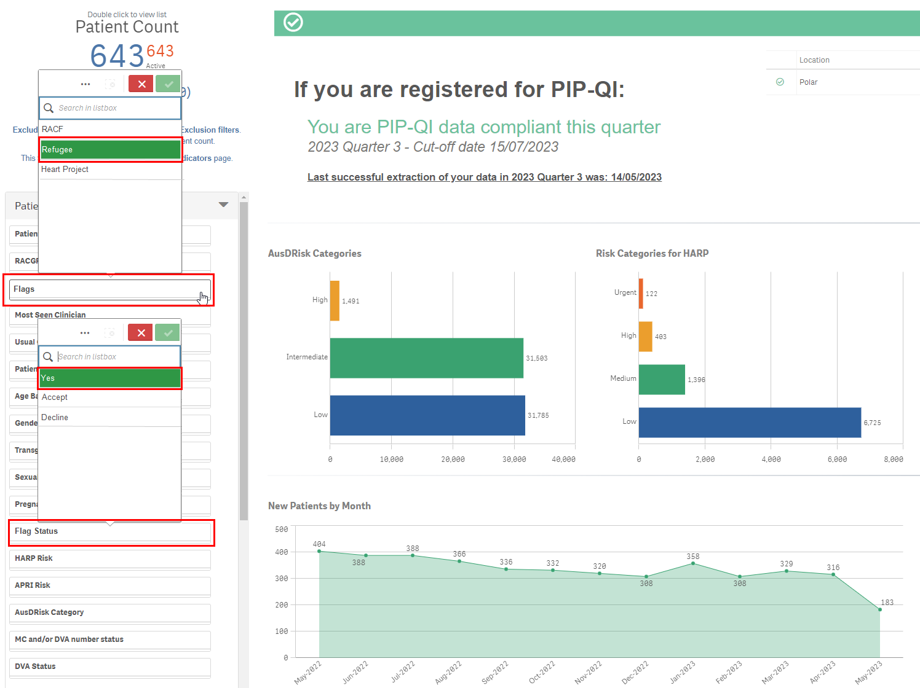

Stakeholder/PHN flags versus Practice Flags
Different stakeholders/users of the POLAR system can create flags. For example, a Stakeholder or PHN can create a flag to track patients within the Practice as part of a Commisioning exercise. When the practice user logs in to POLAR, they will see all flags created by the PHN, as demonstrated in Figure 39.
NOTE: The practice user cannot edit these flags.
Figure 40 - Stakeholder/PHN created flags
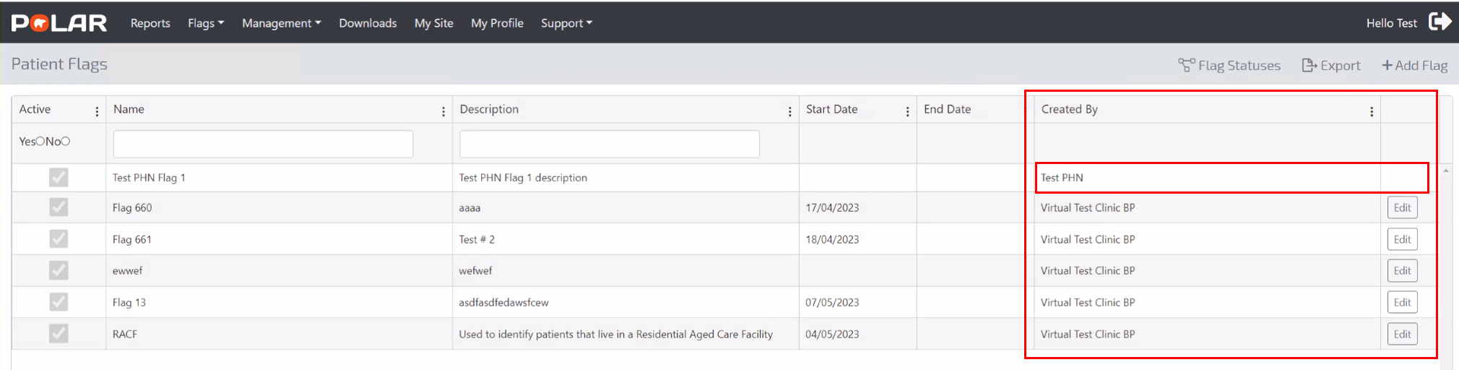
When selecting a flag, a practice user will see a PHN or Stakeholder represented with a ‘phn’ symbol against it, as demonstrated in Figure 40.
Figure 41 - Stakeholder/PHN flag selection
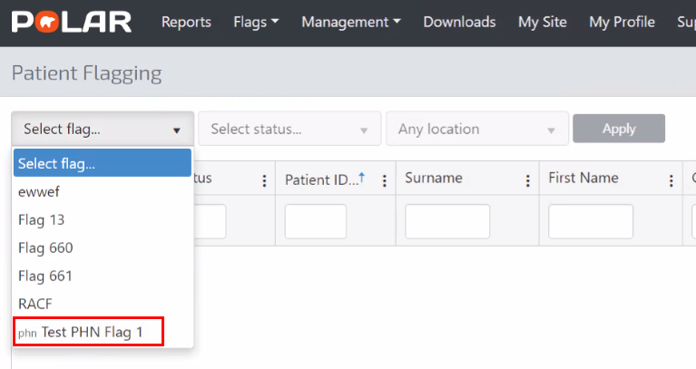
Data associated with Stakeholder/PHN flags are available to the Stakeholder or the PHN within their de-identified POLAR reports or data mart extracts.
NOTE: Any flags created by the Practice are NOT made available to the Stakeholder or PHN.

