COVID Vaccine Phase 1b Walkthrough (Patients Only)
Patient Cohort Included:
- Elderly adults aged 80 years and over
- Elderly adults 70-79
- Aboriginal and Torres Strait Islander People >55
(These cohorts are excluded from this walkthrough as the data is not recorded: Other Healthcare workers, Younger adults with an underlying medical condition (we are trying to get further clarification on what this means) Clinical and high risk workers including defence, police , fire, emergency services and meat processing.)
Open POLAR and Select Clinic Summary Report | 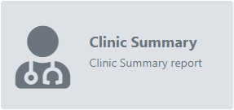
Select Patient Status Active filter  (You may also wish to use the RACGP Active filter which will filter patients that have been 3 or more times in the last 2 years however in doing this you may eliminate patients that have only attended your practice one or two times in the last 2 years) | 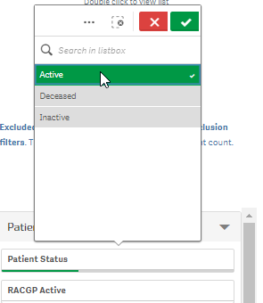
- Use the patient/age band filter to select 80-84 and 85+ | 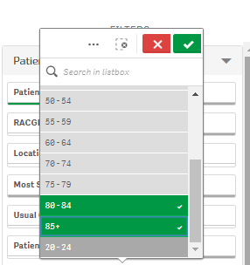
Go to patient list  Export list to excel | 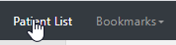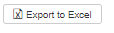
Remove the Age filters | 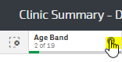
Repeat for
2. Age cohort 70-79 year olds
Remove the Age filters
3. Aboriginal and Torres Strait Islander people over 55 years.
Go to the Patients page | 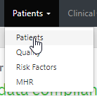
Using the Age Group chart to select all age bands above 55 years and confirm the selection | 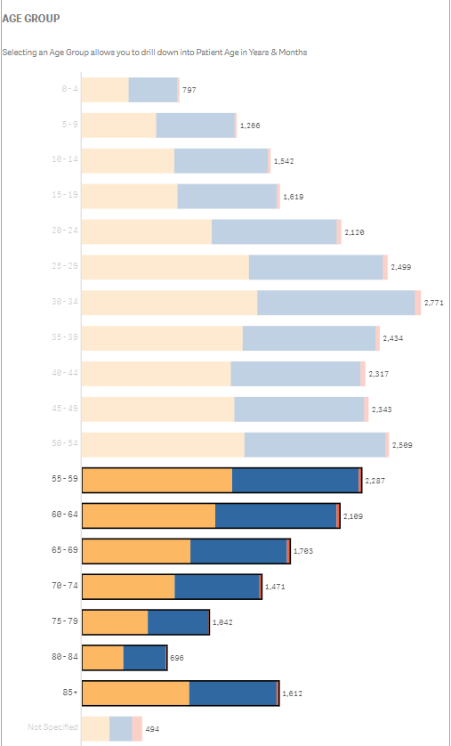
In the Aboriginal & Torres Strait Islander Status select  - Aboriginal  - Aboriginal and Torres Strait Islander  - Torres Strait Islander | 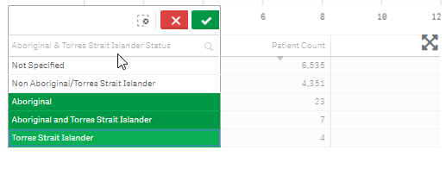
Go to patient list
Export list to excel

AIR- Reminder once patients have been vaccinated with COVID, Practices must register the encounter through your Medical Software with the Australian Immunisation Register (AIR)
Please use the opportunity to upload a Shared Health Summary or an event summary to the My Health Record for your patient. If you need assistance contact digitalhealth@emphn.org.au

