Quality Improvement Activity – Implementing Electronic Referrals in the Practice using HealthLink SmartForms.

Quality Improvement Activity for practices who want to move to electronic referrals for both Outpatient Clinics and Private Specialists.

Electronic referrals are an alternative to faxing referrals, both Northern Health and Eastern Health (early 2021) have committed to only accepting Outpatient referrals electronically.
Healthlink SmartForms e-referral solution is integrated within Medical Director, Best Practice, Medtech and Genie and will streamline the completion and submission of electronic referrals. From your software programs, GPs will be able to select a SmartForm, have it pre-populated automatically with data from the electronic patient record, have it validated and sent securely to the intended recipient, and receive an acknowledgement of receipt without the need to print and fax. A copy of the form will automatically be stored securely in the patient’s record. HealthPathways Melbourne is now integrated into the referral form for Outpatient Clinics.

The following quality improvement activity and sample Plan Do Study Act (PDSA) may be used to assist your practice to implement electronic referrals with the aim to transmit referrals using HealthLink functionality. This QI activity will also assist practices to meet PIP QI requirements.

Activity topic: Implementing eReferrals using the Healthlink Smart Forms
Improvement Activity Start Date |  | Improvement Activity Completion Date | PIP QI Quarter Record
 |  |  | Select Quarter | PIP Quarter | PIP Quarterly Period
 |  |  |  | Q1 | November to January
 |  |  |  | Q2 | February to April
 |  |  | Q3 | Q3 | May to July
 |  |  |  | Q4 | August to October
Identify the lead team at your practice who will be responsible to drive this quality improvement work
Name | Role/Responsibility

Goal: What are you trying to accomplish?
Tip: Create a SMART goal (Simple, Measurable, Achievable, Realistic and Timely). What do you want to achieve and by what date?
To implement electronic referrals in the practice using the HealthLink SmartForms within 3 months.

Measure: What data will you use to track your improvement journey?
Tip: Use this spreadsheet to capture your data to track your improvement journey. It is important to capture your baseline data before you start any improvement activity.
Data report/source used: Clinical Information System
Measure/Data | Practice  Target | Date | Baseline  Data | Month/PIP Quarter
Number of HealthLink Referrals sent (see attached how to track referral numbers in BP and MD
Ideas: What changes will you make that will lead to an improvement (small steps)?
Tip: Capture a list of practical steps to undertake and test using PDSA cycles. Refer to Appendix A for a PDSA log and Appendix B for PDSA template to record your activities.

Ideas: How you plan to achieve your goal
- Assign staff that will be responsible for implementing the eReferrals  - Allocate a person to be responsible for managing the change and training staff.  - Ensure the practice has a HealthLink account and that the forms are available (Contact your PHN to confirm digitalhealth@emphn.org.au  - Contact your PHN Digital Health Team to organise a training session at digitalhealth@emphn.org.au  - Download the How to Guides and watch the video from here  - Get baseline data of any HealthLink forms that have been sent in the last month. (see attached)  - Track HealthLink forms.  - Acknowledge the efforts of your general practice team. This will help to ensure these changes are sustained. | Date completed:
 | PDSA Completed (Yes/No):
 | Notes:

Appendix A: PDSA Log
PDSA Number | Plan Implement electronic referrals in the practice as an alternative to faxing to Outpatients and Private Specialists |  |  |  | Do  Was the activity completed?  Any problems? | Study  Record, analyse and reflect on results. Did the results match your predictions? | Act  Decide to adopt, adapt or abandon
 | What | Who | When(date)  and where | Prediction
1 | Implement eReferrals by ensuring this feature is available, training staff and ensuring compliance. |  |  |  | Yes  No, if not why? |  | Adapt  Adopt  Abandon
2 |  |  |  |  | Yes  No, if not why? |  | Adapt  Adopt  Abandon
3 |  |  |  |  | Yes  No, if not why? |  | Adapt  Adopt  Abandon
4 |  |  |  |  | Yes  No, if not why? |  | Adapt  Adopt  Abandon
5 |  |  |  |  | Yes  No, if not why? |  | Adapt  Adopt  Abandon

Appendix B: PDSA Template
Idea |  |  |  |  | Date
Implement eReferrals in the practice using the HealthLink SmartForms
PDSA Number:

Plan
Briefly describe exactly what you will do?

List the tasks necessary to complete this test (what) |  | Person responsible  (who) |  | When | Where
Meet with staff to discuss activity

Run search for baseline data (see attached)

Organise training for GPs and Staff contact digitalhealth@emphn.org.au
Download How to guides and watch video from here
Run monthly data search for comparison

What do you predict will happen?
The number of referrals being faxed will decrease and the number of electronic referrals will increase.

Do: Was the cycle carried out as planned? Yes No, if not why?
Study: Record, analyse and reflect on the results. Did the results match your predictions?
Act: Decide to adopt, adapt or abandon.
Select |  |  | Describe
Adopt | Select changes to implement on a larger scale and develop an implementation plan and plan for sustainability.
Adapt | Improve the change and continue testing plan.  What will be next PDSA cycle?
Abandon | Discard this change idea and try a different one.
Reflection report
As you complete quality improvement activities, it is important to take a moment to reflect on what your team has undertaken. A reflection report allows you to assess the successful changes you have made, the lessons learnt, and areas for further improvement. Completing this report will also provide an opportunity to consider activities you plan to undertake as a team to imbed continuous quality improvement within your general practice.
On reflection of the past QI activity period, what changes have you implemented and what have you learned as a result?
Provide an example of one innovative change/idea that did work well.

Provide an example of any roadblocks or ideas that did not work well.

What do you plan to work on next? Consider new ideas you will consider implementing to continue your improvement journey?

How to track referral numbers in Medical Director and Best Practice
In Medical Director
- Tools
- HealthLink
- Track Forms

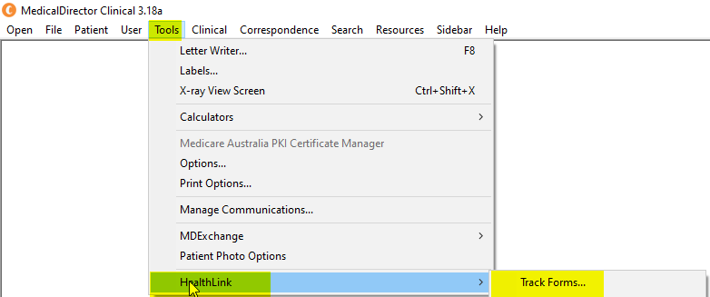

Select a date range & OK & Select Form Status Submitted
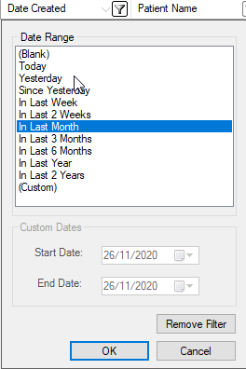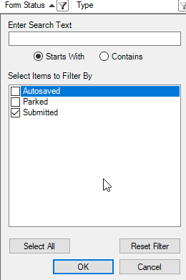
This will give you the list of referrals for that time period (note this is dummy patient data)
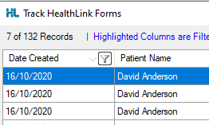

In Best Practice
- View
- HealthLink Forms
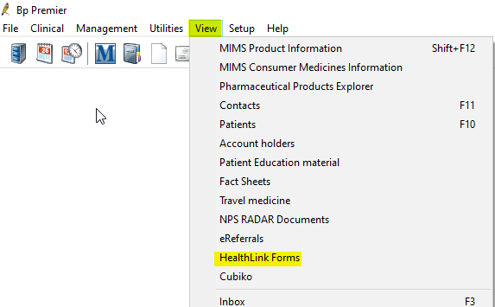
Select a date range and Status Completed This will give you the list of referrals for that time period (note this is dummy patient data)
