Australian Immunisation Register update: addition of new influenza vaccine names
In preparation for the 2023 influenza season, the following enhancements were made to the Australian Immunisation Register (AIR) on 11 February 2023.
Addition of new influenza vaccines
The additional vaccine names added to the AIR will enable vaccination providers to select whether an influenza vaccine is funded under the NIP or purchased on the private market. When reporting to the AIR, vaccination providers should select the relevant vaccine name i.e. (NIP) for NIP funded vaccines and (Non-NIP) for privately purchased vaccines.
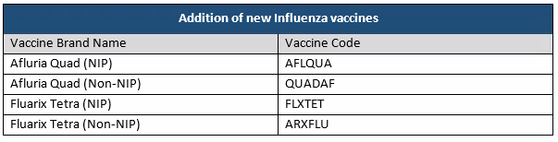
For individuals, only the vaccine brand name will display on their Immunisation History Statement. For example, Afluria Quad (NIP) will display as “Afluria Quad”.
These new vaccine names will be available to report to the AIR using clinical software, however if these vaccines do not appear we recommend vaccination providers contact their software provider in the first instance. Alternatively, vaccination providers can report the vaccine to the AIR using the AIR site.
Updates to existing influenza vaccines
To improve the data quality and reporting of influenza vaccines, the AIR will be updated to prevent the reporting of historical vaccine brands that are no longer registered or available for use in Australia. Please see below:
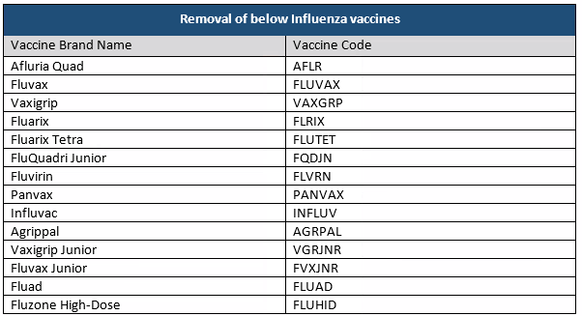
Please note:
- Vaccination providers will still be able to report these vaccines if they were administered prior to 11 February 2023
- Influenza vaccines reported to the AIR prior to 11 February 2023 will remain recorded on the AIR and display on individuals’ vaccination evidence.
In instances where an individual has been vaccinated (i.e., overseas) and the vaccine brand is not available to report to the AIR, vaccination providers can report it as a generic vaccine brand, for example ‘Generic Influenza’. This ensures that individuals have a complete AIR record and can provide evidence of vaccination for education, employment, or travel purposes.
It is mandatory under the Australian Immunisation Register Act 2015, for vaccination providers to report all Influenza vaccinations administered on, or after, 1 March 2021.
Reporting timely, high quality and accurate vaccination information ensures that the AIR contains a complete and reliable dataset to enable the monitoring of immunisation coverage and administration.
The Department of Health and Aged Care will continue to work with Services Australia to help software developers and vaccination providers meet their reporting obligations.
Further information: AIR vaccine code formats - Medicare Online for software developers - Services Australia

