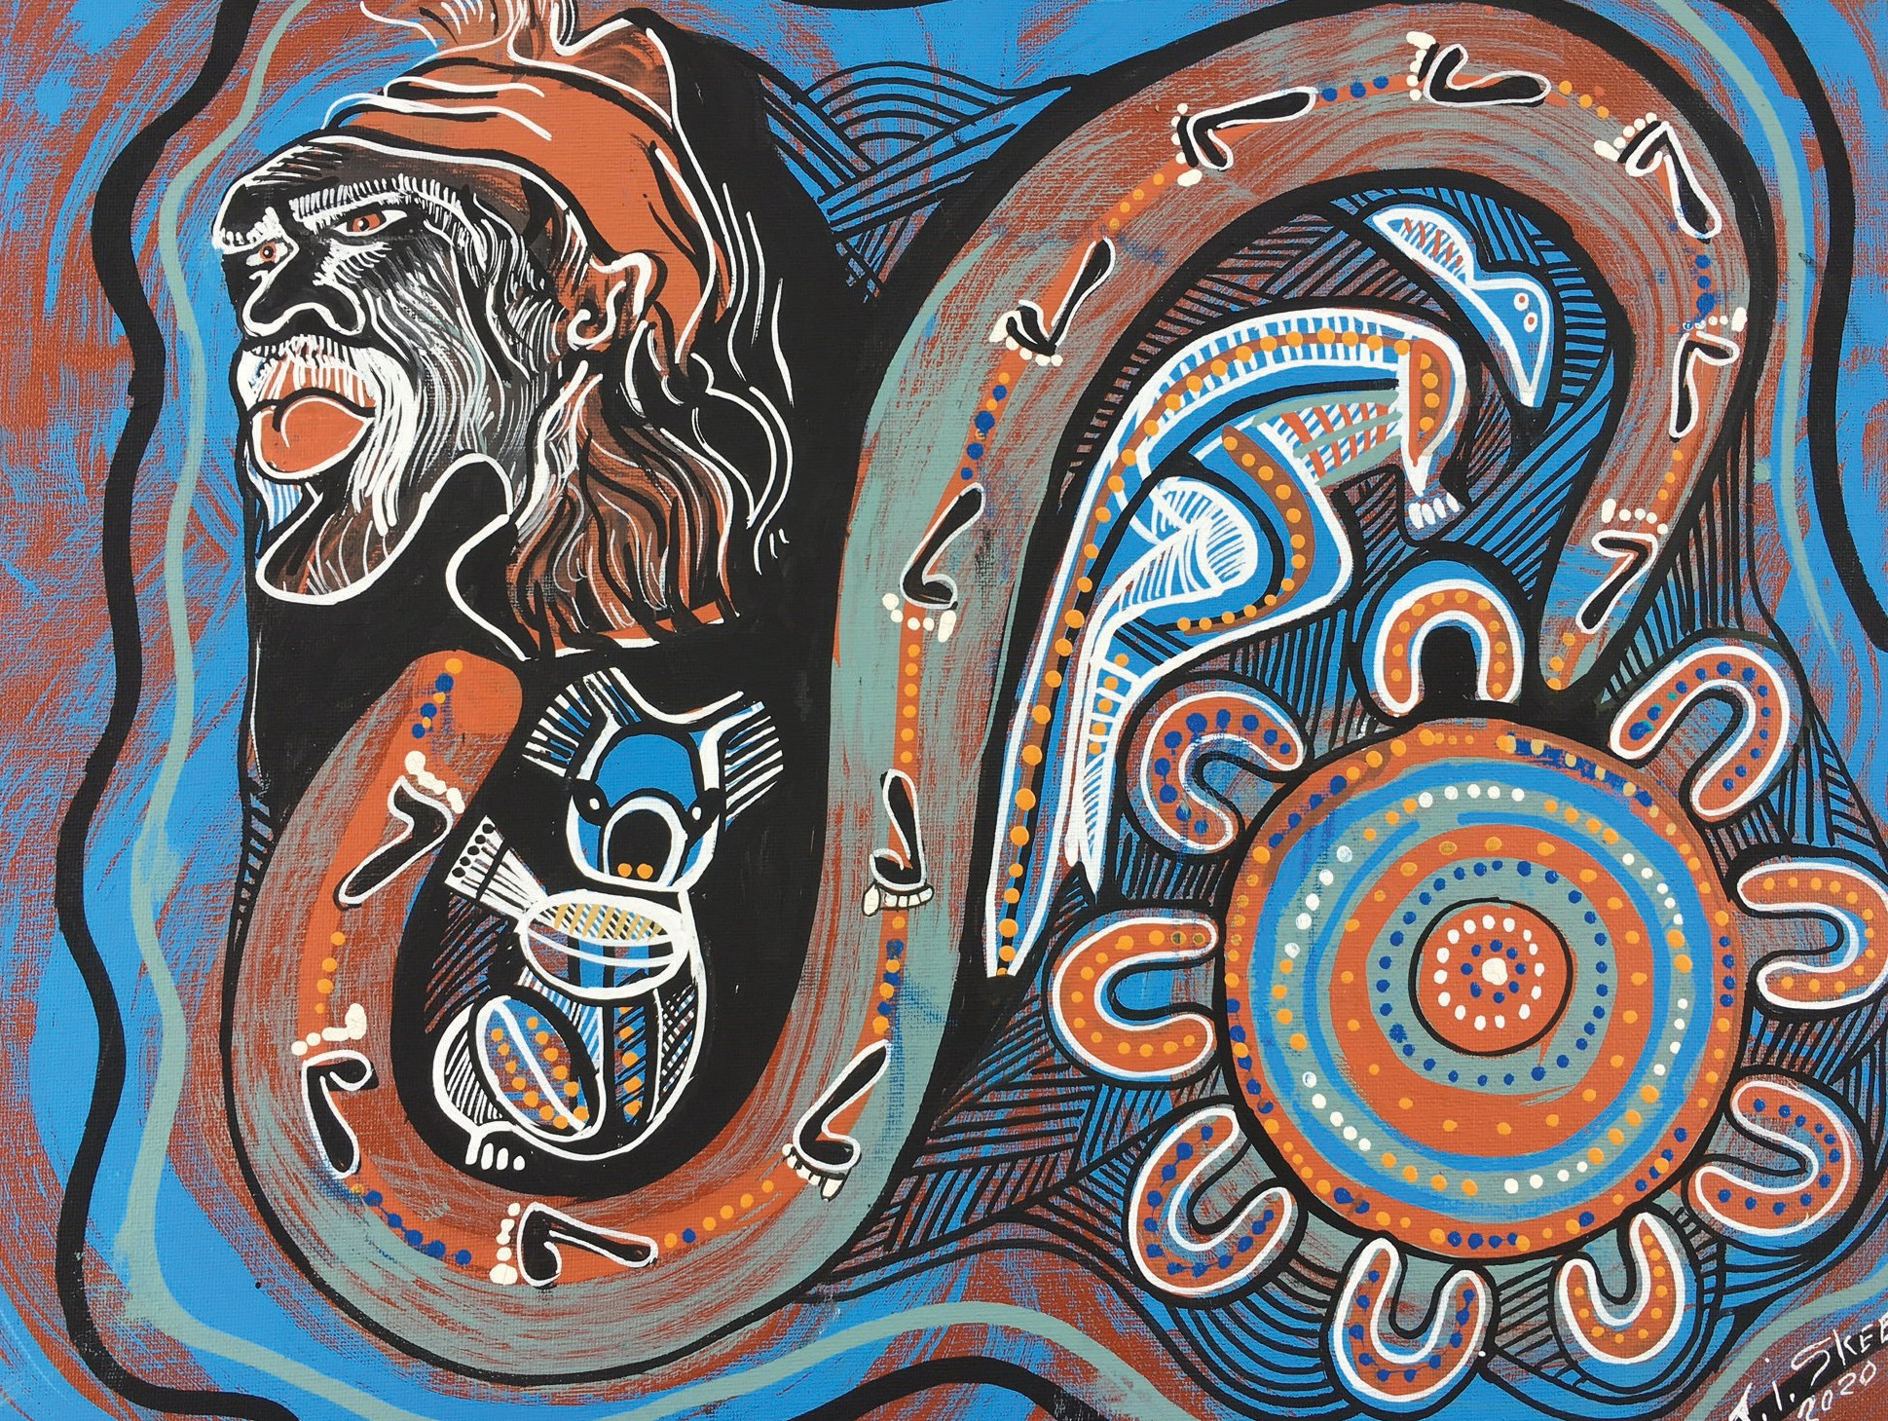

**“Yarn about me and my life**

**for my well-being”**

**NDIS Aboriginal and Torres Strait Islander Planning Workbook**

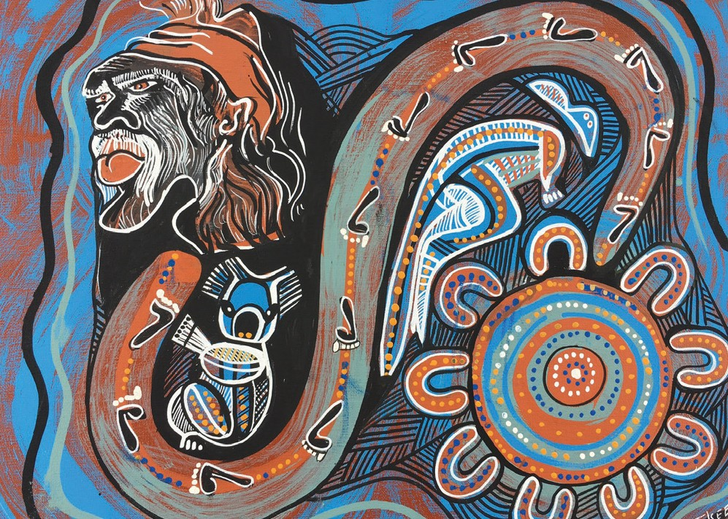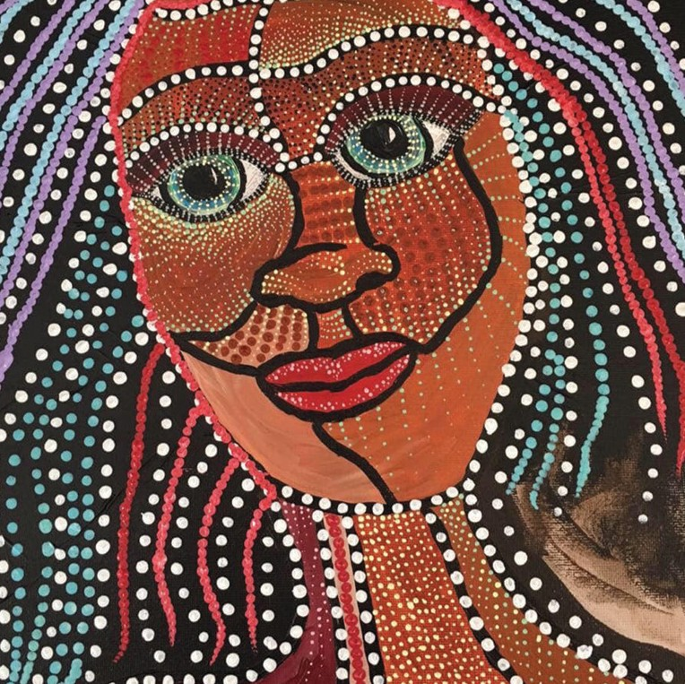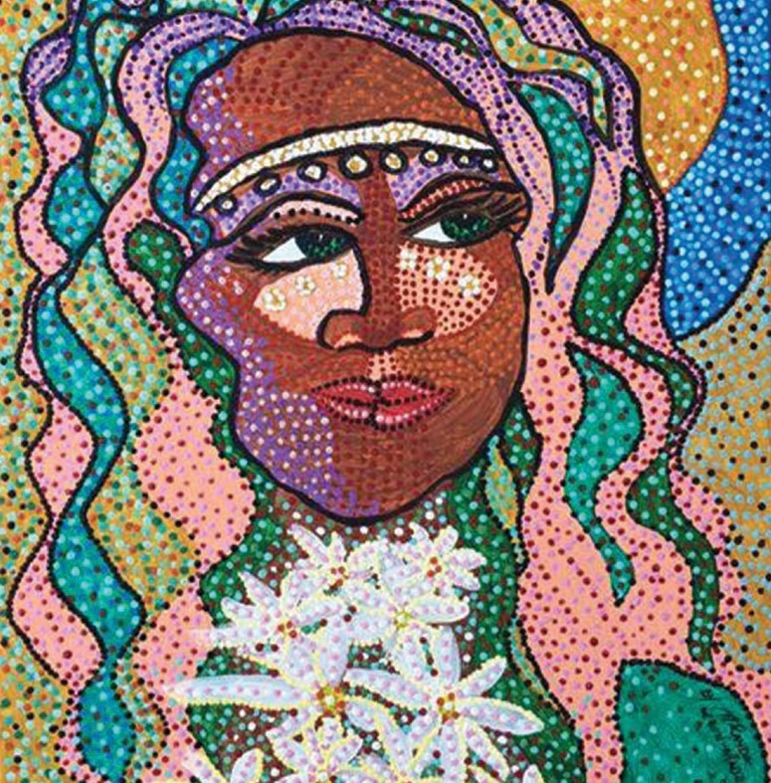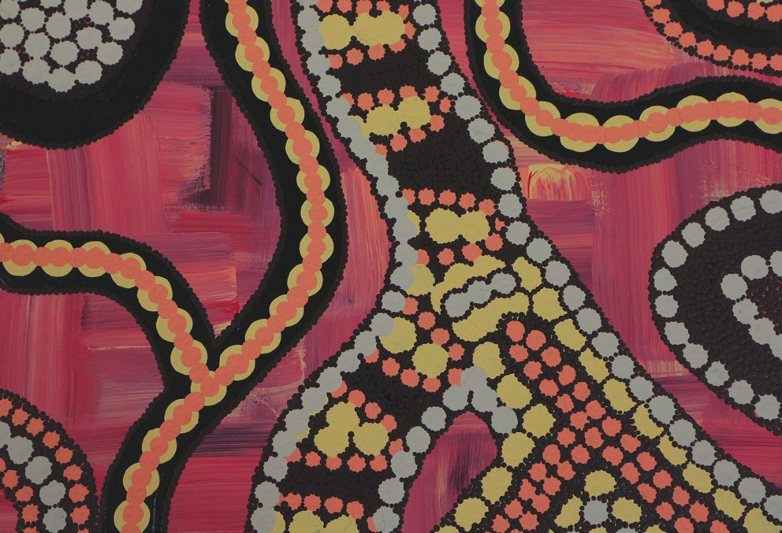

**The Painting: Going through life on a journey Artist: Joseph Skeen**

*Kuku Langi, Kuku Taipan and Birri Gubba tribe*

**1**

This picture is a painting and reflection of Josephs life. Kuku Langi and Kuku Taipan (Koala Totem) was from his mums side the koala Birri Gubba (Kangaroo Totem) was from his dad’s side. Joseph was taken to Cherbourg mission from Innisfail when he was 18 months old with his brothers and sisters away from his parents. He was put into the boy’s dormitory

separated from his sisters. Joseph spent 14 of his young years in the dormitory. On occasion Joseph’s father was allowed to visit the dormitory. During this time together his father taught him the traditional crafts of making boomerangs.

Joseph grew into a young man and went out on his own trying to find work. As a young Aboriginal person it was not easy

for Joseph. He was doing casual jobs from town to town, trying to find himself his footsteps and his own path in this world. At 21 years of age, Joseph had seen an opportunity to make a living by going back to his family heritage by making boomerangs, doing Aboriginal artefacts, teaching others the Indigenous Culture and traditions. To this day, Joseph is now doing the Aboriginal artefacts, family traditions and culture. Joseph Skeen is now 81 years old. He and his wife now have 14 children. He has passed on his culture, his traditions and artistic expertise to all his children. Joseph and his wife have a family business they have been operating for over 50 years called ‘Skeenarang Booma’.

1

**The painting: Journey Artist: Nikki Madgwick** *Worimi/Biripi*

**2**

2

Nikki is a proud Worimi-Biripi woman from coastal NSW who lives and works on Wurundjeri Country - in the Yarra Ranges. She has been painting and drawing since she was a young child, as well as writing poetry, which she now performs live at Spoken Words nights and events.

Nikki created this piece for Anne Jenkins- CEO of Oonah Health & Community Services Aboriginal Corporation, her boss and friend and a Kamilaroi woman from NSW, but lives on Wurundjeri Country.

This was a Christmas gift to give Anne a present that was personal and meaningful, that connects their Aboriginal journeys in helping community.

**3**

**The painting: My Spirit Artist: Miranda Madgwick** *Worimi/Biripi & Dunghutti*

3

**4**

**The painting: Grandma Artist: Miranda Madgwick** *Worimi/Biripi & Dunghutti*

Miranda is a grandmother of 2, mother of 3 and sister of 2 brothers and 5 sisters. Her mother Jan Leon is also an Aboriginal Artist and her daughter too.

Miranda lives and works on Wurundjeri Land in the Outer Eastern region of Melbourne. She is one of the founding members of Oonah Aboriginal Health & Community Service Aboriginal Corporation and works for them. Miranda has been married for 35 Years and hopes that it will be many more.

4

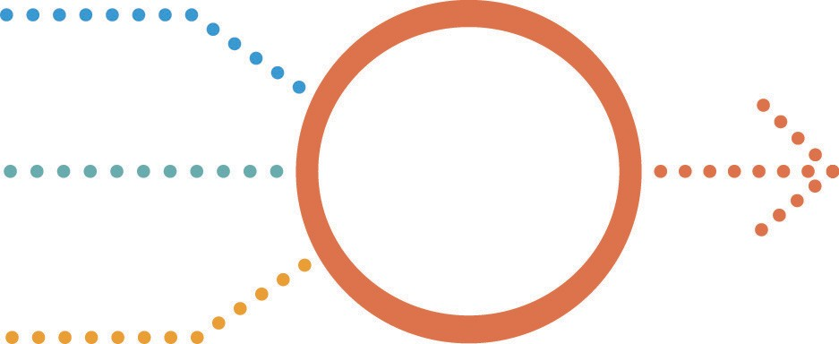

**Culture and Connection**

**Me Family**

**Community**

**Culture**

**Beliefs and Spirituality**

**Me and my mob**

**Culture and Connection:**

Our culture and connection to Country play a big part in Aboriginal and Torres Strait Islander wellbeing. This is important to remember when doing our plan.

**Beliefs and Spirituality:**

Our beliefs and spirituality play a big part in our daily rituals and meaningful practices. Remember these practices when planning your goals.

**Me, Family and Community:**

Our family and community gives us the universal and individual human lived experiences we need in our day-to-day lives.

**This enhances the foundation of self.**

*The working group acknowledge the Traditional Owners who have walked upon and cared for this land for thousands of years. We acknowledge the continued deep spiritual attachment and relationship of Aboriginal and Torres Strait Islander peoples to this country and commit ourselves to the ongoing journey of Reconciliation.*

Page 3



**Family, friends and community**

My Aboriginal/Torres Strait Islander organisation:

My Aboriginal/Torres Strait Islander worker:

My Local Area Coordinator:

My early childhood early intervention worker:

My doctor:

My specialist:

Page 4



My name:

**Personal Identity**

My Country

My mob:

My address:

My contact:

Phone number: Email address:

My doctor: Name: Address:

Phone number:

My support people and phone numbers:

Name:

Phone number: Name:

Phone number: Name:

Phone number: Name:

Phone number:

Page 5



**My Story**

*This could be provided in any format including drawings or voice/video recording.*

Page 6



**My cultural values, beliefs and practices**

My cultural values are:

My cultural beliefs are:

My cultural practices are:

Why these cultural values, beliefs and practices are important to me and should be put in my NDIS goals:

Page 7



**My totems**

Page 8

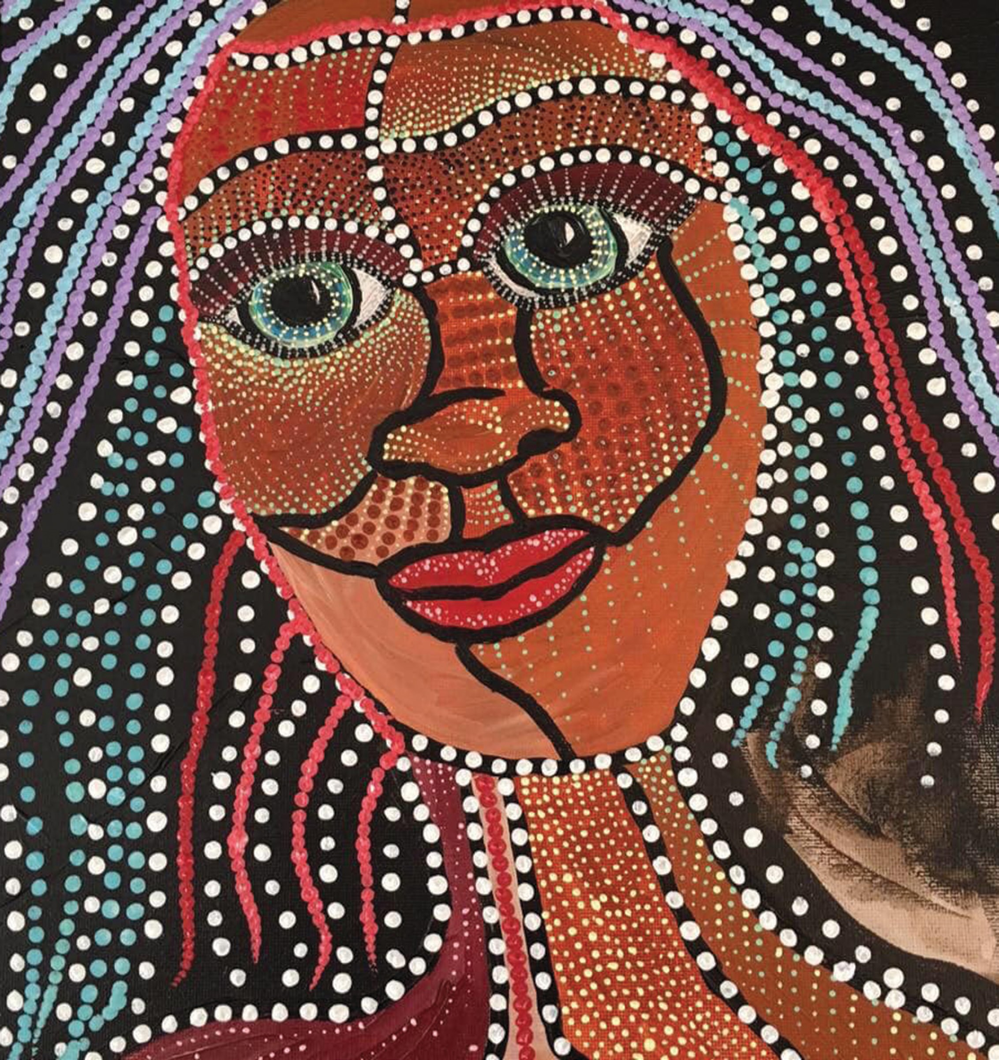

**The painting: Grandma Artist: Miranda Madgwick** *Worimi/Biripi & Dunghutti*



**My cultural art and events**

Why these cultural activities are important to me:

Men’s business

Women’s business

Do I want them in my goals?

Page 10



**My needs and goals**

Page 11

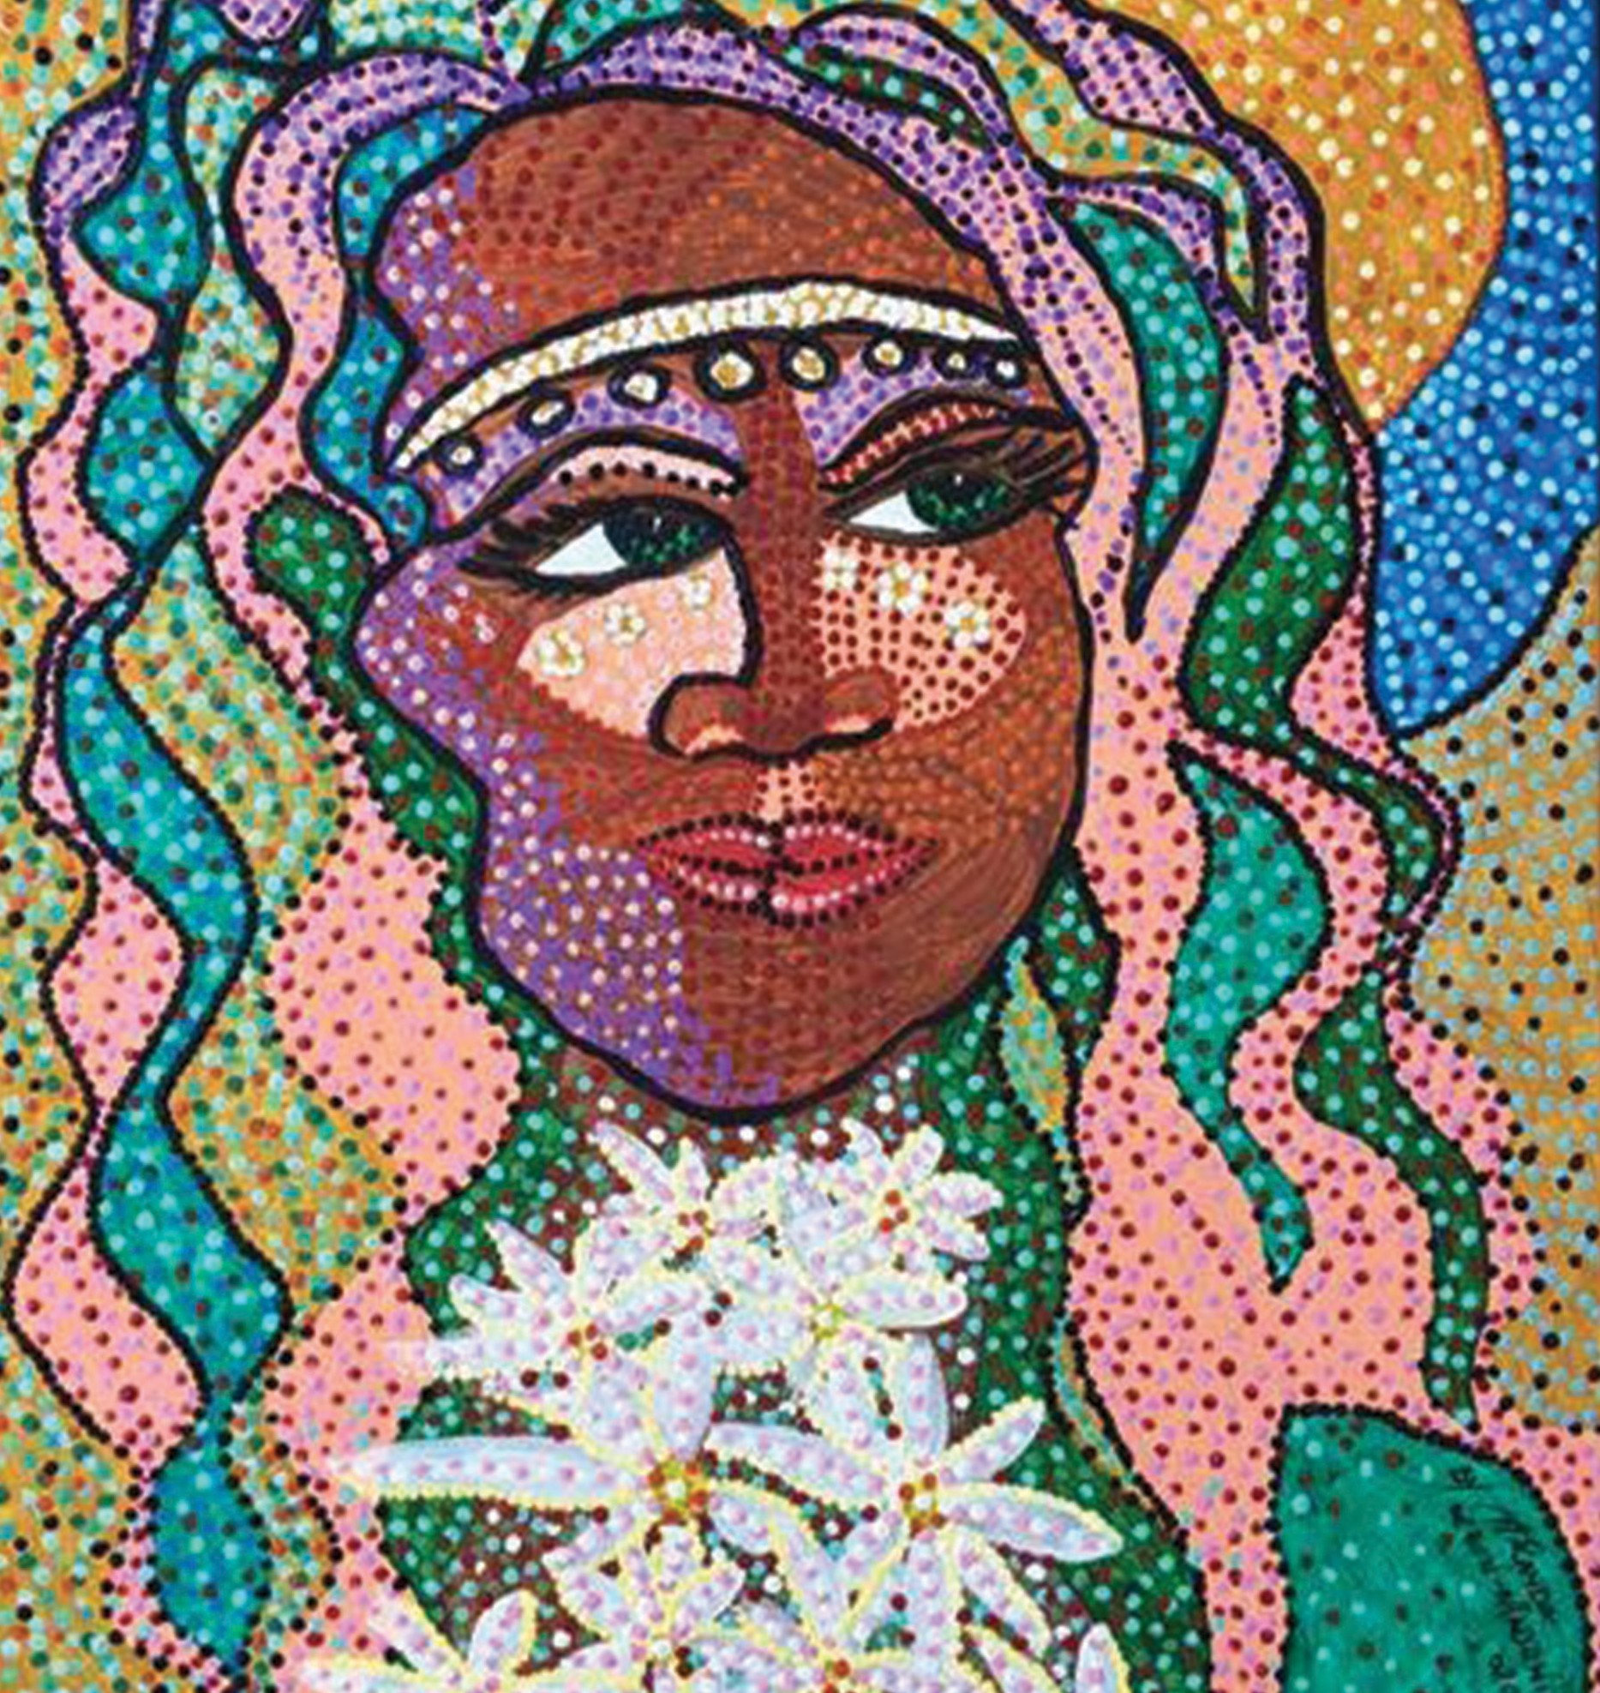

**The painting: My Spirit Artist: Miranda Madgwick** *Worimi/Biripi & Dunghutti*



**What I need help with right now**

Page 13

**Are you Will they**

**What I need Why I need it able to help me**

**help with get a reach my**

**quote? goals?**

Shopping

Transport

Educational

Cleaning

Gardening

Reading documents

Personal care

Wellbeing/ mental health

Socialising

Connecting to my Country

Cultural activities

Cultural education/ knowledge

Communication aide for isolated people

Assistive Technology

Any additional information



**What documents will help me show I need help?**

Letter from my Aboriginal organisation

Letter from my doctor/General Practitioner (GP) Letter from my carer

Psychosocial report filled in by my doctor and support worker Letter from my mental health worker

Letter from my teacher/school

Letter from my Orthopaedic surgeon Letter from my Occupational Therapist

Letter from my Speech Pathologist (Therapist) Letter from my Neurologist

Letter from my Psychologist Letter from my Psychiatrist Letter from my Physiotherapist Letter from my Paediatrician

Letter of impact from my carer/family

**To help you work out what documents you need, go to these websites:**

Providing evidence of your disability

[https://www.ndis.gov.au/applying-access-ndis/how-apply/information-support-your-](http://www.ndis.gov.au/applying-access-ndis/how-apply/information-support-your-) request/providing-evidence-your-disability#what-is-considered-good-evidence-of- disability

Mental health and the NDIS

[https://www.ndis.gov.au/understanding/how-ndis-works/mental-health-and-ndis](http://www.ndis.gov.au/understanding/how-ndis-works/mental-health-and-ndis)

Page 14



**My future goals**

My future goals are:

Why these are important to me:

Page 15



**Checklist for my NDIS plan meeting**

For assistance with getting your plan started go to:

[https://www.ndis.gov.au/participants/using-your-plan/who-can-help-start-your-plan](http://www.ndis.gov.au/participants/using-your-plan/who-can-help-start-your-plan)

or call NDIS Phone: 1800 800 110

Bring any report or evidence of your disability to help in your planning meeting.

Things to take to the meeting: This document

Support documents, quotes and letters My bank account details

My MyGov login and password

A family member, friend, advocate or anyone else to your meeting

Page 16



**Useful resources for you and your worker**

•

First People’s Disability Network

https://fpdn.org.au/

NDIS consent to share information form

[https://www.ndis.gov.au/about-us/policies/access-information/consent-forms](http://www.ndis.gov.au/about-us/policies/access-information/consent-forms)

Yarn Up Cards by Synapse

https://synapse.org.au/our-services/indigenous-services/yarn-up- cards/#:~:text=Synapse%20developed%20our%20Yarn%20Up,urban%2C%20 rural%20and%20remote%20communities

Sensory items/fidget tools

https://yarnstrongsista.com/product-category/aboriginal-and-torres-strait- islander-resources/balls/

NDIS Aboriginal and Torres Strait Islander Engagement Strategy [https://www.ndis.gov.au/about-us/strategies/aboriginal-and-torres-strait-islander-](http://www.ndis.gov.au/about-us/strategies/aboriginal-and-torres-strait-islander-) strategy

NDIS types of disability evidence

[https://www.ndis.gov.au/applying-access-ndis/how-apply/information-support-](http://www.ndis.gov.au/applying-access-ndis/how-apply/information-support-) your-request/types-disability-evidence

How to write good therapy reports

[https://www.valid.org.au/resources-and-media/resources/10-steps-excellent-](http://www.valid.org.au/resources-and-media/resources/10-steps-excellent-)

ndis-therapy-reports/

•

•

•

•

•

•

**Websites that have information about the NDIS:**

•

TSP for All – Psychosocial disability explained

https://tspforall.com.au/

Reimagine – Mental health, my recovery and the NDIS

https://reimagine.today/

•

Page 17



**About the project**

The Transition Support Project is based at Flinders University and has been funded by the Australian Government Department of Health and Department of Social Services. The project provides support to organisations to help people who were previously receiving supports from community based mental health programs apply to the NDIS in order to continue to receive ongoing help with the impact of their mental health condition on their everyday life.

The Transition Support Project has worked closely with organisations, people with mental health conditions, their carers, the Department of Health, the Department of Social Services and the National Disability Insurance Agency to identify the challenges in the NDIS rollout. The project then works with the relevant groups to develop resources and training to address those challenges.

These resources are available free of charge through our public website [www.tspforall.com.au](http://www.tspforall.com.au/)

During the past four years it has become clear there is a need for locally developed culturally appropriate NDIS resources for Aboriginal and Torres Strait Islander people. To help address this need the Transition Support Project has brought together individuals who are supporting Aboriginal and Torres Strait Islander people to identify what resources were needed and to then develop the resources based on their knowledge and experience. Throughout this project the Transition Support Project has facilitated the developmental process by providing administrative support.

**Acknowledgement**

**We acknowledge the following working group members in the development of this resource:**

**Janine Wyles *– Girrimay, Warragamay, Tagalaga***

I would like to acknowledge and pay respect to our ancestors, elders and emerging leaders.

I live in Townsville and am priviledged to work on Palm Island and support our mob.

I am the Program Coordinator of selectability Palm Island and feel privileged and happy to support clients to live the best life they can.

I am thankful for having the opportunity to work alongside great people to develop this outstanding workbook.

**Julio Estorninho**

Respectfully living and working on Wurundjeri Woi wurrung land.

Project Coordinator – Yumarrala Ngarrdji Aboriginal and Torres Strait Islander NDIS Access Project – Wellways.

**Kelly Thatcher**

I would like to acknowledge all Elders past and present.

My name is Kelly Thatcher, I am an NDIS Access and Support worker currently working for Oonah Belonging Place on Wurundjeri land in Healesville, Victoria. I have worked to support people from all walks of life for many years and I have really appreciated the opportunity to help develop this wonderful workbook with such a

great group of people. I really hope this work book helps many Aboriginal and Torres Strait Islander people with NDIS. Thank you for having me as part of this team.

**Jody Skeen *- Kuku Langi, Kuku Taipan and Birri Gubba Tribe***

*Works for Gallang Place (means healing place) Queensland*

I am the Coordinator of the NDIS program at Gallang Place working with participants in the NDIS scheme. I enjoy helping and supporting people to work towards their goals and healing process.

My goal is to paint art and be a good role model to my children as passed on down by my parents and family members.

Page 18



**Madeleine Prince**

I would like to acknowledge my elders past, present and emerging. I am living and working on Dharawal land which is the country of my ancestors for over six generations.

My name is Madeleine Prince and I am a registered Psychologist working for Neami National and Me Well. I have worked for Neami for 6 and a half years supporting people with severe and enduring mental illness. I have supported individuals to both access the NDIS scheme and have provided Specialist Support Coordination.

I continue to provide Specialist Support Coordination through Me Well (a division of Neami National) and I currently manage a homelessness service across the Greater Western and South Western Sydney areas, supporting individuals from temporary accommodation into a longer term sustainable housing pathway.

participant and family members knowledge and capacity and empowering them to have a voice and take greater control of their lives through utilising their NDIS plan, working collaboratively with diverse service providers and helping

my resilient participants to meaningfully connect back with community. Helping Minds is a registered NDIS provider specialising in Psychosocial services with National Disability Insurance Agency (NDIA).

**Tiffany Broadbent – Maclean**

*Works for Mission Australia*

I am the team coordinator for suicide prevention and Aboriginal and Torres Strait Islander healing programs, located in Katherine and Darwin in the NT.

I enjoy helping people to work towards achieving their goals, whilst empowering people to take control of their wellbeing and mental health.

**Miranda Leon-Madgwick**

I like to acknowledge all my Elders past and present.

My name is Miranda Leon-Madgwick, I am a Worimi woman who works on Wurundjeri in Victoria. I am one of the founding members of Oonah Health & Community Services Aboriginal Corporation ICN 9155. I stepped off the board and took a position with Oonah as NDIS Engagement worker, Cultural Educator & AOD outreach. I have enjoyed working with everyone on this project

and doing art work for it too. I hope this workbook enhances everyone’s experience with NDIS first Plan process.

**Suraya Bin Talib *– Bardi and Jabirr Jabirr woman from Broome, West Kimberley region***

Started in the role of Coordinator Individualised Services rolling out NDIS services in Broome last year in February 2019 since then I’ve engaged, supported, advocated and successfully transitioned a number of local Aboriginal participants with enduring Psychosocial Disability (Mental ill-health) to access their very first NDIS Plans. Now Support Coordinator working with diverse clients to assist with building individual

Page 19

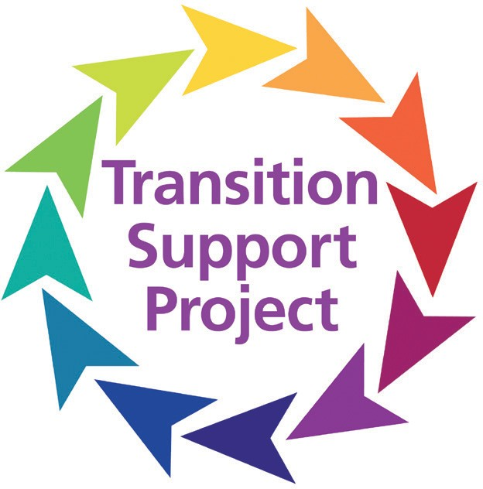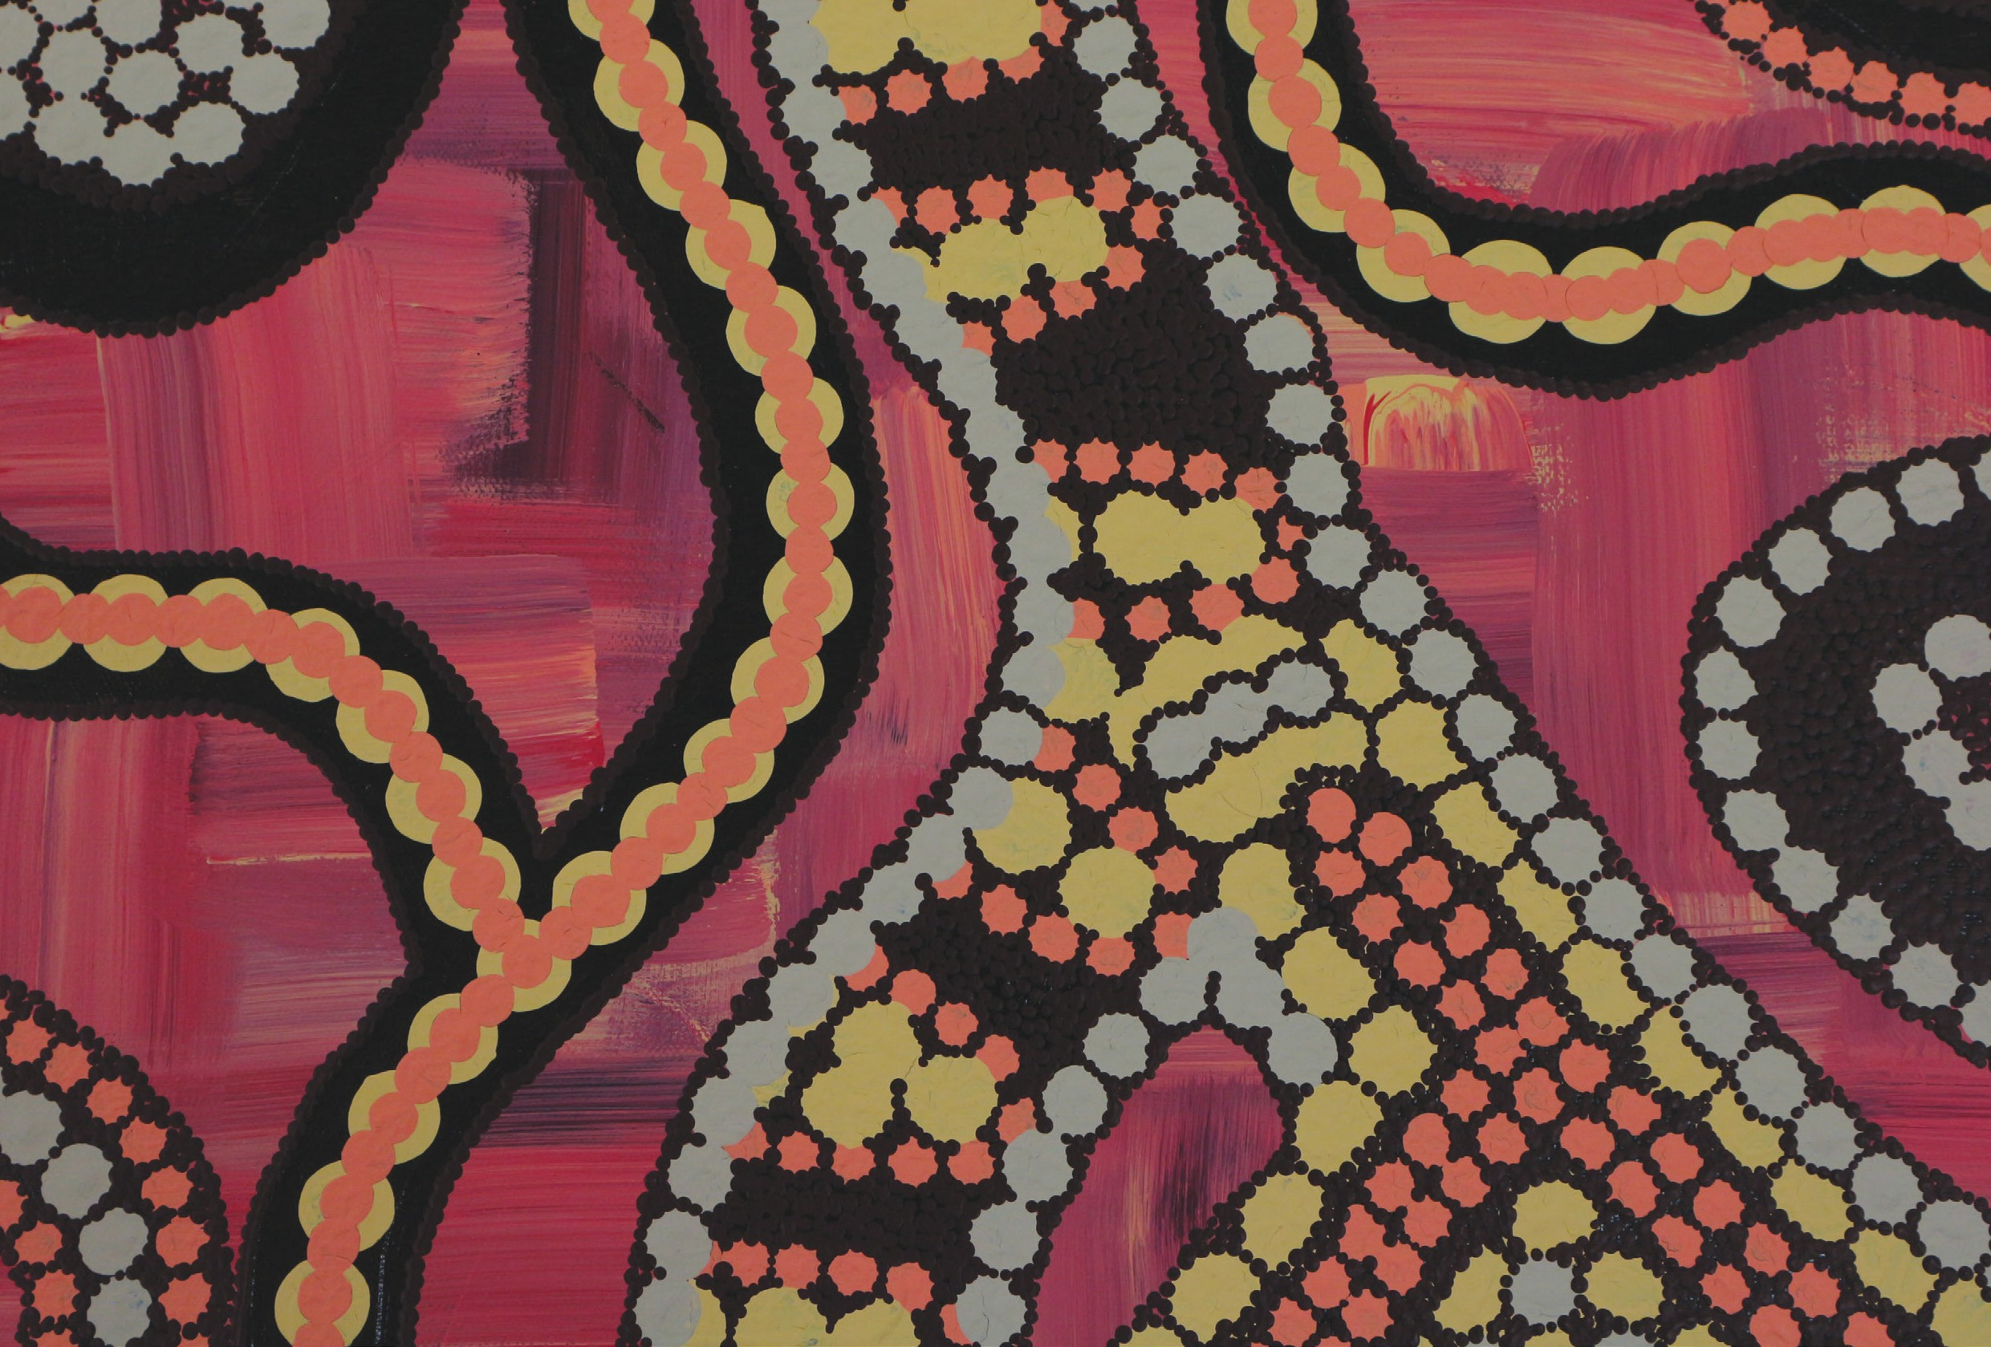

This resource was commissioned by the Transition Support Project. The project is based at Flinders University in Adelaide and funded by the Australian Government Department of Health and the Department of Social Services.

**To print copies of this booklet or download a digital version, visit our website:**

[**www.tspforall.com.au**](http://www.tspforall.com.au/)

**NDIS Aboriginal and Torres Strait Islander Planning Workbook**