Data Cleaning Tips in Medical Director
Cleaning up Recall Lists in Medical Director:
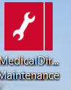
Open Medical Director Maintenance from the desktop Database Tasks/Medical Director Clinical/Merge Clinical Lists/You will need to login and have access to the maintenance programs to continue.
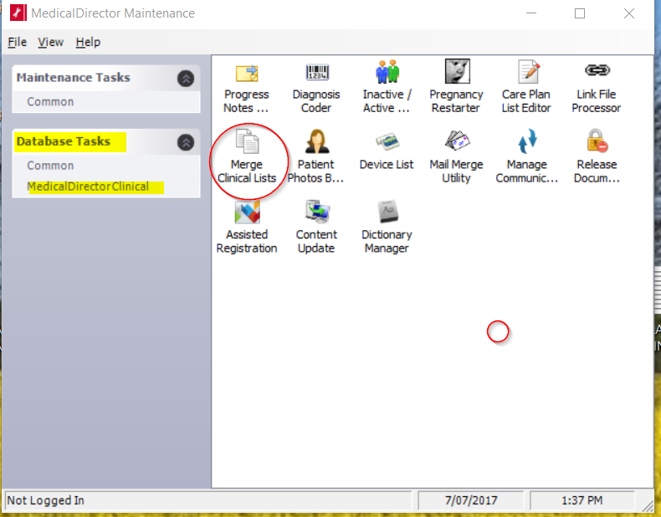
Select Recall List from the drop down list:
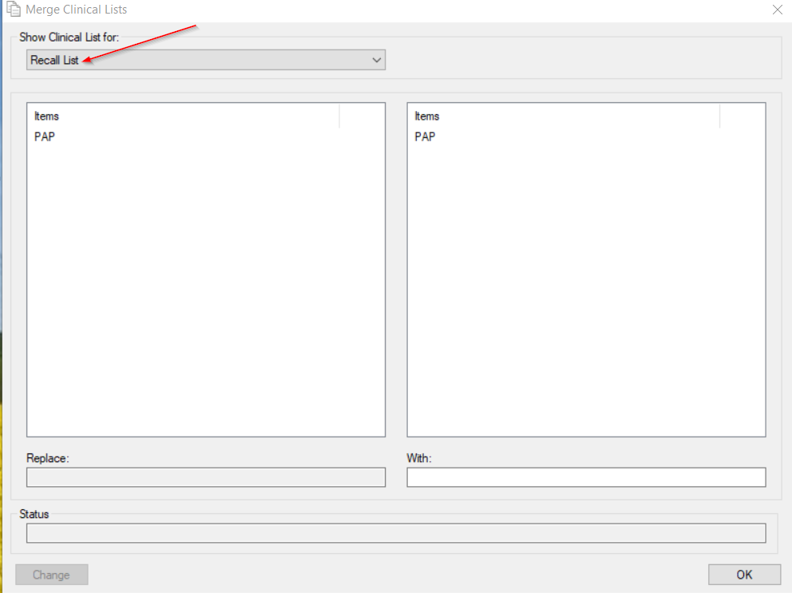
This is where you can link recall reasons that are either misspelt, incorrect, or there are too many recall reasons that are the same from the practice staff continuing to add new recall reasons. Ensure the reason is in “patient speak” as this is what will appear on letters and SMS recalls. See screen shot below where you can replace and tidy up the reasons without losing the recall. Choose the item and the one you wish to link it to then change and okay. Encourage GPs to stick to the list and not to add new recall reasons unless appropriate.
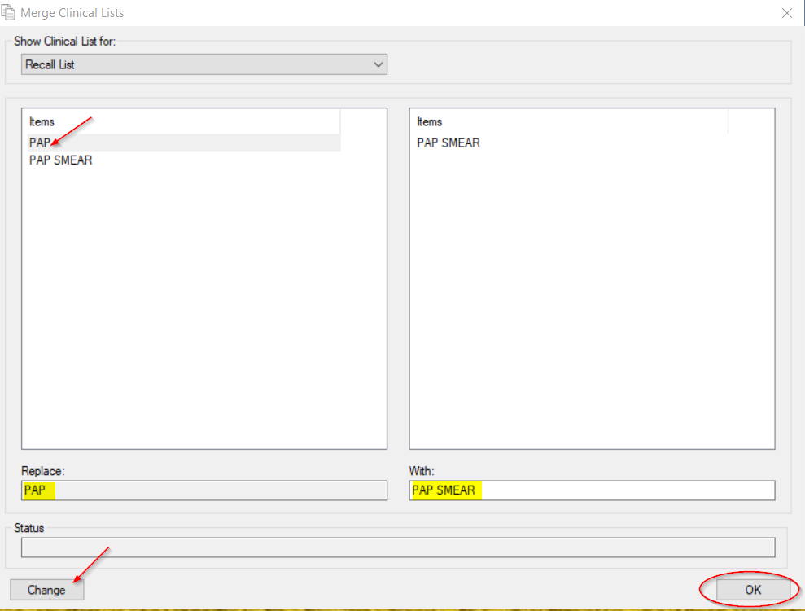

Linking free text reasons for visit with coded reasons for visit:
Open Medical Director Maintenance from the desktop Database Tasks/Medical Director Clinical/Diagnosis Coder/You will need to login and have access to the maintenance programs to continue.
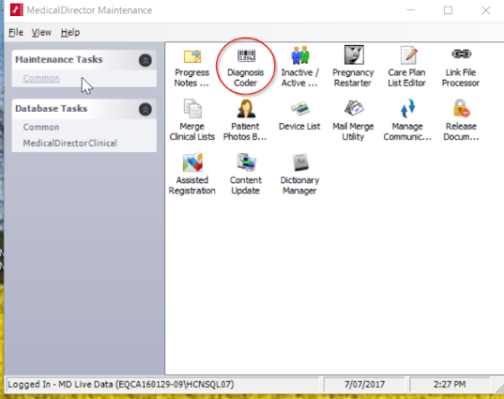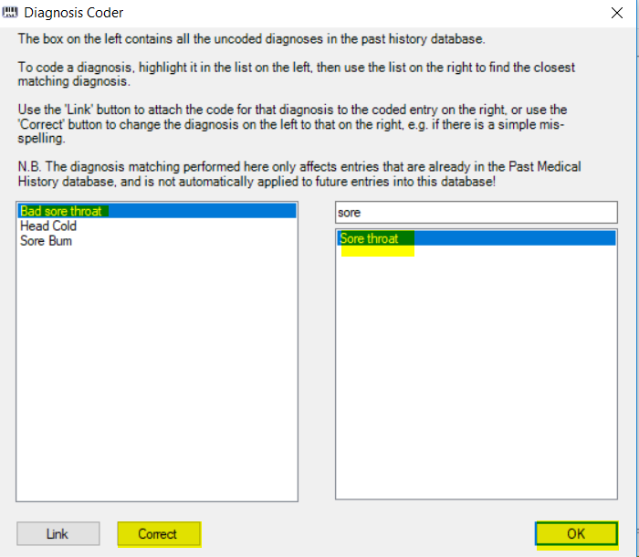
Select the un-coded diagnosis from the left side and link it with the coded reason on the right hand side, correct then ok. See screen shot.

Making patients inactive (bulk inactivation)
In Medical Director not in, a patient file go to Search/Patients
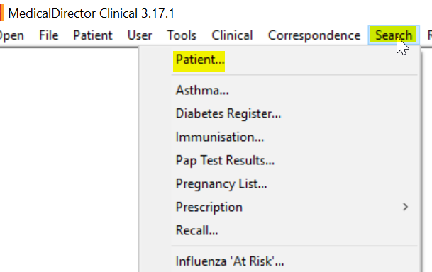
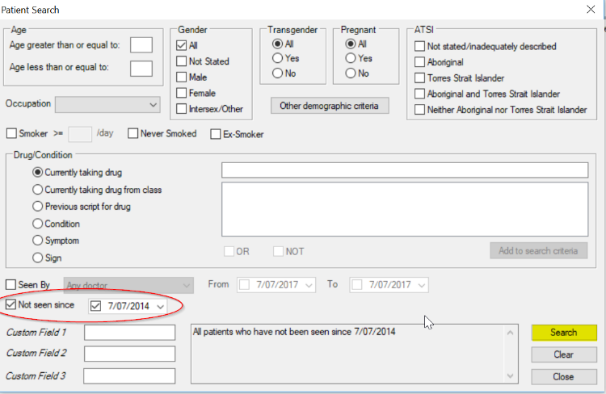
Patients not seen since put in your date range i.e. go back 2 years or whatever is appropriate for your practice and then search once the list is generated check the contents of the window and then inactivate patients this will not delete patients it will create an inactive status they can be made active again but only one by one.
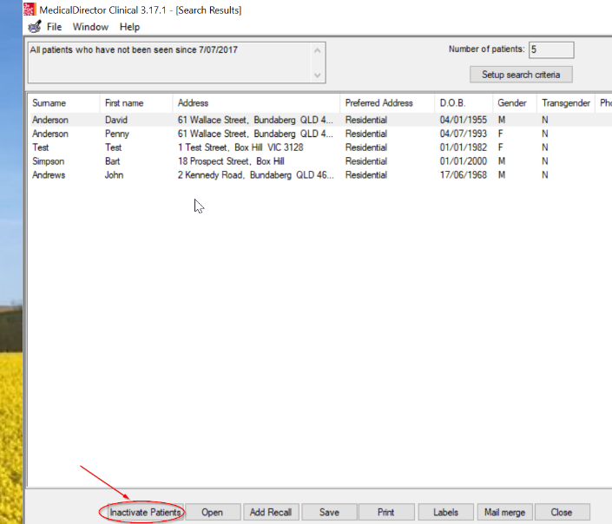

Doctors please mark results as notified add recalls update or delete recalls and when adding Pap smear results please add them to the Pap test record by right clicking on the result and Copy to Record Pap Test Result (see below)
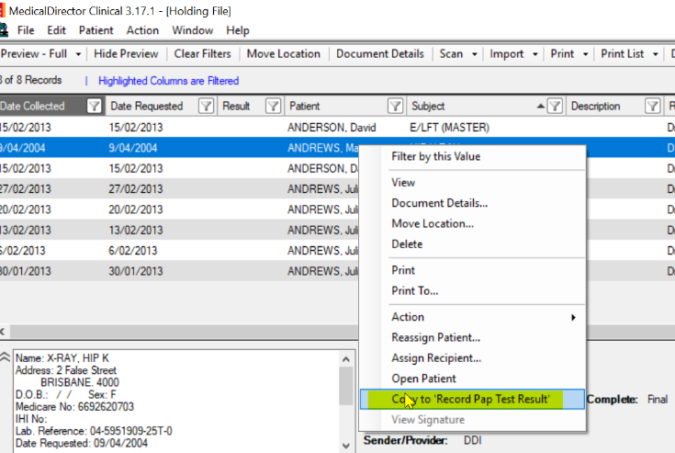
When checking the holding file Doctors Update Medications from Discharge summaries, specialist letters or results
From the holding file, highlight the patient then open patient add RX RX + Prescibed elsewhere. Update new history items if needed.
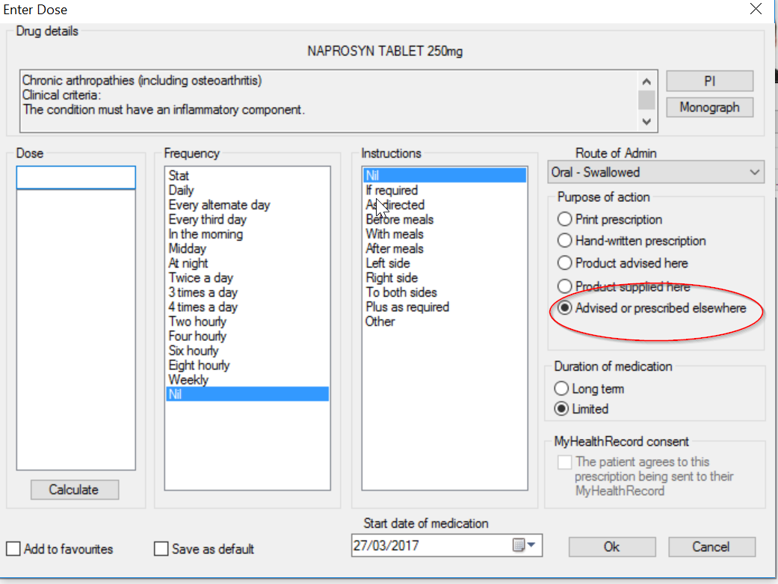

Update patient gender
Open Medical Director Maintenance from the desktop Database Tasks/Common/You will need to login and have access to the maintenance programs to continue. A wizard will open click next
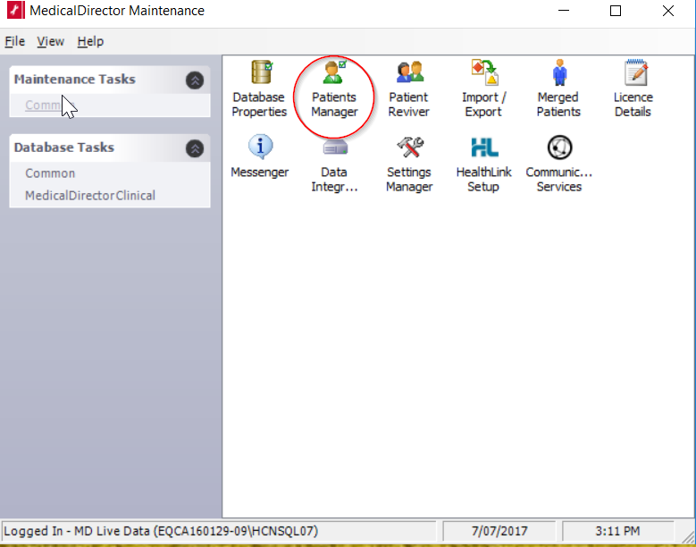
Then select Update patient gender this will update missing gender information by linking it to the patients title (Mr,Mrs etc..)
