Practices can now request for an automatic login to HealthPathways Melbourne.
To request automatic login, please complete this form and return to info@healthpathwaysmelbourne.org.au.

Practice: | Click here to enter text.
IP address: | Click here to enter text.
Contact name: | Click here to enter text.
Date: | Click here to enter text.

How does the automatic login work?
Using your practice IP address, we will set-up a unique HealthPathways Melbourne login for your practice.
This means that your practice staff will not be required to input the username and password for the site. This will make accessing HealthPathways Melbourne faster and easier.

What does disclosing our practice IP address mean?
- We can set-up a unique practice login for you
- To help us prioritise pathway development and identify where we can provide support to practices, we can collect data on:
  - How many practices (not individuals) are using HealthPathways Melbourne
  - How often a practice (not individuals) is using HealthPathways
  - What are the frequently used pathways
  - Terms and keywords most often searched for – this gives us an indication on demand for pathways from general practice
- What the data does not tell us:
  - IP addresses are not connected to your general practice software, therefore we cannot access or extract any patient data
  - We cannot identify individual users

How will this benefit our practice?
An automatic login to HealthPathways Melbourne means your practice staff won’t have to input the username and password for the site. This will make accessing HealthPathways faster and easier.
The data we collect helps us to evaluate parts of the HealthPathways program. The outcomes and recommendations from this evaluation will allow us to understand how we can improve the website – including the possibility of adding new features and increasing the user friendliness for you. It will help us provide you with the best tool that is fit for purpose.
The data we collect will also provide evidence of the usage and demand for HealthPathways among GPs. This evidence will help us secure ongoing funding for the program.

Will the data be de-identified?
At a practice level, we can see the location of your practice and the pathways being searched for. As stated above, we cannot identify individual use and we cannot extract any patient data. The data will only be used to make the website more user-friendly and to help us evaluate its use. Disclosing your IP address is a win-win situation for you and us!

How can I find my IP Address?
There are two easy ways to find your IP address.
- Google search the phrase “what is my IP address”. Google will then automatically provide you with the IP number. Please ensure this is your public IP address
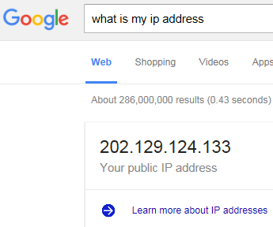

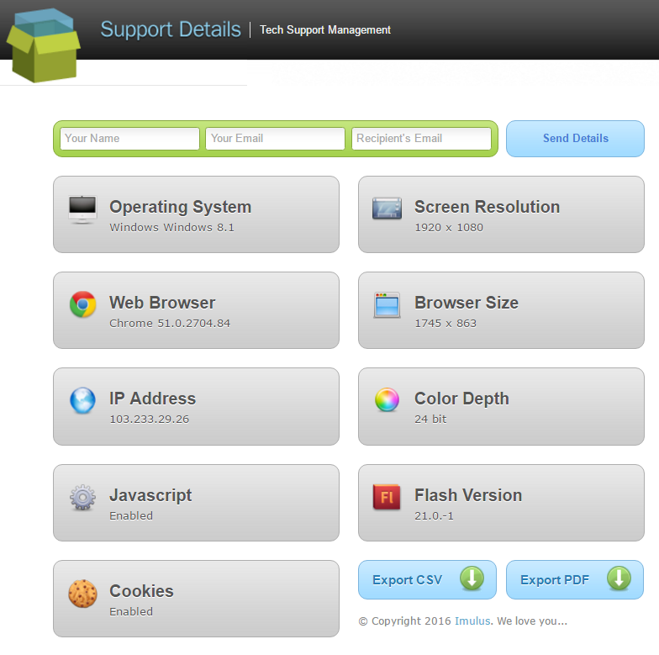
- Visit http://supportdetails.com. You will see a range of details, including the IP address. You can email this to us by entering your name, email address, and our email address, then clicking ‘Send Details’; alternatively, there is an ‘Export PDF’ button. If you download the PDF, you can send it to us, and we can then forward it our technical team.

Questions?
If you have questions, please contact the HealthPathways Melbourne team on info@healthpathwaysmelbourne.com.au.

