FAQ Walrus

* Walrus will need to be installed on each workstation, per user
* Practices will need to open Walrus and login each day (enable Start with Windows in configuration screen)
* In order to enable the ability for Walrus to open the appropriate screen (e.g. alcohol recording when no alcohol consumption recorded), tick “Screen Triggering”
* Practices will need to set up Walrus with the following settings:

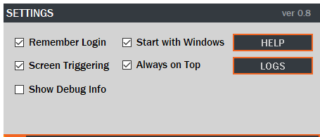

* Practices cannot install Walrus in a Terminal Services environment.
* There is a 24 hour window for data reload (The aim is have updates occur multiple times a day in future updates)
* NOTE: some bugs (hidden characters in patient names) cause Walrus to say it cannot connect to MD database
* In order to use the patient timeline the “Patient Timeline WALRUS” must be enabled for the user in the user management screen (available to admins only)

