EACH
Psychological Strategies
Psychological Strategies is a free program that provides structured groups and
individual counselling for people of all ages with or at risk of developing a diagnosed
mild to moderate mental illness and their carers.
The program has been developed for people who will benefit from short to medium
term psychological interventions and who are not able to afford full fee or MBS Better
Access subsidised services.
Of particular significance in this model:
•
The inclusion of service access capacity for humanitarian entrants
•
The capacity to offer a combination of individual and group sessions
•
Up to 20 individual sessions where this is clinically appropriate
This program offers:
•
Structured therapeutic and skill-based groups
•
Individual counselling support

Psychological Strategies is delivered by the following credentialed allied health professionals
):
AHP
(
•
Psychologists
•
Credentialed mental health nurses
•
Occupational therapists with documented mental health training
•
Accredited mental health social workers
•
Aboriginal and Torres Strait Islander health workers with a Certificate four in Primary Health Care
Practice.

Who is eligible for this service?
To be eligible for Psychological Strategies individuals must:
- Have a clinical diagnosis of mental illness of mild to moderate severity as defined by the International Classification of Disease (ICD) OR
- Have symptoms of/ be at risk of developing a mental illness, for children up to age 17 OR
- Aboriginal and/or Torres Strait Islander people
- Have a current Mental Health care plan from their GP
- Benefit from a short to medium term psychological strategies intervention
- Not be able to afford full fee or MBS Better Access subsidised psychological services
- Live or have a GP within the EMPHN catchment

Please note:
- PHN can subsidise GP support to complete the necessary MHTP for humanitarian entrants who meet the above criteria
- Those with severe and/or chronic mental illness may access Psychological strategies where the primary goals are related to a mild-moderate co-existing condition
- Family, and parent sessions are available through the program for children up to the age of 17 at the time of referral

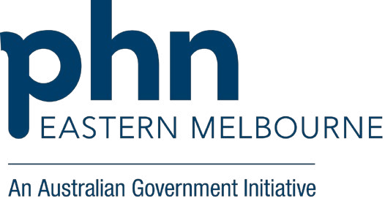
Exclusion criteria
The following exclusion criteria apply to the Psychological Strategies program:
- Treatment of severe mental disorders which would not benefit from short to medium term psychological services
- Treatment of people who are more suited to other mental health services (higher or lower intensity services) or can afford full fee or subsidised services
- Those in Government funded Aged care places or facilities

Support is provided in a variety of settings: site-based, one to one and in groups in:
- Whitehorse • Knox • Yarra Ranges • Monash • Whittlesea

How to refer: Complete the Mental Health Services Referral Form, including ‘EACH PS’ as your preferred provider (www.emphn.org.au/what-we-do/mental-health) OR
Contact the EMPHN Referral and Access Team:

Phone: 9800 1071

Secure fax: 8677 9510

Email: referral.access@emphn.org.au

This service is supported by funding from the Australian Government under the PHN Program.

