INSTRUCTIONS FOR PRACTITIONERS

REGISTERING, YOUR PROFILE, YOUR AVAILABILITY 2
Your profile 5
aVAILABILITY 9

bOOKING patients over the phone & confirming appointments 11
patient registration 11
Booking appointments 13
confirming appointments 22

VIDEO CALLS 26

DECLINING AND CANCELLING APPOINTMENTS 30

REGISTERING, YOUR PROFILE, YOUR AVAILABILITY

- Go onto the Cyber Clinic website - https://cyberclinic.com.au/

- Click on ‘Login’
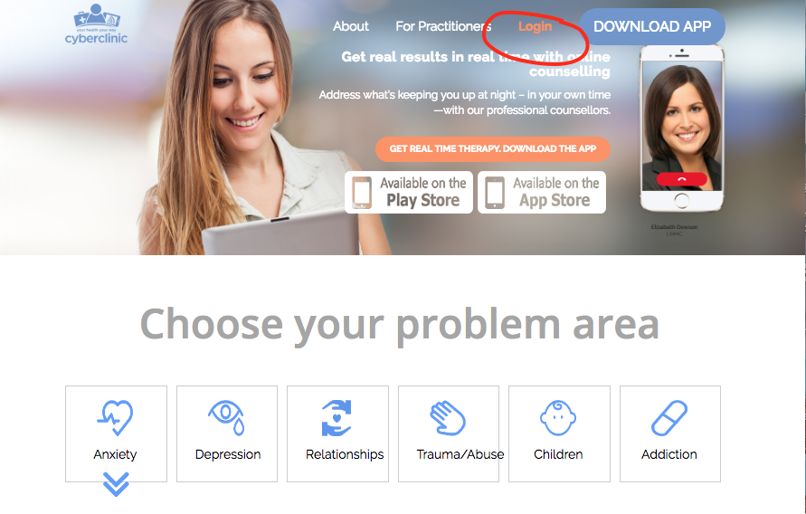

- Click on ‘Register’
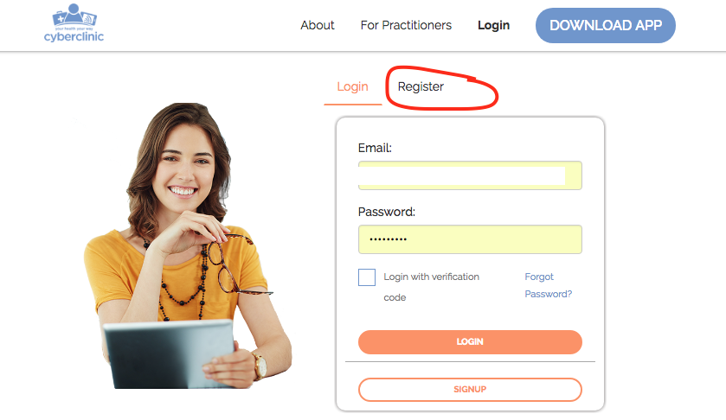

- Enter in your details, BSB number and Bank Account Number, read the terms & conditions/privacy policy and tick if you accept, then click ‘signup’.
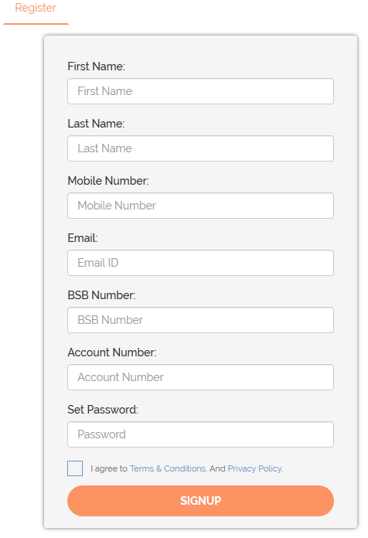

- Check your email and click on the verification link.
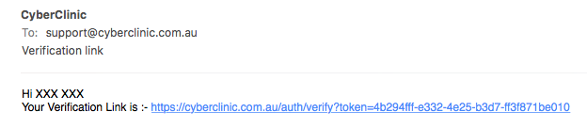

- Click submit under ‘individual practitioner’ 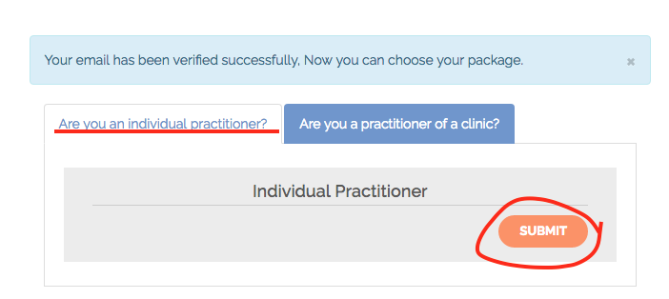

- Next, log into your Cyber Clinic account.
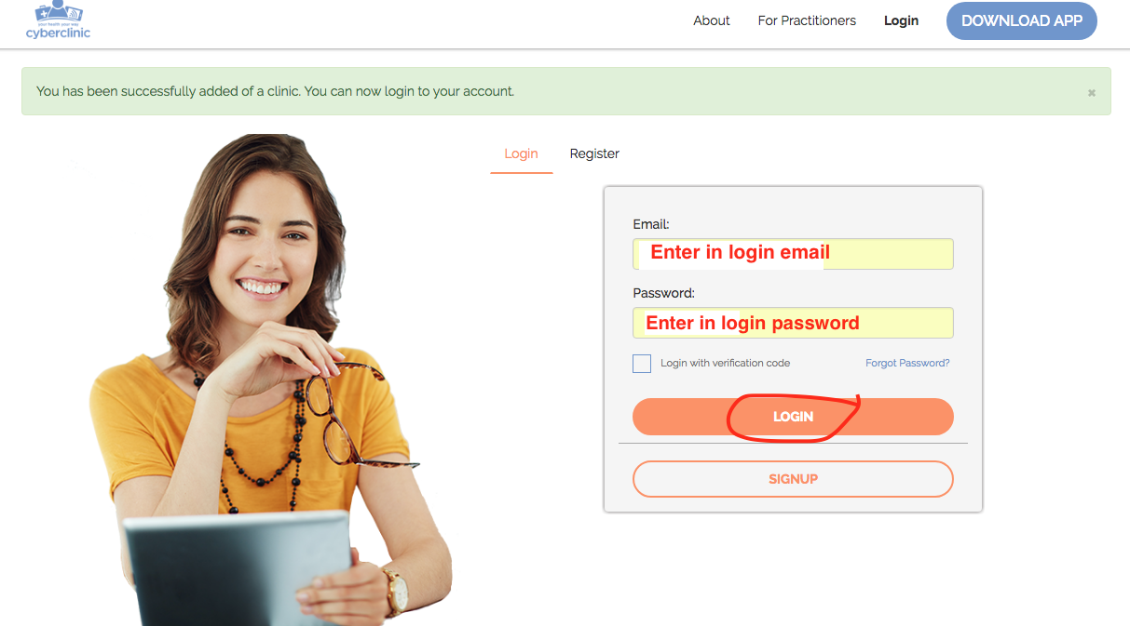

- Click Continue twice and you will see the ‘My Profile’ page.
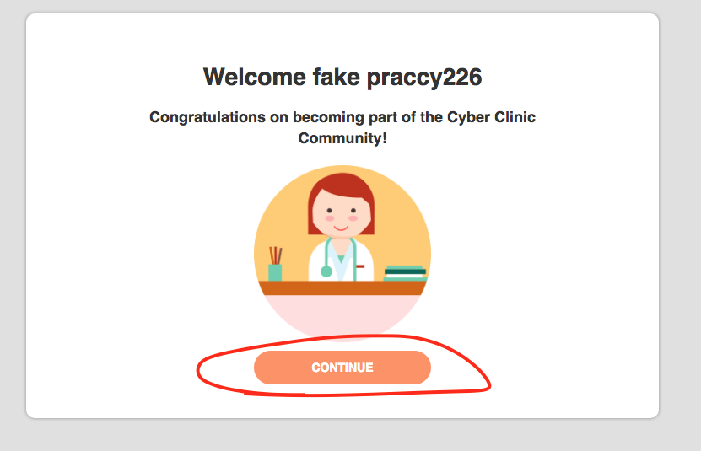
Welcome DR. XXX

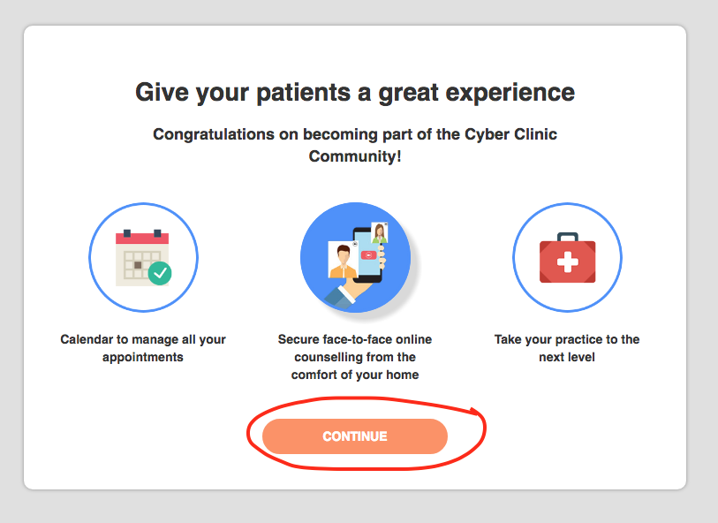

YOUR PROFILE

- Under the ‘My Profile’ page, fill out your details. Most of it is straightforward.

- Verify your mobile number

  - Click on the red question mark

  - Click ‘submit’ if the number is correct.
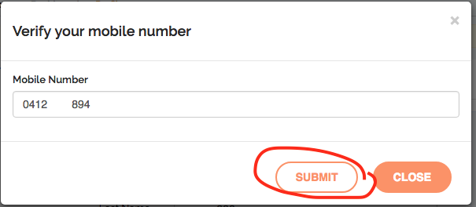

  - You will receive a text message on your mobile with a code. Enter in the code and click ‘submit’. 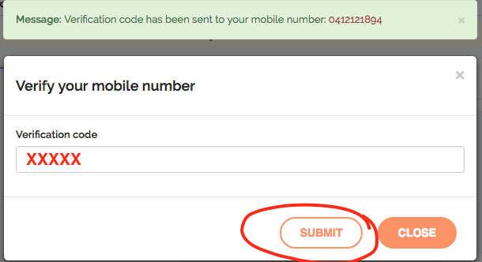

  - If done correctly the red question mark from step 16a should turn into a green tick.

- Indemnity Insurance: Click ‘browse’ to attach your indemnity insurance.
  - Find the correct document and click ‘open’
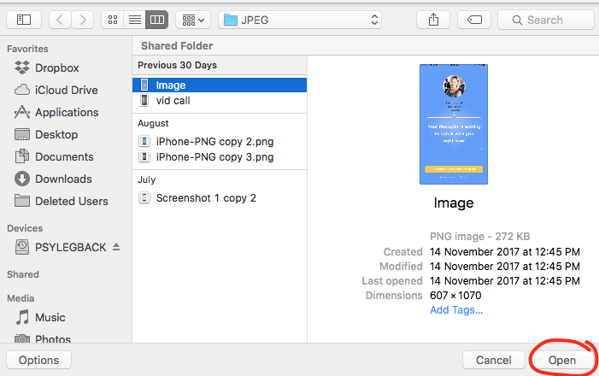

- Registration:
  - Click ‘add more’
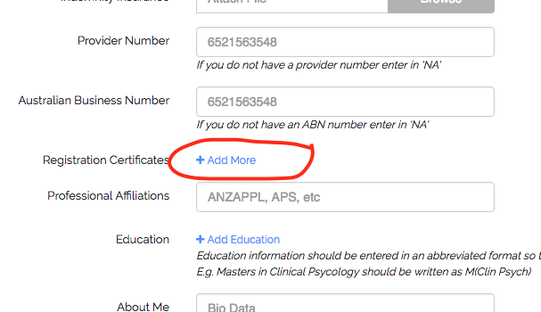
  - Click Browse
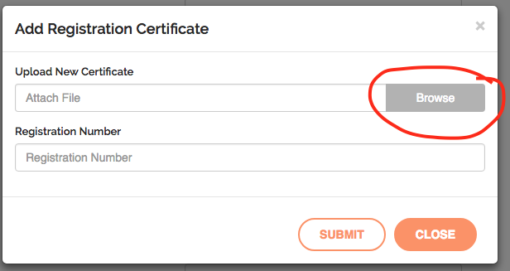

  - Find the correct document and click ‘open’
  - Enter in the registration number and click ‘submit’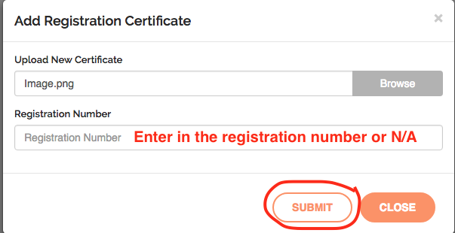

  - You can click ‘add more’ to add more documents. If adding more repeat steps 16a to 16e.

- Education: Enter in all of your relevant post - high school education. You will need to add each course at a time.
  - Click ‘add education’

  - Enter in course/education details and click ‘submit’.
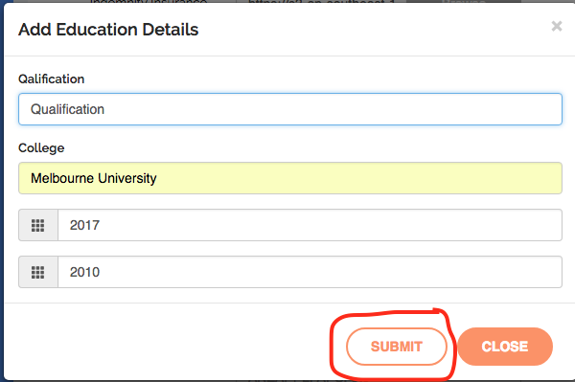
  - Repeat 17a-17b to add more education details.

- Profile Pic: Upload a professional portrait of yourself

- Choose your speciality. Most people only have 1 speciality / occupation but you may have more.
  - Click ‘add speciality’
  - Click the drop down menu, scroll & choose your speciality.
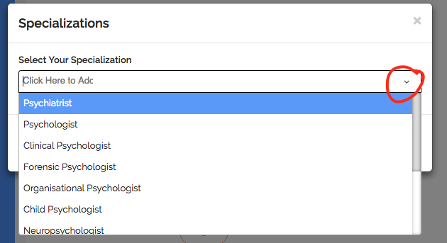

  - Click ‘submit’.
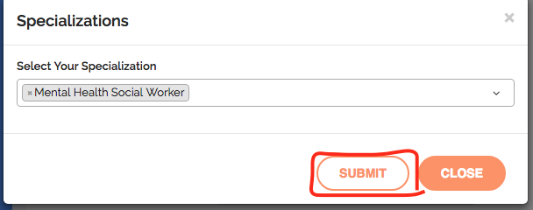
- Choose your skill areas. These are any psychological issues you are confident in treating and may be as many as you like.

- Click ‘submit’ to update/save any changes to your profile.

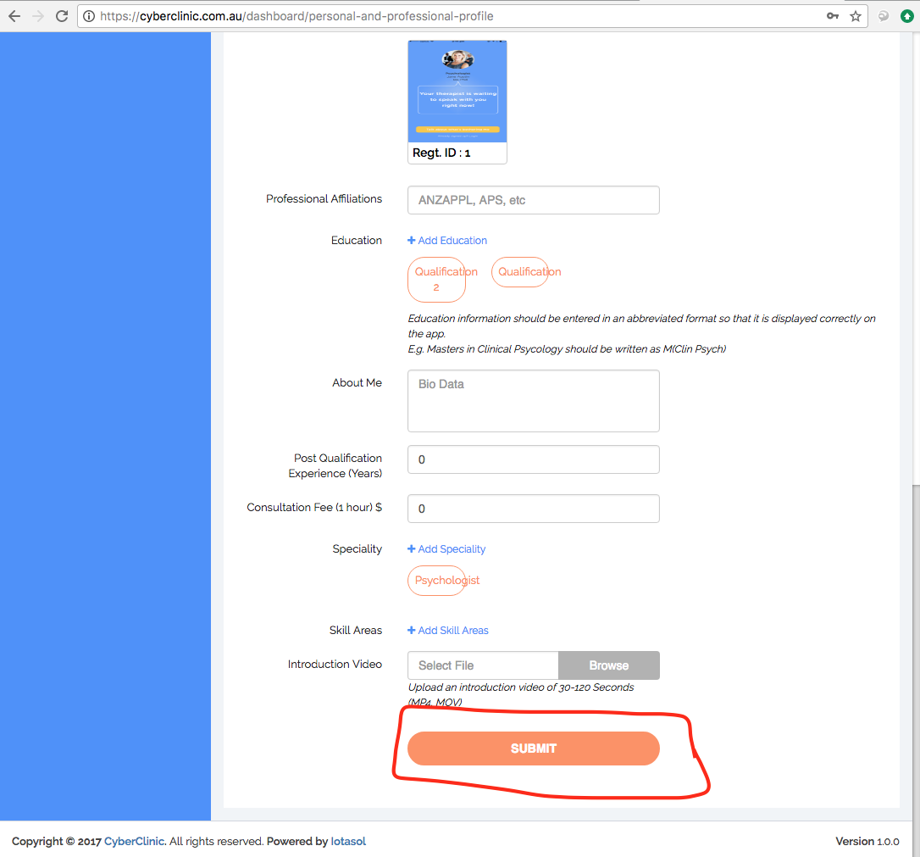
YOUR AVAILABILITY

- Click on ‘calendar’ on the left panel.
- Click on ‘availability settings’
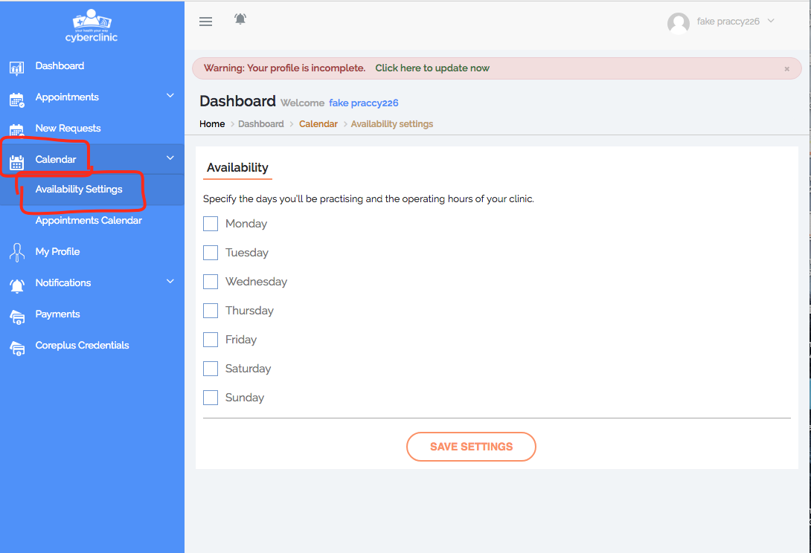

- Enter in the days and times you are generally available.
  - For example if you are available Monday from 6am-10am enter in like below.
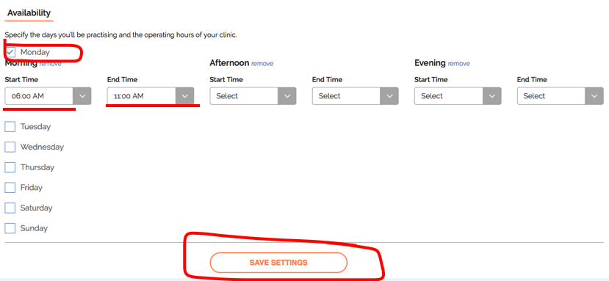
  - Click ‘save settings’

- Please note that your profile will not go live until Cyber Clinic have approved your account.

For support call 1300 112 115 or email support@cyberclinic.com.au.

BOOKING NEW PATIENTS / CONFIRMING APPOINTMENTS

- You will receive an email (referral) on Fixus from EM-PHN with client details.
- It is up to you to help the patient book the first appointment.
The patient has been told to await your call.
- Call the patient’s mobile / home phone.
  - Confirm their details to ensure you have called the correct person.
  - If you have called their mobile number, ask them to put you on loud-speaker so that they can use their phone/ follow your instructions.
- Ask them to download the Cyber Clinic app
  - iPhone – they will need to use the App Store
  - Android – they will need to use Google Play

Once downloaded the patient will need to do the following to REGISTER:

- Click on ‘talk about what’s bothering me’
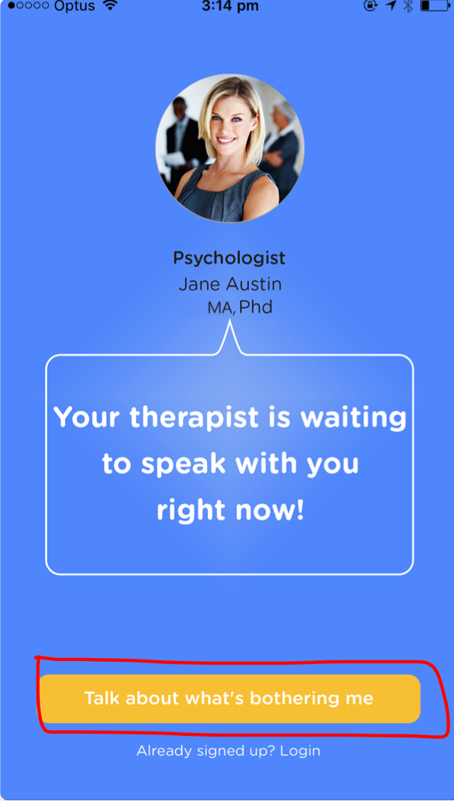

- Click ‘register’
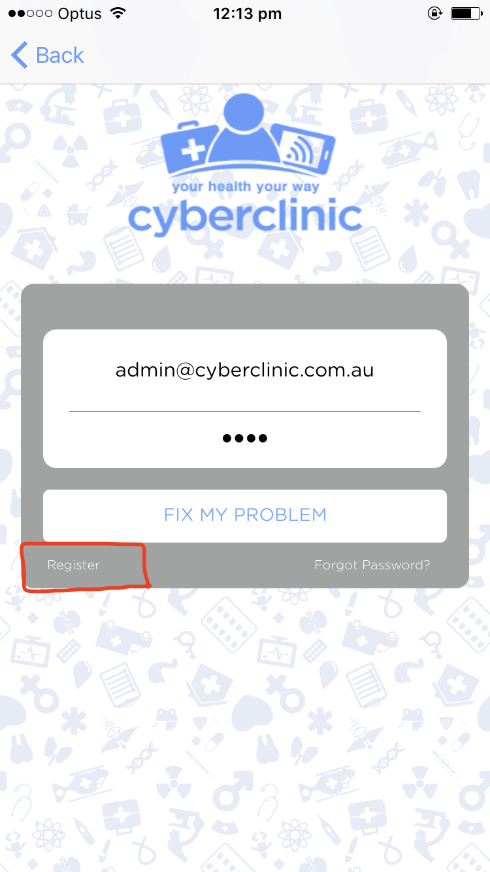

- Enter in their name, email and password twice and click proceed.
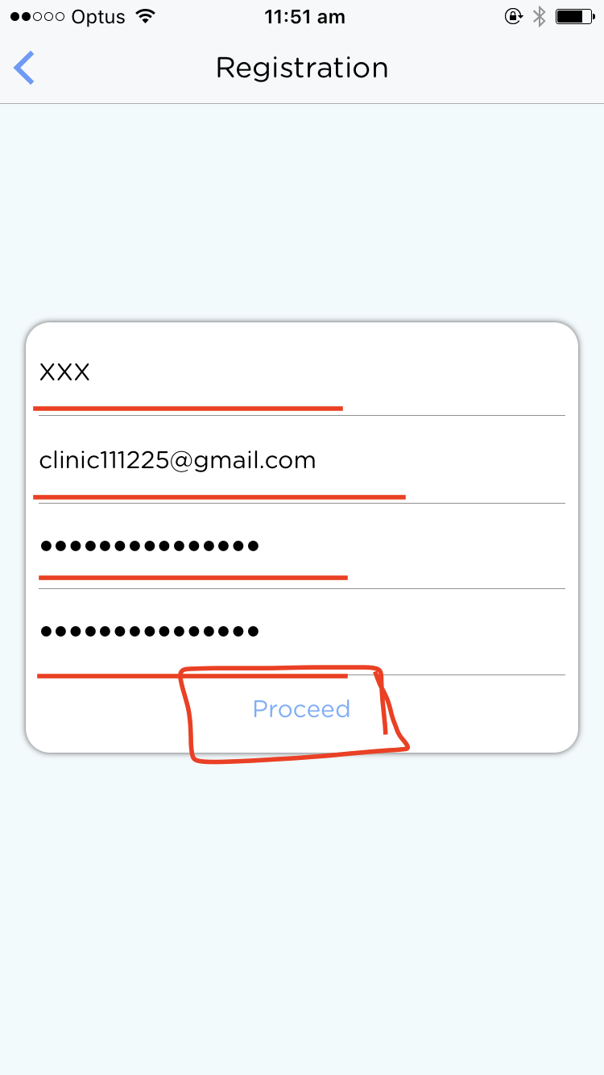

- Check their email for the verification code.
- Enter the code and click ‘Verify’.
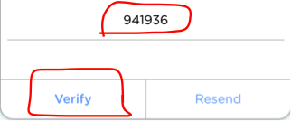

- Read the Terms and Conditions, tick if you agree and click ‘proceed’.

Once registered the patient will need to do the following to BOOK AN APPOINTMENT:

- Click ‘Contract’
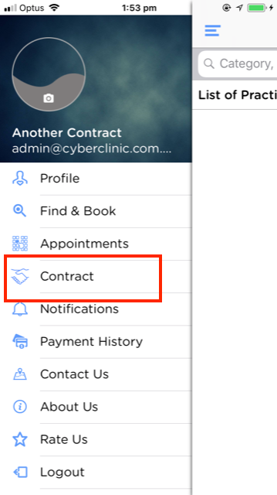

- Click ‘add contract’
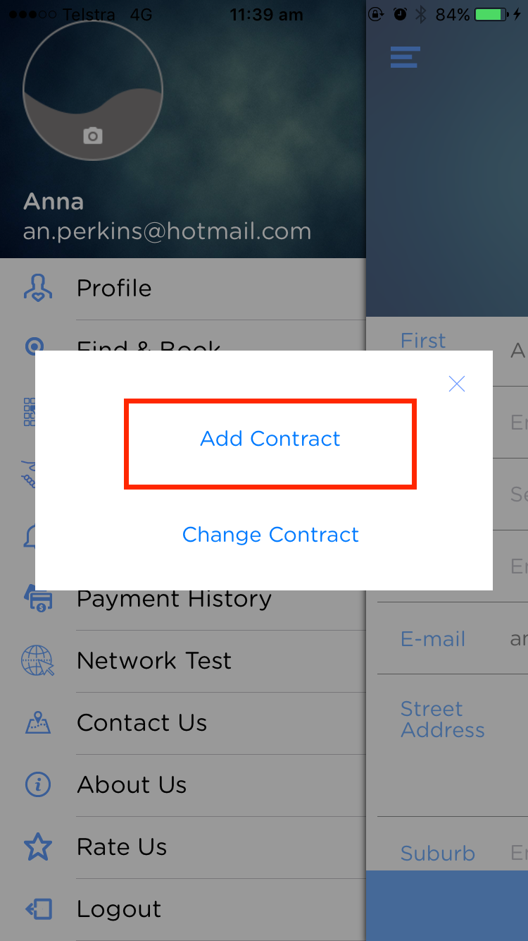

- The patient needs to enter in their email address, and your contract key, to be able to connect with you.
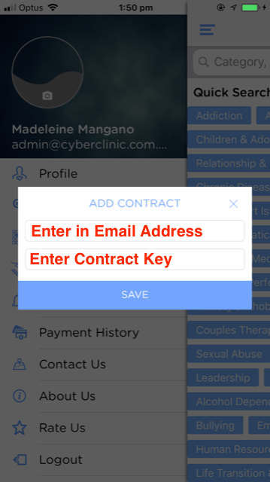

- Once the email address and contract key have been entered, they will need to select ‘Change Contract’
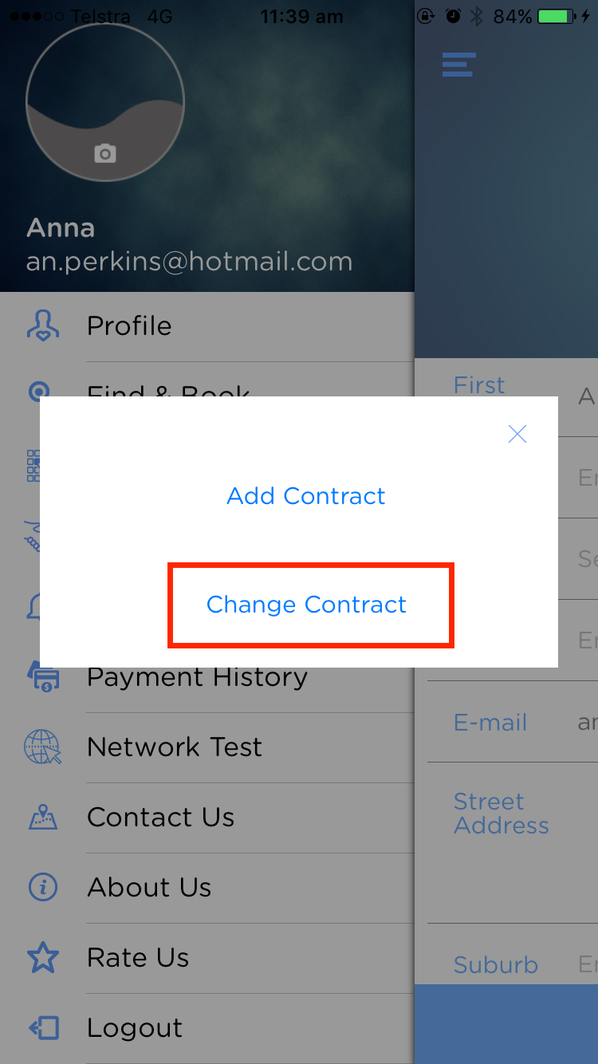

- Then the patient can select your specific contract and click ‘OK’
  - They will now see that the name of contract (e.g. Cyber Clinic) is shown above their email address.
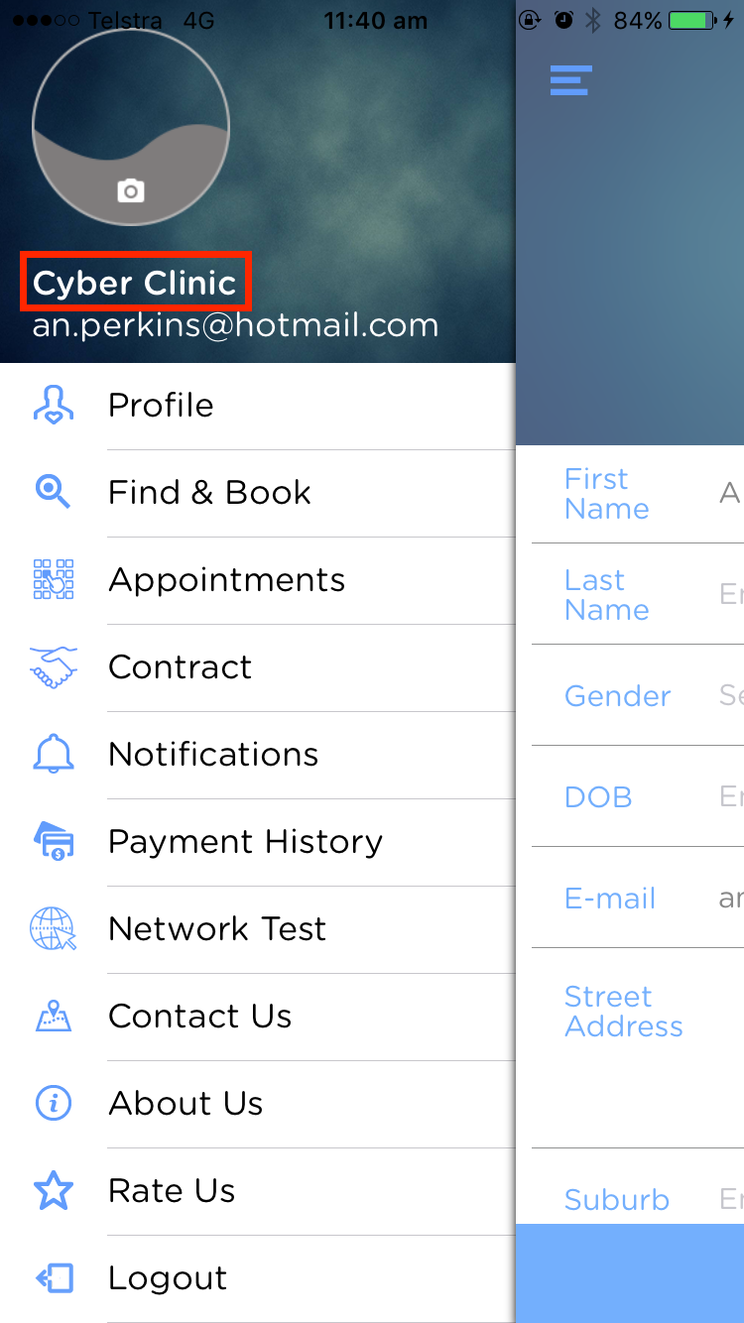
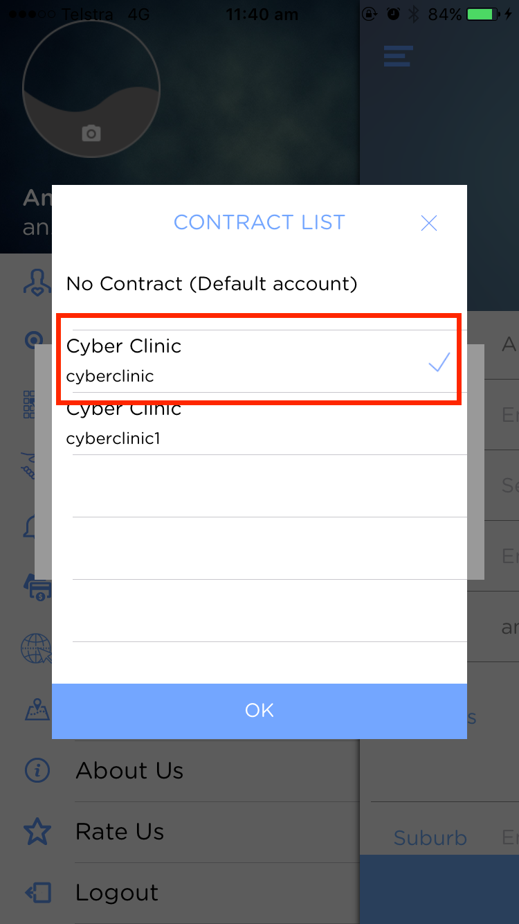

- Now they need to go to the ‘Find & Book’ page.
  - A list of practitioners under this contract will show up.
  - Tell the patient to find and select you.
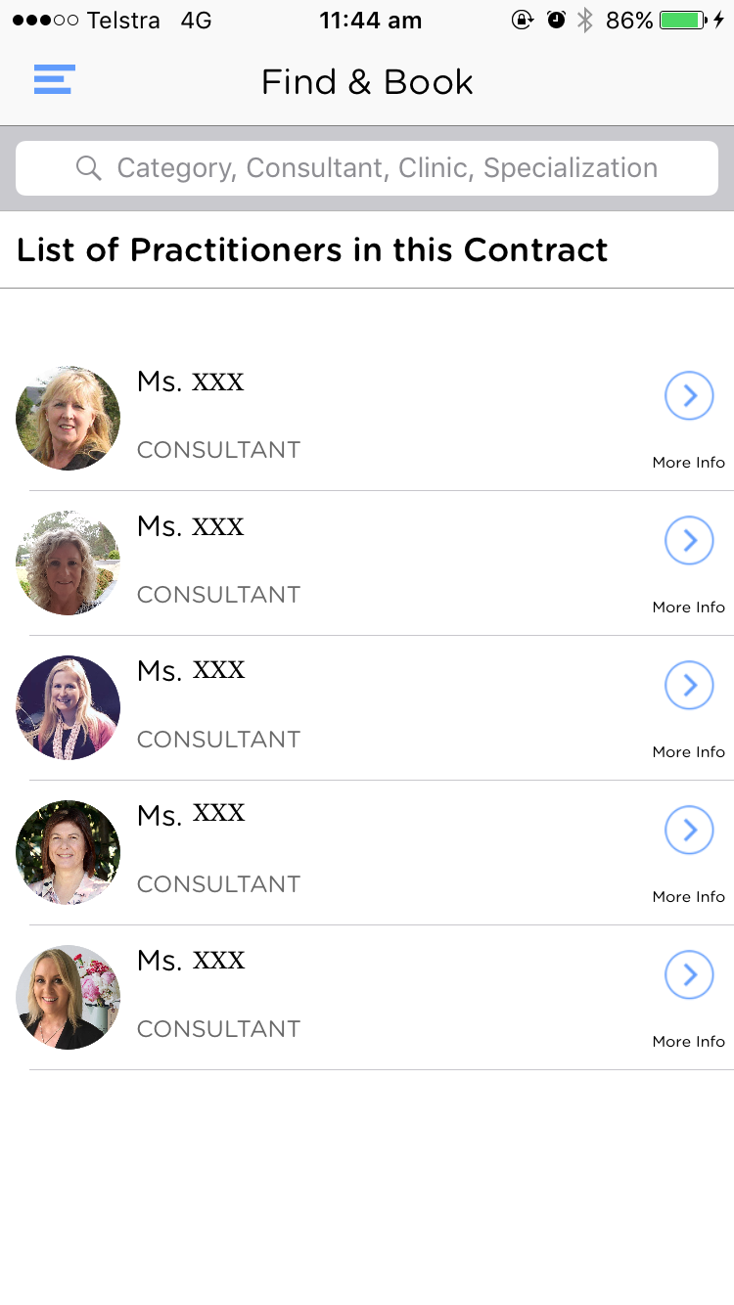
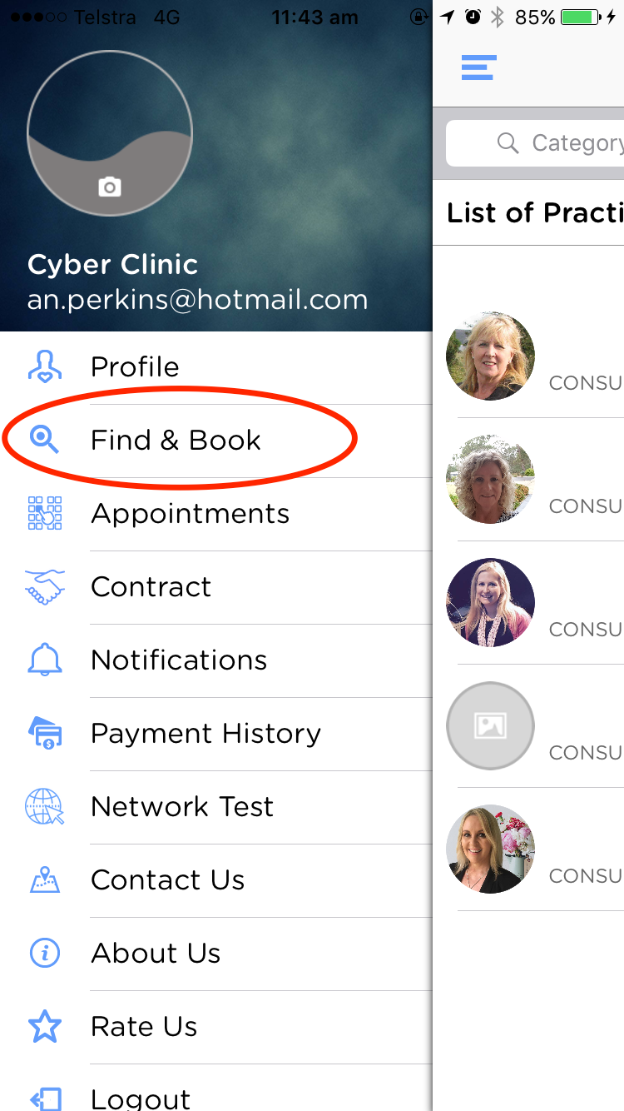

- Click ‘book’
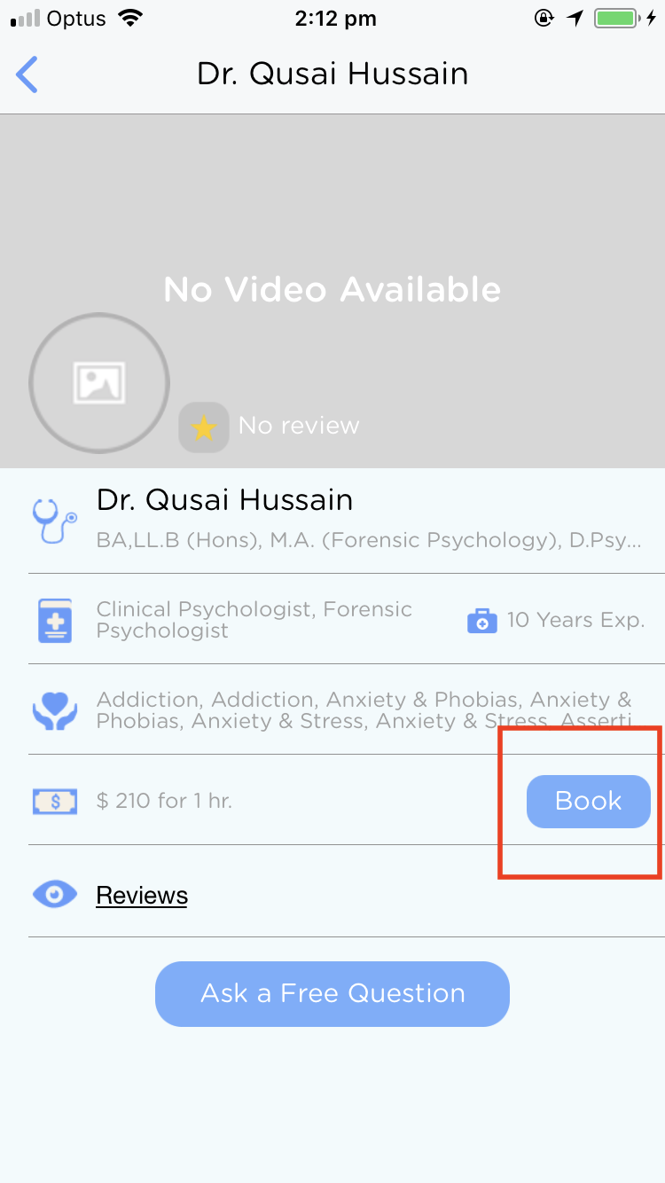
This will be your profile on the patient’s phone

- Select appointment day/ time
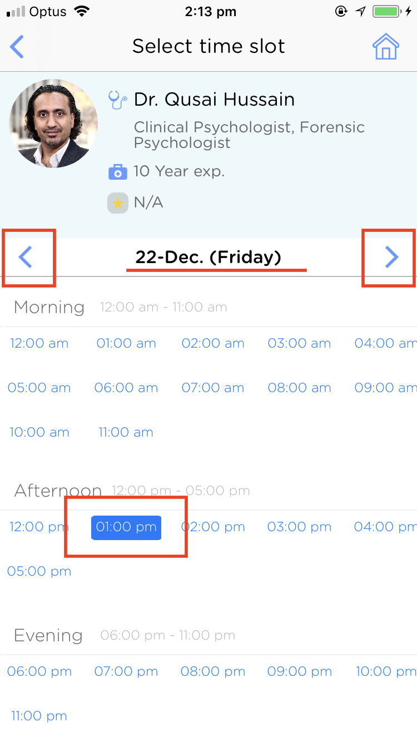

Make sure your availabilities/times are up to date!

- Read the consent form, tick if they agree, click ‘proceed’.

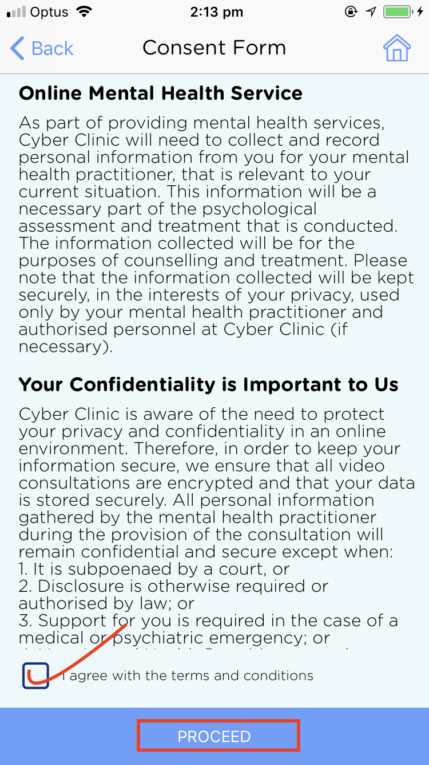

- Fill out the basic info under intake form and click ‘continue’
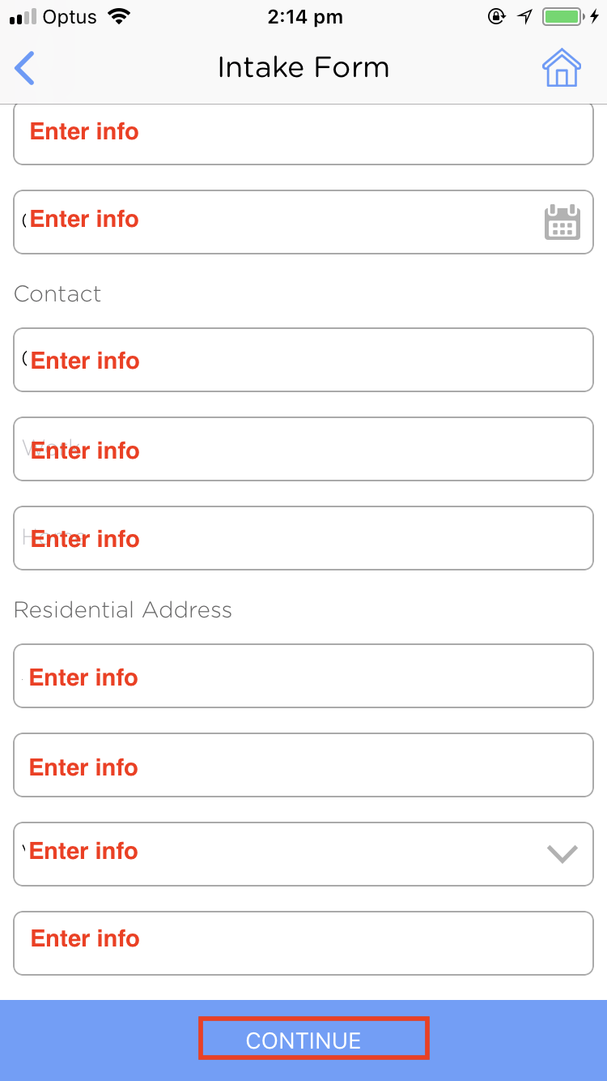

- They will need to summarise their issue E.g. Anxiety, Depression.

- They will need to enter in their Medicare Card details & referral details. You may need to help them with this process, especially with entering in the GP’s Provider no. and referral expiry, then click ‘submit.’

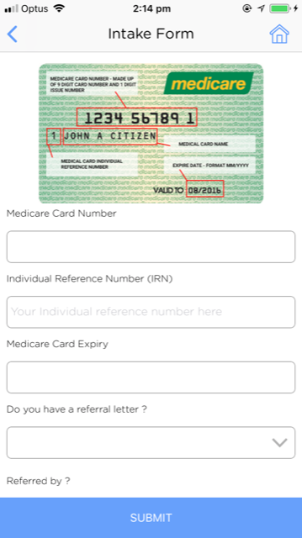
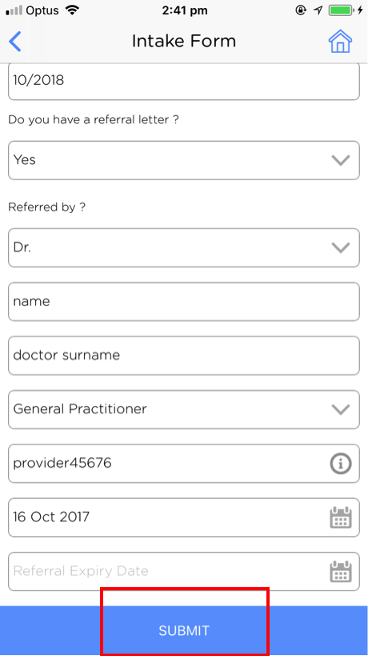

- They will need to click ‘proceed to payment’ even though they are not paying
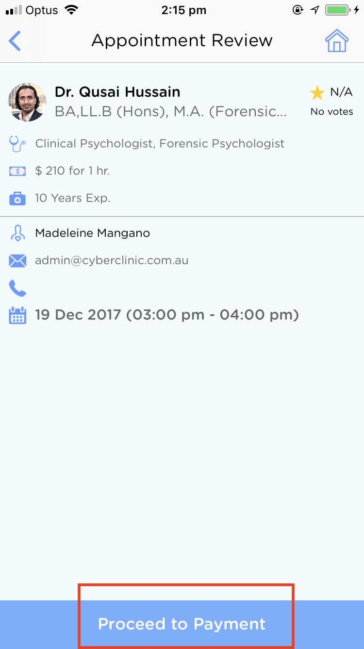

- A warning will come up “you have 24 hours notice to cancel your appointment otherwise your consultation will be forfeited” – make sure they understand this and tell them to click OK.

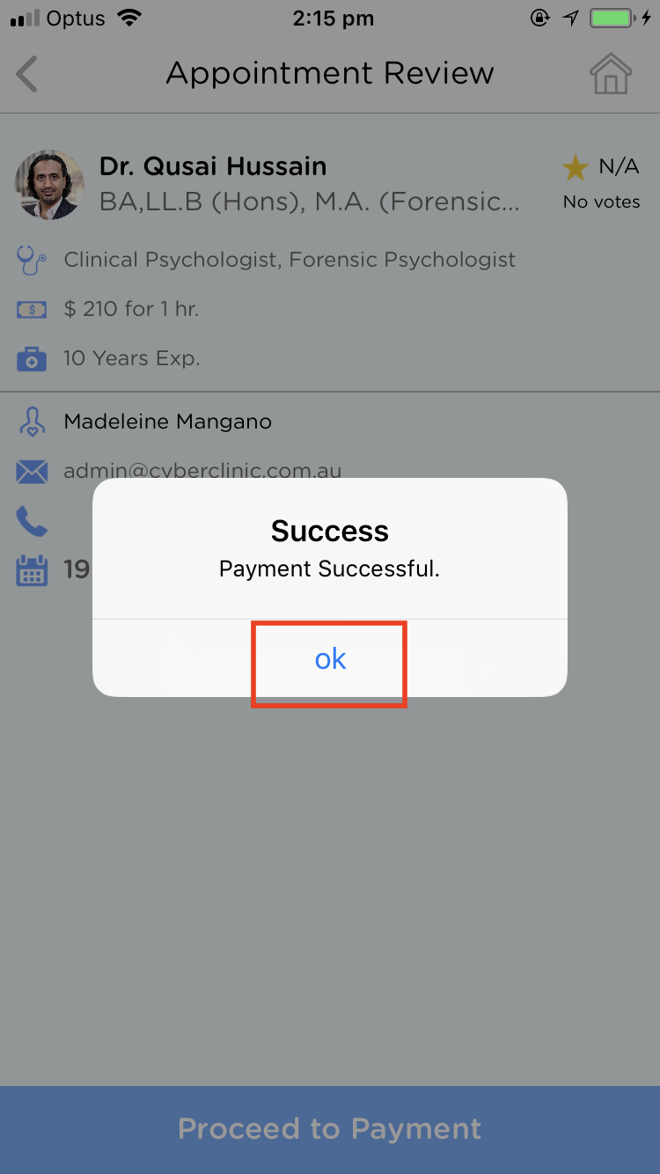

- It will automatically say ‘Payment Successful’ – tell them to click OK

- Check that the patient has booked the appointment successfully.
  - You will need to check to see if you’ve received a new request from the correct patient – these steps will be outlined in the next section
  - You cannot hang up the phone without the appointment being booked successfully

In order to CHECK/ CONFIRM APPOINTMENT HAS BEEN BOOKED you will need to do the following:

- Go to your computer
  - Ensure you are connected to the internet
  - Open Google Chrome/ Firefox (not safari or internet explorer)
- Go onto the cyber clinic webpage https://cyberclinic.com.au/
  - Click ‘Login’
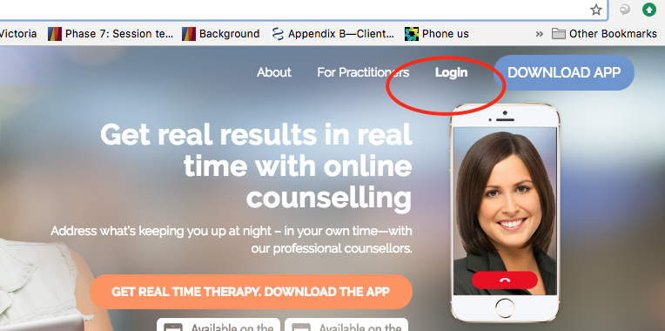

- Enter in your login details
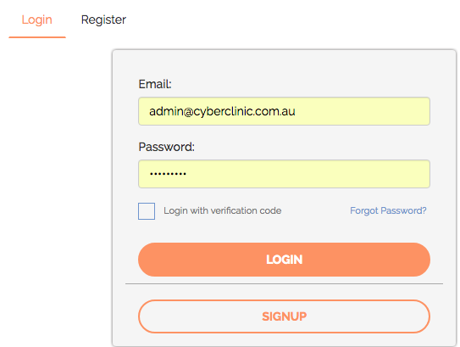

- The request should appear on your dashboard as soon as you login.
  - In the case that it doesn’t appear on your dashboard, click on ‘new requests’ on the side panel. The patient’s name / appointment should appear.

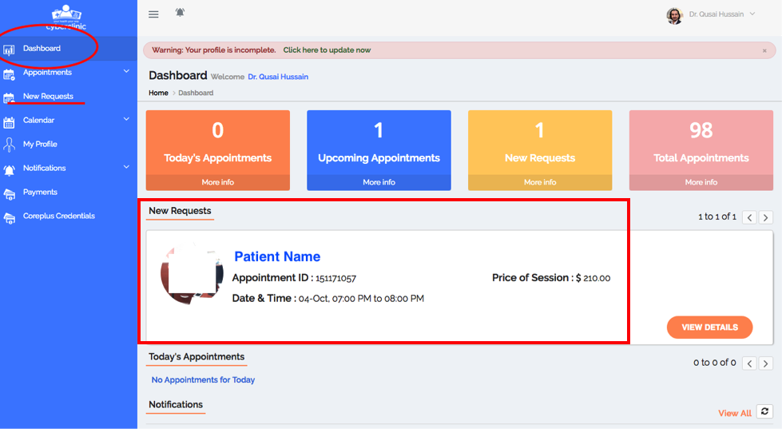

  - If the appointment is not showing up, try refreshing the page.
  - If it still is not showing up then something went wrong along the way.
You may need to repeat steps 11-23 or call Cyber Clinic Support for help 1300 112 115.

- If it is showing up then tell the patient:
  - “Okay you have booked in the appointment successfully.
- At the time of the appointment you will receive a video-call from me, the same way you would if you were using Facetime or Skype.
- If by chance I cannot connect with you then I will call you on your mobile number, is that ok?”
  - If they say OK, then confirm their mobile number
  - Remind them of the 24 hours notice for cancellation
  - Hang up

In order to ACCEPT THE APPOINTMENT you will need to do the following:

- Click ‘View Details’
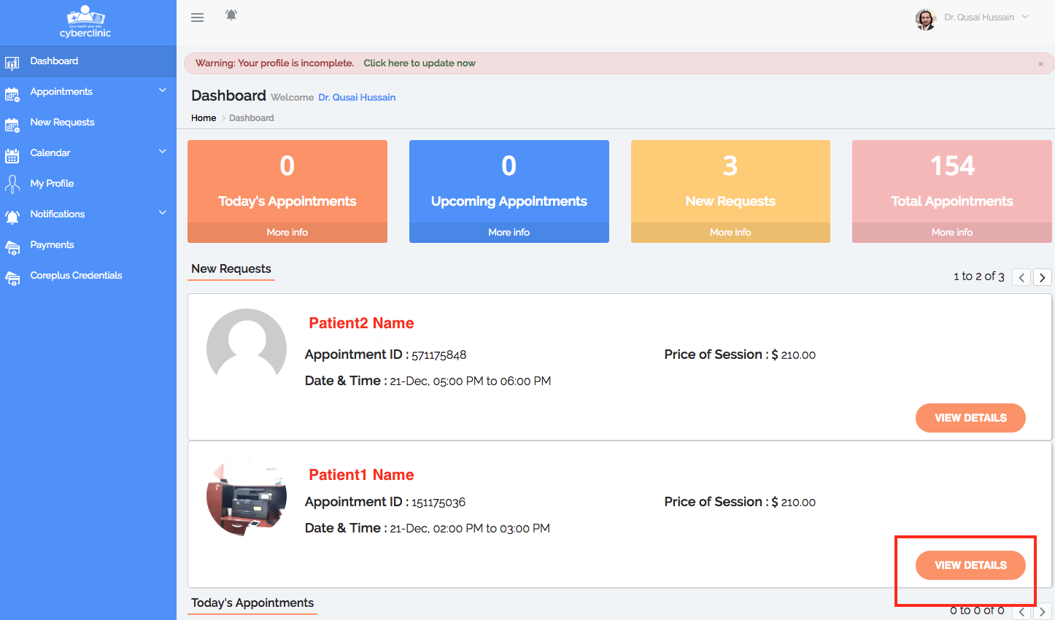

- Check details and click ‘accept’.
  - The patient will receive a text message/ email notifying them that you have accepted their appointment request. 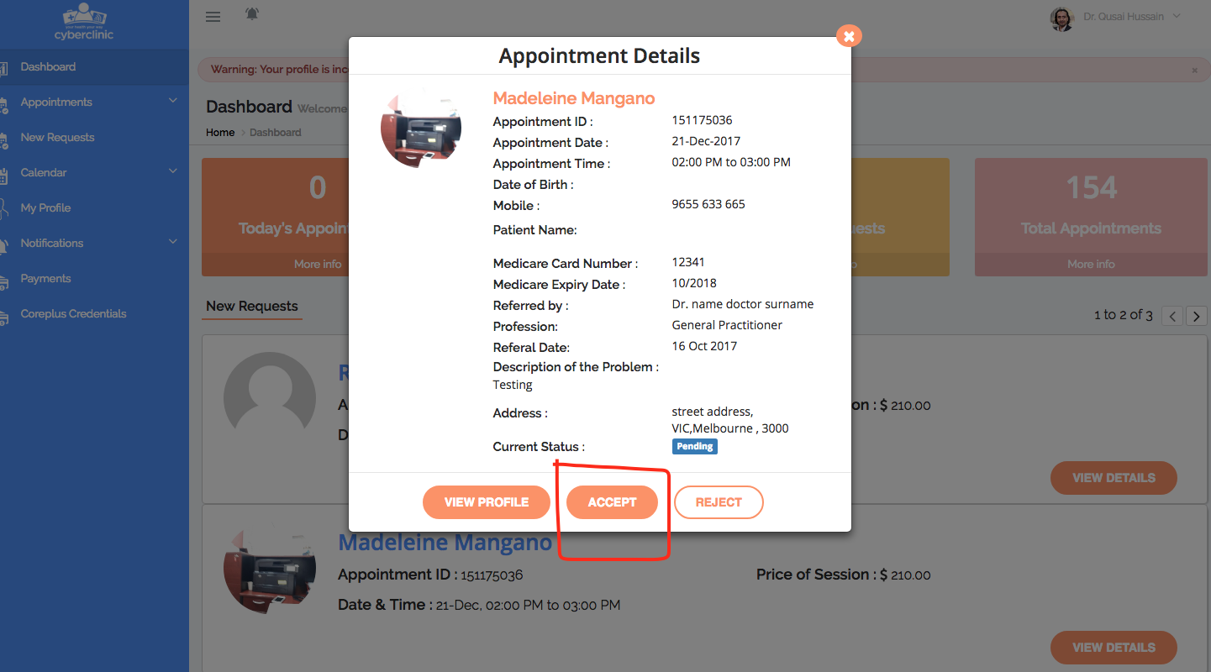

- The appointment should appear in your upcoming appointments
  - Go to ‘Appointments’ then ‘Upcoming Appointments’ and it should appear.
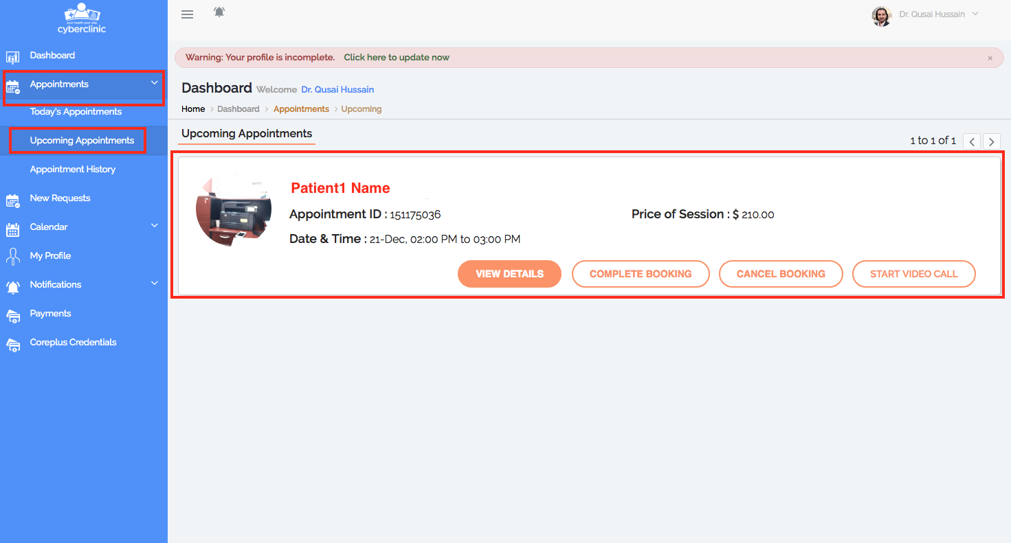

For support call 1300 112 115 or email support@cyberclinic.com.au

VIDEO CALLS

- Go to your computer
  - Open up Firefox or Google Chrome (not safari)

- Go onto the cyber clinic webpage https://cyberclinic.com.au/
  - Click ‘Login’

- Enter in your login details

- Click on ‘Appointments’ then ‘Today’s Appointments’
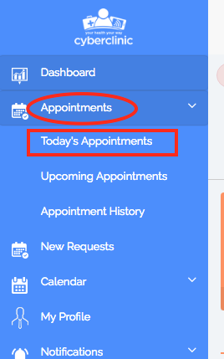

- Click ‘Start call’ again. Please note that when you click ‘start call’ the client will receive a notification/ call on their mobile.
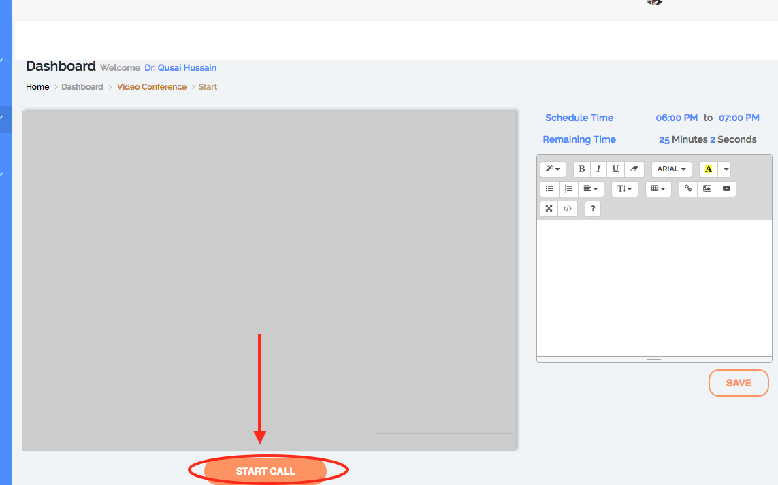

- If it is taking too long to connect this could be because the client has not noticed the invitation / has missed the call. In this case click ‘disconnect’ and in 2 minutes, try again by clicking ‘start call’.

- ‘Scheduled time’ and ‘remaining time’ in the screenshot below are self-explanatory.
  - Please note that Cyber Clinic will not automatically disconnect you when there is 0 remaining time – you will need to click ‘disconnect’ when you are ready.
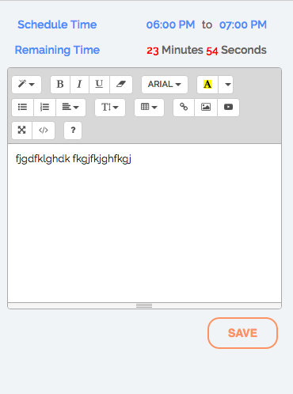

- As can be seen in the above screenshot, you can take clinical notes and click save.
  - Please keep in mind that these notes are not assigned to the client – they are assigned to the appointment (Booking ID)
- Therefore if you ever want to access these notes you will need to go to your Appointment History.
- For this reason it is recommended that right after the consultation has ended, you copy and paste these notes into a word document and print them/ file them.
- This will make it more convenient to keep all client notes on file together.
- If you prefer you can ignore this feature and hand-write your notes.

- To end the call click ‘disconnect’
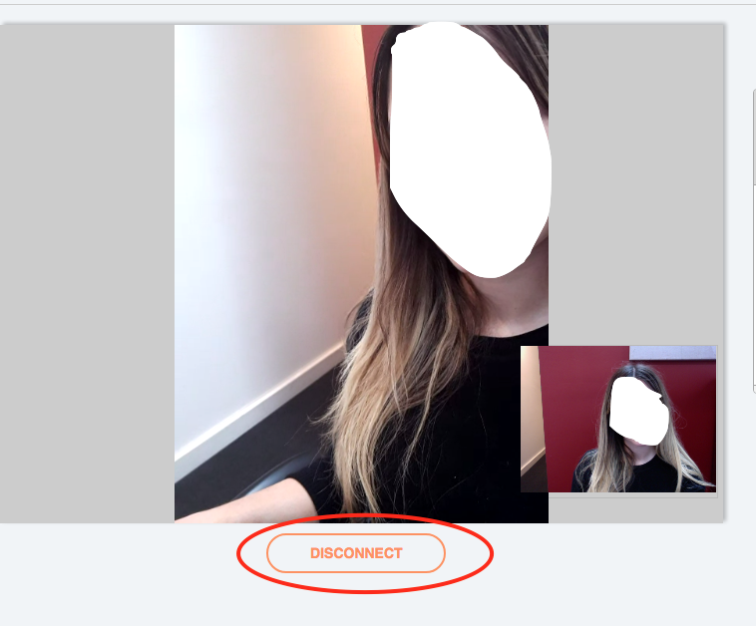

For support call 1300 112 115 or email support@cyberclinic.com.au

DECLINING & CANCELLING APPOINTMENTS

You will get an email notification if a patient books in with you. When this occurs:

- Go to your computer
- Go onto the cyber clinic webpage https://cyberclinic.com.au/
- Click ‘Login’
- Enter in your login details

- The request should appear on your dashboard as soon as you login in. In the case that it doesn’t then click on ‘new requests’ on the side panel.
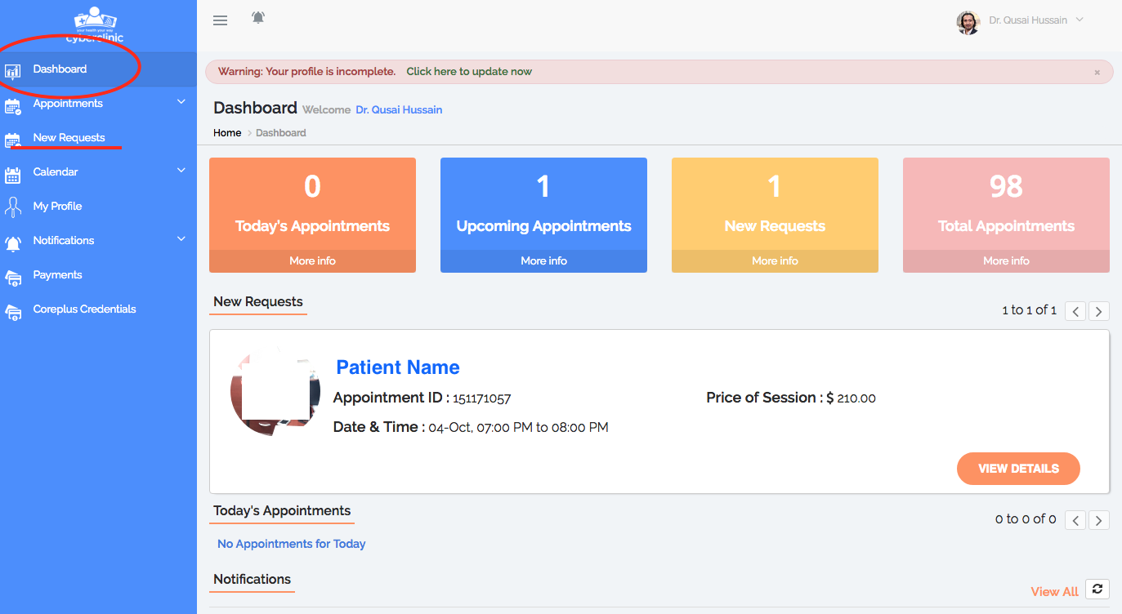

- Click on ‘View Details’
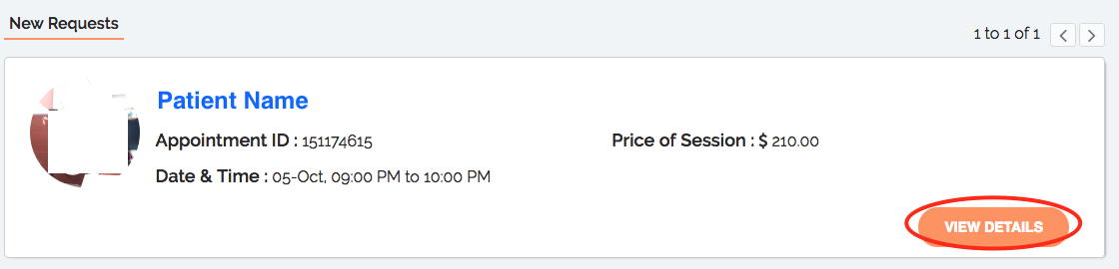

- Check the patient’s details and the description of the patient’s problem to make sure you are suitable to see this patient.

- Click decline accordingly
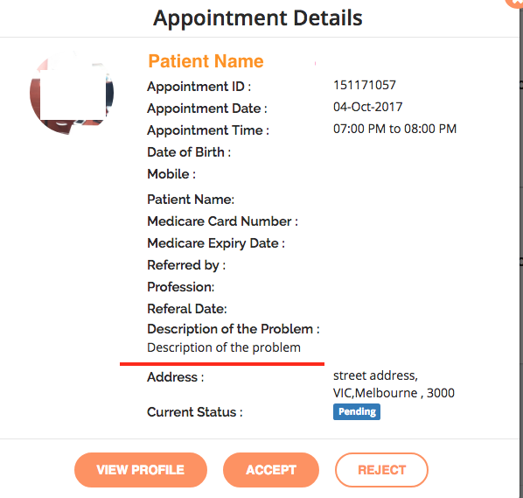

- DECLINING
  - You will need to give reason for why you are declining.
  - If you will never be able to see this patient, you should suggest that they book with another practitioner on Cyber Clinic or refer them to a specific practitioner on Cyber Clinic who might be appropriate for them.
  - You should always end the declination with “If it is an emergency or you are in crisis please contact lifeline on 13 11 14, or the ambulance on 000.”

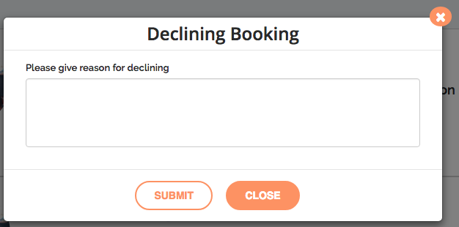

CANCELLING AN APPOINTMENT AFTER IT’S BEEN ACCEPTED

- Login as shown in steps no. 1,2,3,4 (from pg.30)

- Click on ‘upcoming’ or ‘todays’ appointments depending on which appointment you are cancelling.

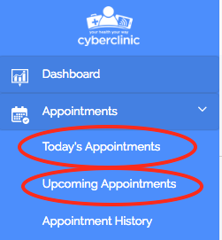

- Click cancel booking.
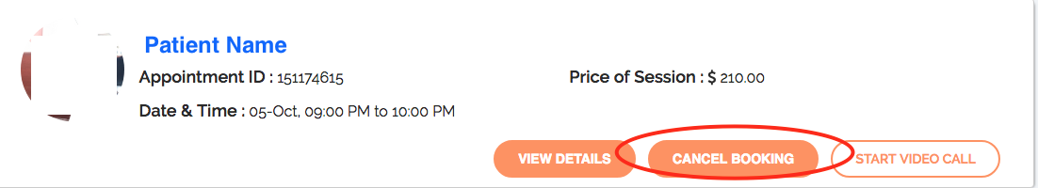
  - Double check the appointment time and date is correct; that you are cancelling the appointment you actually want to cancel.
- You will need to enter in a description of why you are cancelling the appointment. Refer to step 9 above (from pg. 32).
  - Click Submit.

For support call 1300 112 115 or email support@cyberclinic.com.au

