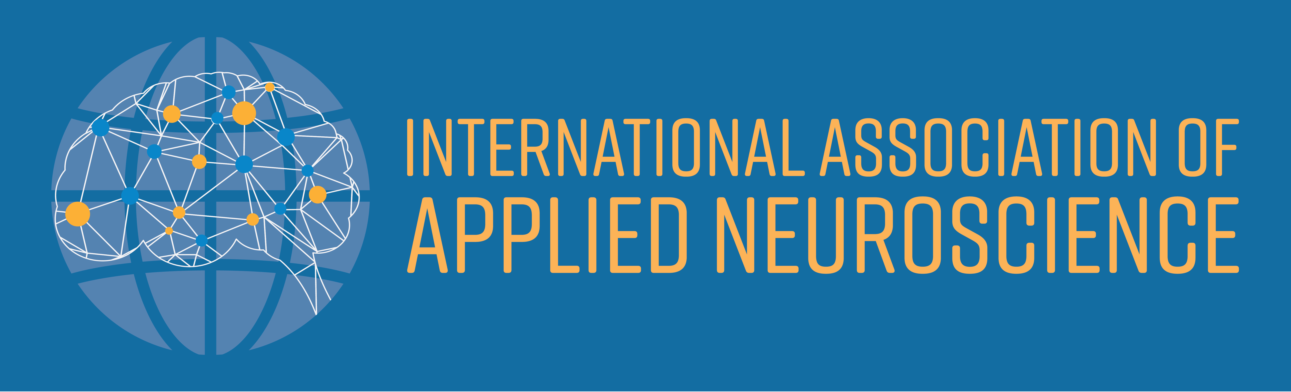

**2nd Annual IAAN Conference of Applied Neuroscience**

**Thursday 21 May – Saturday 23 May 2020**

Rydges on Swanston, 701 Swanston Street, Carlton

& The Melbourne Brain Centre

|  |  |
| --- | --- |
| * Up to 20 additional speakers, covering a wide range of applied neuroscience topics | * Peer-to-peer networking and forum * IAAN Annual General Meeting |
| * 3 conference streams (Psychotherapy,   Organisational and Educational)   * Keynotes, oral presentations and workshops | * 24 Continuing Professional Development Points * **FREE IAAN MEMBERSHIP** for full-time students |

**Conference Keynote Speakers**

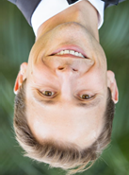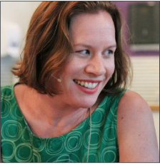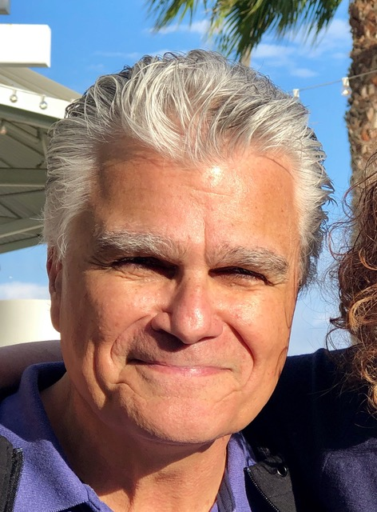

**Dr Louis Cozolino Dr Amee Baird Dr Jared Cooney Horvath**

Psychologist, Author Neuroscientist, Author Educator, Neuroscientist

Los Angeles, USA Newcastle, Australia Melbourne, Australia

**Dr Louis Cozolino**

* **Pre-Conference Full Day Workshop – 20 May 2020 – Rydges Hotel**
* **Public Lecture – 21 May 6.15pm – Melbourne Brain Centre**

Dr Cozolino holds degrees in philosophy, theology, and clinical psychology. His interests are in the areas of the synthesis of neuroscience with psychotherapy, education, management and leadership. He is the author of seven books *The Neuroscience of Psychotherapy, The Social Neuroscience of Education, The Neuroscience of Human Relationships, The Healthy Aging Brain, Attachment-Based Teaching, The Making of a Therapist, and Why Therapy Works.* He has also authored, co-authored articles and book chapters on child abuse, schizophrenia, education, language and cognition. Dr Cozolino lectures around the world on brain development, evolution, psychotherapy and maintains a clinical consulting practice in Los Angeles.

**Please register online at** [**www.iaan.com.au/events/**](https://www.iaan.com.au/events/)

PO Box 5 Katoomba NSW 2780 [**conference@iaan.com.au**](mailto:conference@iaan.com.au) +61 (0) 491 073 689